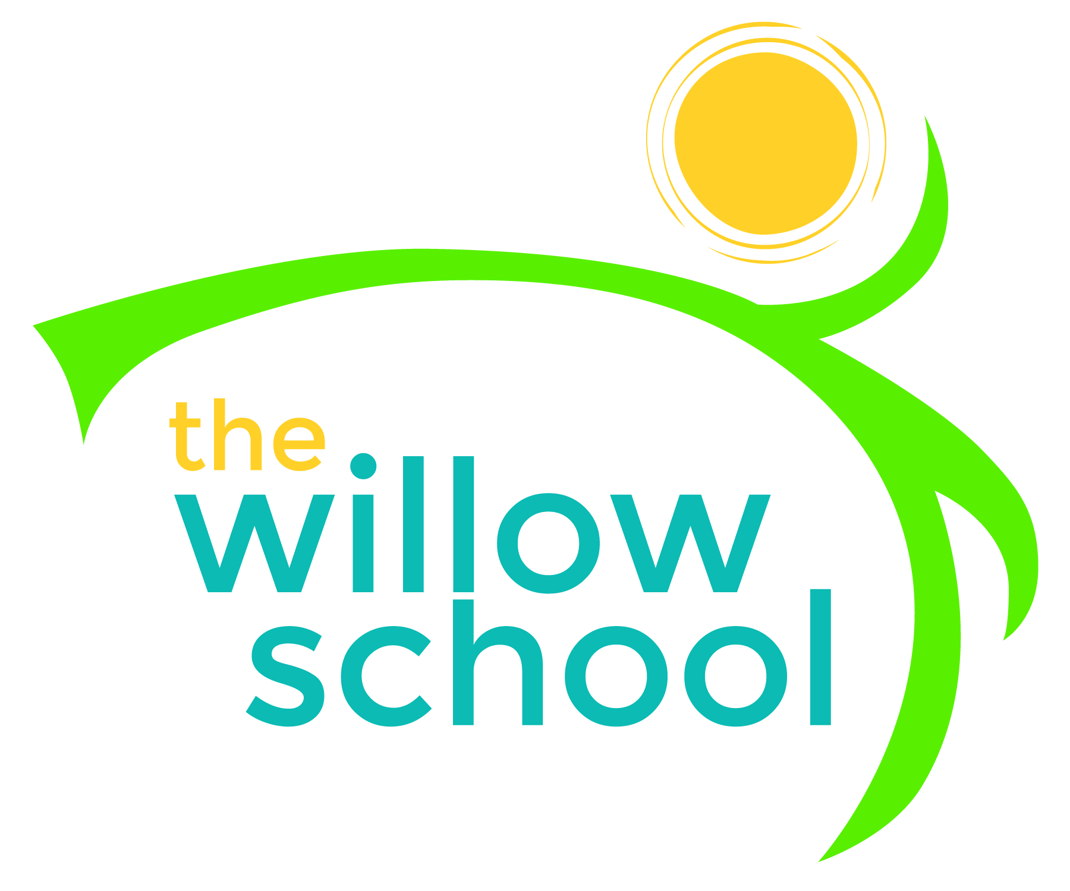

Menu – June 11-15, 2018
 | Monday  June 11 | Tuesday  June 12 | Wednesday  June 13 | Thursday  June 14 | Friday  June 15
Breakfast | Cinnamon Toast  Pineapple  Milk | Breakfast Biscuits  Raisins  Milk | Whole Grain Cereal  Pears  Milk | Creamy Grits  Oranges  Milk | Cinnamon Toast  Bananas  Milk
Lunch | Kidney Bean Salad  Tortilla Chips  Oranges  Milk | Veggie Sliders w/Peppers & Onions  Roasted Carrots  Apples  Milk | Broccoli Rice Casserole  Green Salad  Strawberries  Milk | Taco Pasta Salad  Rolls  3-Berry Medley  Milk | Spinach & Cheese Quesadillas  Steamed Corn  Melon  Milk
Afternoon Snack | Pita w/Hummus  Baby Carrots  Water | Graham Crackers w/Sunbutter Yogurt Dip  Water | Pretzels  String Cheese  Apples  Water | Fig Bars  Raisins  Water | Trail Mix w/Dried Fruit  Water
*Serving sizes and meal components will be in compliance with USDA as per the attached guidelines.

