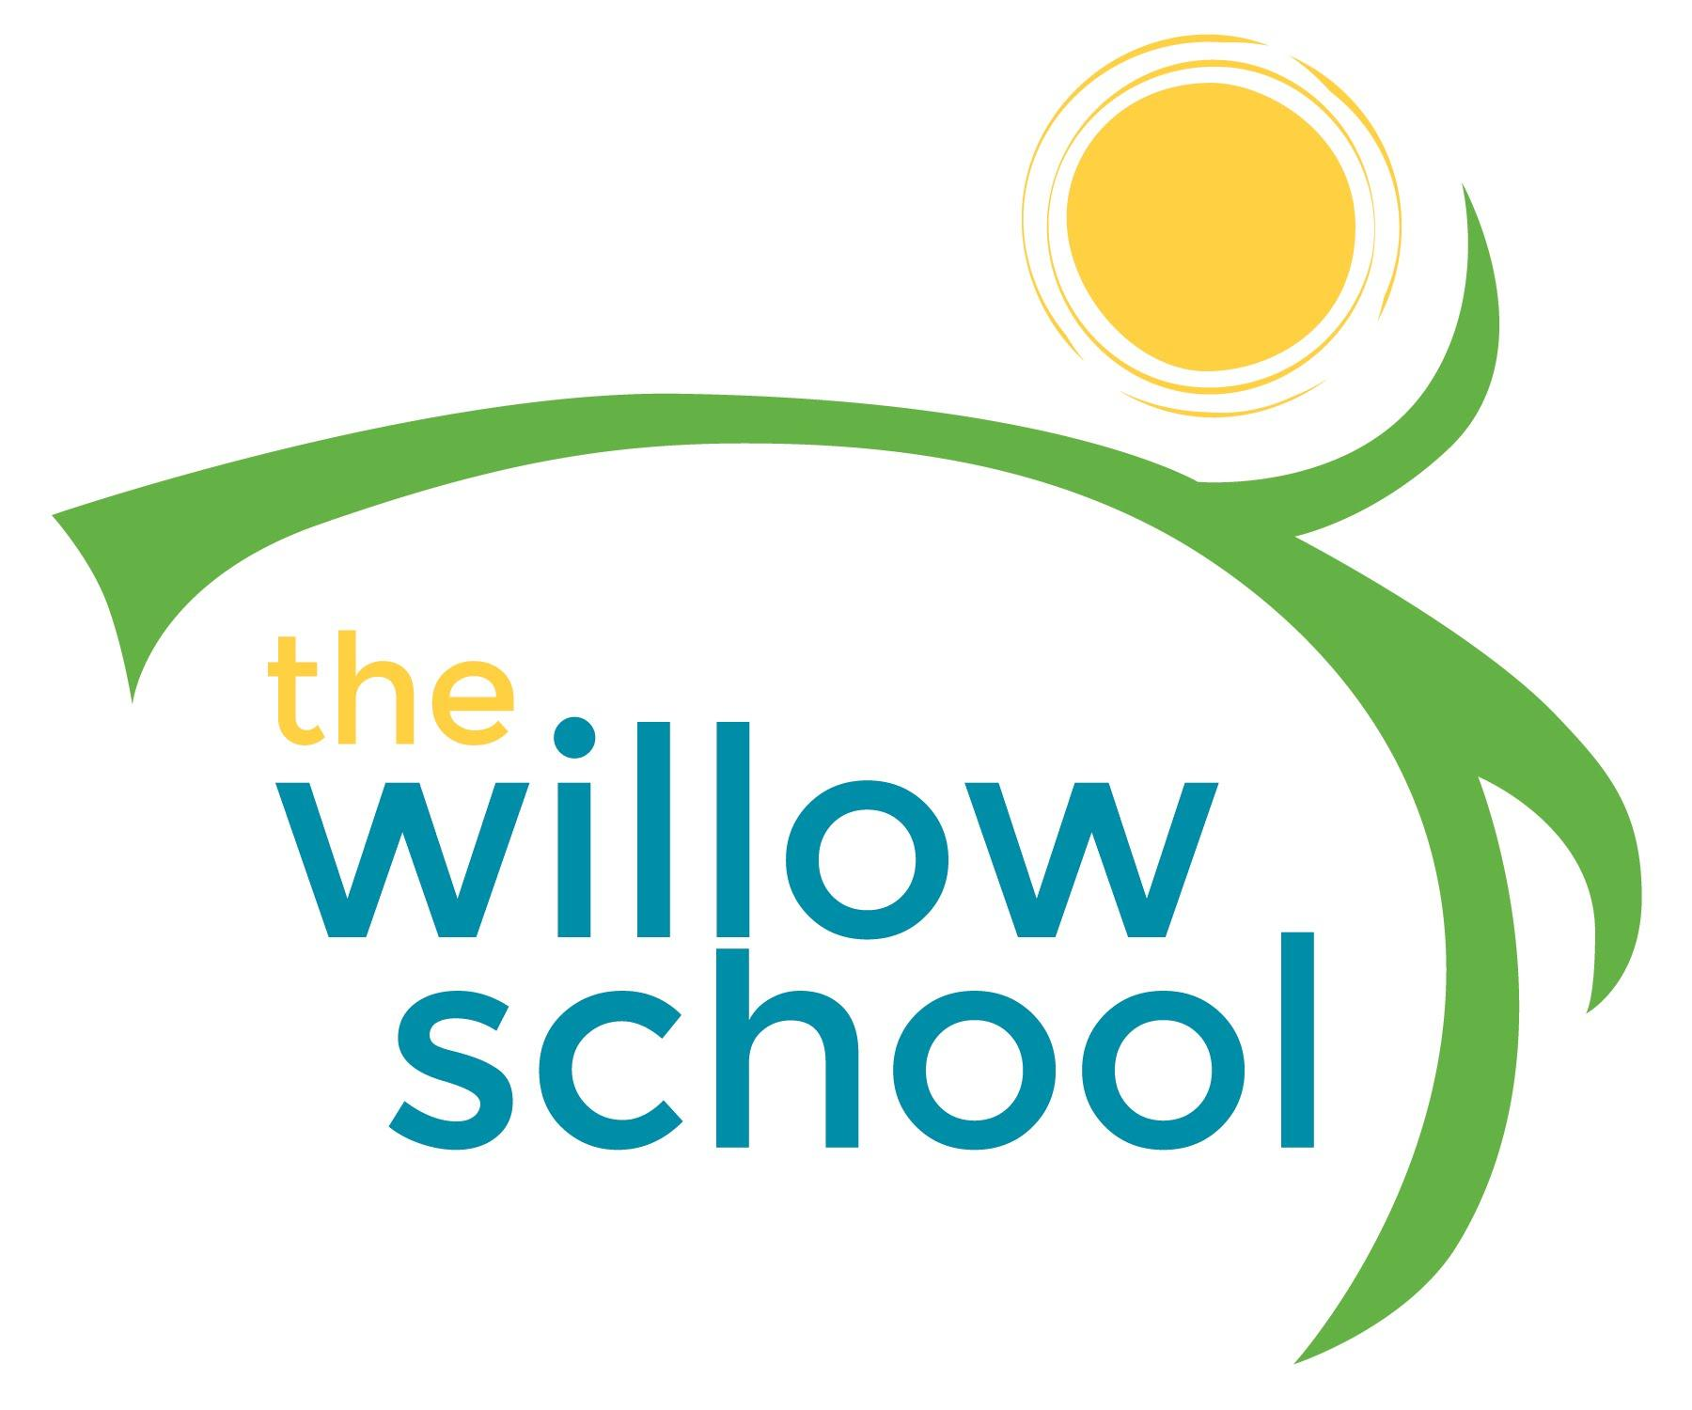 Menu: Oct. 5 – Oct. 9, 2015*

 | Monday  Oct 5, 2015 | Tuesday  Oct 6, 2015 | Wednesday  Oct 7, 2015 | Thursday  Oct 8, 2015 | Friday  Oct 9, 2015
Morning Snack | Bagels  Cream Cheese  Strawberries  Water | Whole Grain Cereal  Apples  Milk/Water | Rice Cakes  Sunbutter  Bananas  Water | Quinoa Porridge  Raisons  Water | Scramble Tofu  Toast  Water
Lunch | Baked Ziti  Garden Salad  Garlic Bread  Pears  Milk | Butternut Squash Soup  Cherry Tomatoes  Honeydew  Milk | Mac and Cheese  Steamed Green Beans  Mixed Fruit  Milk | Jerk Tofu  Rice and Beans  Sweet Plantains  Mango Slices  Milk | Veg. Sheppards Pie  Wheat Roll  Mixed Fruit  Milk
Afternoon Snack | Hummus  Chips | Animal Crackers  Bananas | Trailmix | Wheat Crackers  Grapes  Cheese | Green Smoothie  Pretzels

*Serving sizes and meal components will be in compliance with USDA as per the attached guidelines.

