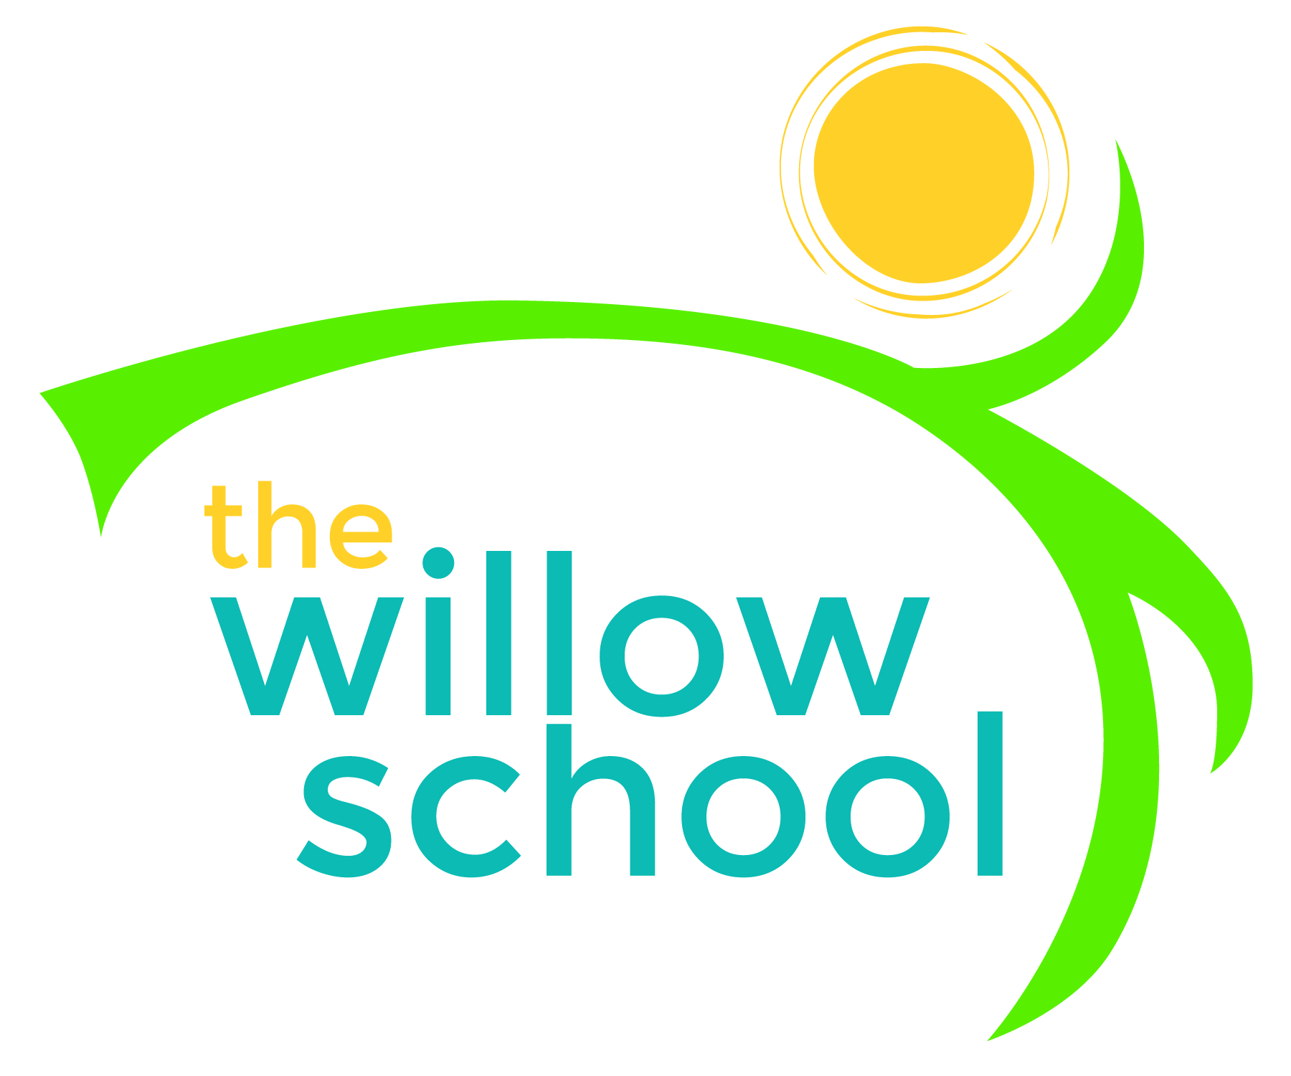 Menu – October 26-30, 2015

 | Monday  October 26 | Tuesday  October 27 | Wednesday  October 28 | Thursday  October 29 | Friday  October 30
Morning Snack | Quinoa Porridge  Dried Fruit  Water | Oatmeal  Blueberries  Water | Whole Grain Cereal  Bananas  Water | Vegan French Toast  Kiwi  Water | Granola  Mixed Fruit  Water
Lunch | Minestrone Soup  Rolls  Melon  Milk | Squash Chili  Cornbread  Grapes  Milk | Cheese Quesadillas  Black Beans  Collards  Pineapple  Milk | Sunbutter & Banana Sandwiches  Cucumbers & Dill  Fruit Salad  Milk | Baked Ziti With Eggplant, Fennel & Veggie Sausage  French Baquette  Spinach Salad  Milk
Afternoon Snack | Wheat Crackers  Cheese  Apples  Water | Chocolate Hummus  Strawberries  Water | Babaganoush  Pita Bread  Water | Vegan Rice Krispy Treats with Frozen Yogurt  Water | Cucumber Tofu Rolls  Apple Slices  Water

*Serving sizes and meal components will be in compliance with USDA as per the attached guidelines.

