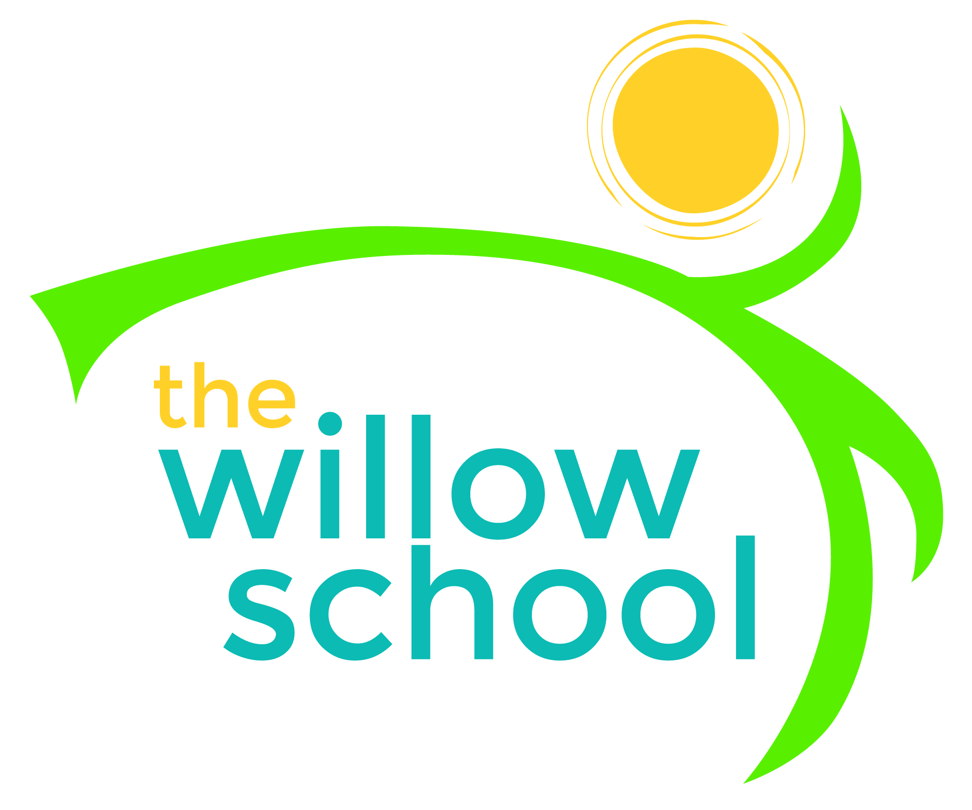 Menu – October 19-23, 2015

 | Monday  October 19 | Tuesday  October 20 | Wednesday  October 21 | Thursday  October 22 | Friday  October 23
Morning Snack | Whole Grain Cereal  Banana  Milk/Water | Waffles  Strawberry  Shortcake  Water | Oatmeal  Fresh Fruit  Water | Grits  Toast  Sausage  Water | Bagels  Cream Cheese  Sliced Pears  Water
Lunch | Three Bean Chili  Maple Pan Yams  Rolls  Grapes  Milk | Veggie Taco Salad  Lettuce  Tomato  Cheese  Mango  Milk | Yellow Rice  Black Eyed Peas  Mixed Greens  Mixed Melon  Milk | Tomato Basil Soup  Grilled Cheese  Kiwi  Milk | Sloppy Joe Falafel  Fried Corn & Spinach  Sliced Apples
Afternoon Snack | Rice Cakes  Sunbutter  Berries | Chips  Guacamole | Smoothie Bowl  Fruit  Flaxseed Topping | Banana Berry Frozen Yogurt Bars | Animal Crackers  Trail Mix  Banana Ghost Pops

*Serving sizes and meal components will be in compliance with USDA as per the attached guidelines.

