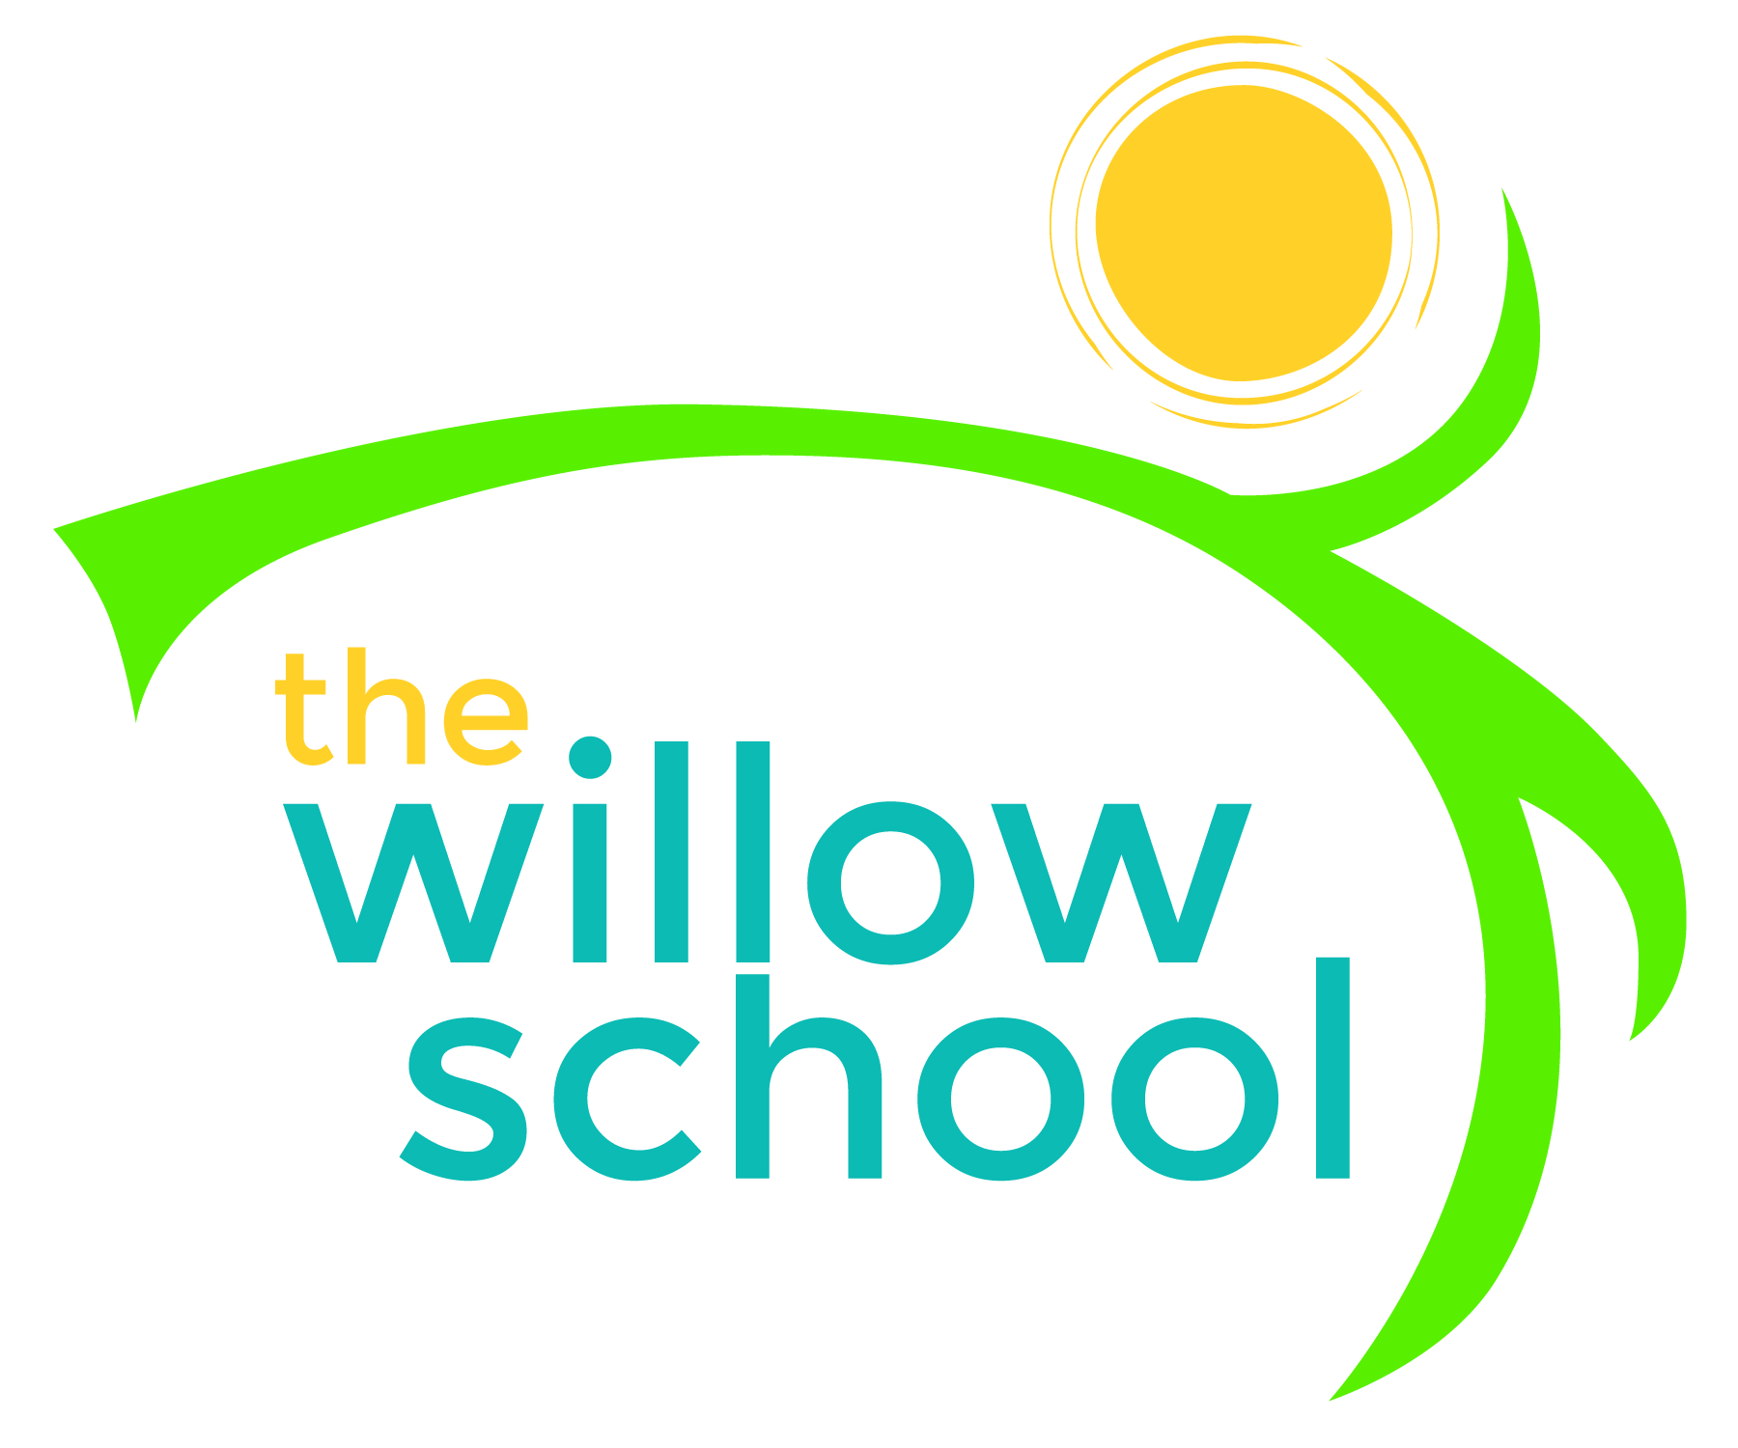 Menu – October 12-16, 2015

 | Monday  October 12 | Tuesday  October 13 | Wednesday  October 14 | Thursday  October 15 | Friday  October 16
Morning Snack | Bagels  Cream Cheese  Apples  Water | Whole Grain Cereal  Banana  Milk/Water | Potato Hash  Veggie Sausage  Oranges  Water | Cinnamon Raisin Toast with Cream Cheese  Strawberries  Water | Buttermilk Pancakes  Blueberry Compote  Water
Lunch | Veggie Sausage  Onions & Peppers  Rice & Beans  Spinach & Pear Salad | Broccoli Rice Casserole  Cherry Tomatoes  Grapes  Milk | Savory Vegetable Stew with Quinoa  Green Beans  Pineapple Chunks  Milk | Honey Grilled Tofu  Mashed Potatoes  Steamed Cabbage  Apple Slices  Milk | Sweet Potato & Lentil Soup  Corn Griddle Cakes  Fruit Salad  Milk
Afternoon Snack | Graham Crackers with Sunbutter  Strawberries  Water | Fruit & Cheese Kabobs  Animal Crackers  Water | Banana Muffins  Pears  Water | Fruit & Yogurt Smoothies  Wheat Crackers  Water | Fig Bars  Bananas  Water

*Serving sizes and meal components will be in compliance with USDA as per the attached guidelines.

