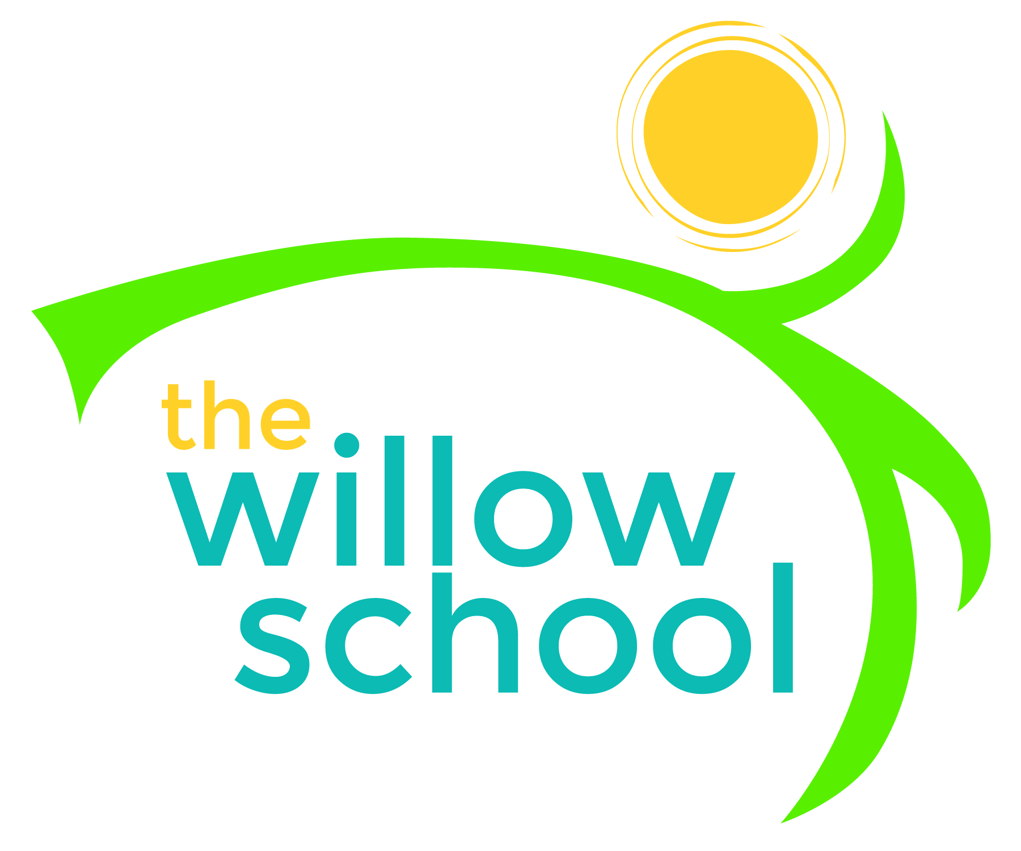 Menu – November 9-13, 2015

 | Monday  November 9 | Tuesday  November 10 | Wednesday  November 11 | Thursday  November 12 | Friday  November 13
Morning Snack | Waffles  Mixed Fruits  Water | Hashbrowns  Veggie Sausage  Biscuit  Water | Warm Cinnamon Quinoa  Blueberries  Water | Cornmeal Porridge  Bananas  Water | Superstar Breakfast  Couscous & Apples  Water
Lunch | Butternut Squash,  Sunflower Seed & Sage Pasta  Grilled Asparagus  Melon  Milk | Black Bean Quesadillas, Steamed Carrots  Pineapples  Milk | Chickpea Salad on Whole Grain Bread  Lettuce & Tomato  Grapes  Milk | Lima Bean  Steamed Rice  Cabbage  Honey Dew Melon  Milk | Mushroom & Barley Soup  French Bread  Mixed Fruit  Milk
Afternoon Snack | Applesauce  Animal Crackers  Water | Gluten-Free Chex Trail Mix  Water | Chips  Homemade Salsa  Water | Fig Bar  String Cheese  Strawberries  Water | Vegan Banana Pudding  Cookies  Water

*Serving sizes and meal components will be in compliance with USDA as per the attached guidelines.

