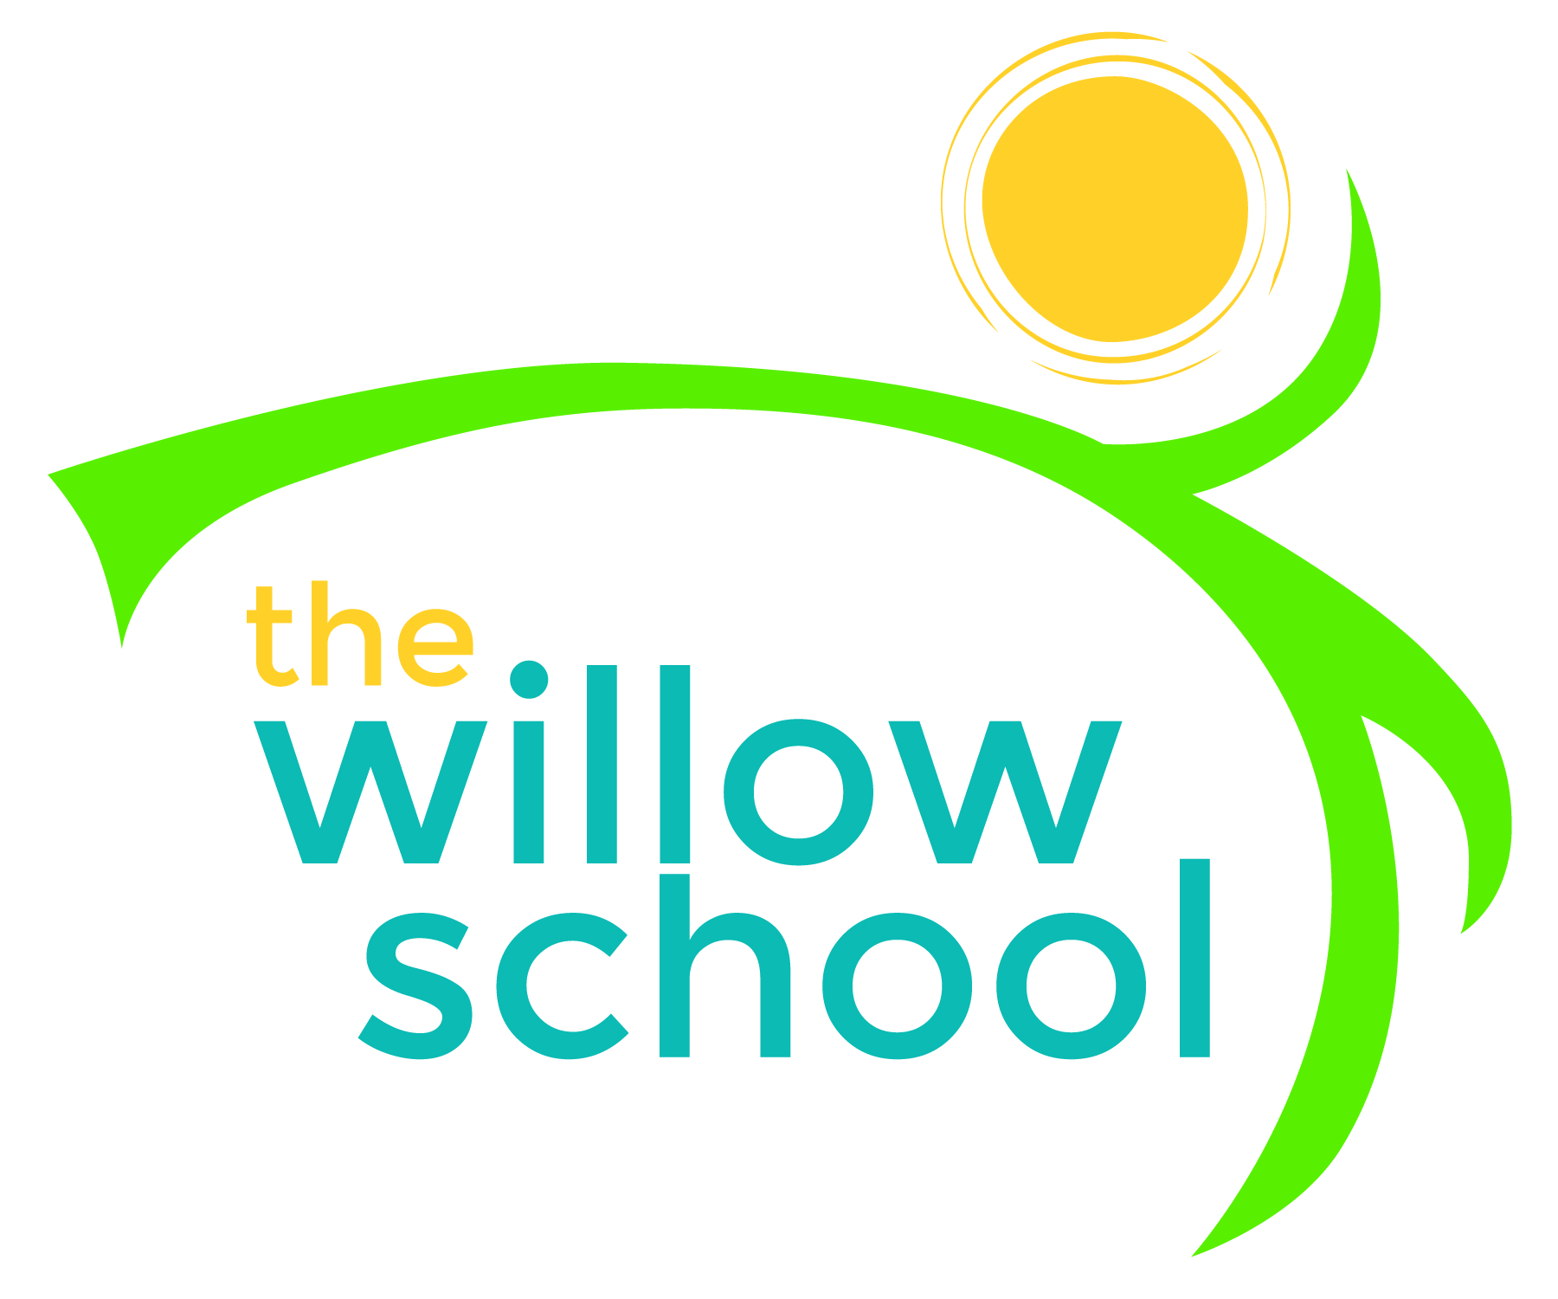 Menu – November 30 – December 4, 2015

 | Monday  November 30 | Tuesday  December 1 | Wednesday  December 2 | Thursday  December 3 | Friday  December 4
Morning Snack | Rice Cereal w/ Bananas & Milk  Water | Grits  Apples  Water | Bagels w/cream cheese  Pineapple  Water | Oatmeal w/ Dates & Cinnamon  Water | Cinnamon Toast  Blueberries  Water
Lunch | Pasta w/Marinara  Corn Bread  Apples  Milk | Red Beans  Rice  Collard Greens  Grilled Parsnips  Milk | Black Eyed Peas  Sweet Potatoes  Couscous  Melon  Milk | Veggie Hummus Wraps  Pretzels  Cantaloupe  Milk | Veggie Mexican Lasagna  Green Salad  Oranges  Milk
Afternoon Snack | Pretzels  Cheddar Cheese  Apples  Water | Fig Bars  Grapes  Water | Applesauce  Graham Crackers  Water | Raisin Toast  Cheddar Cheese  Bananas  Water | Sunbutter  Crackers  Pears  Water

*Serving sizes and meal components will be in compliance with USDA as per the attached guidelines.

