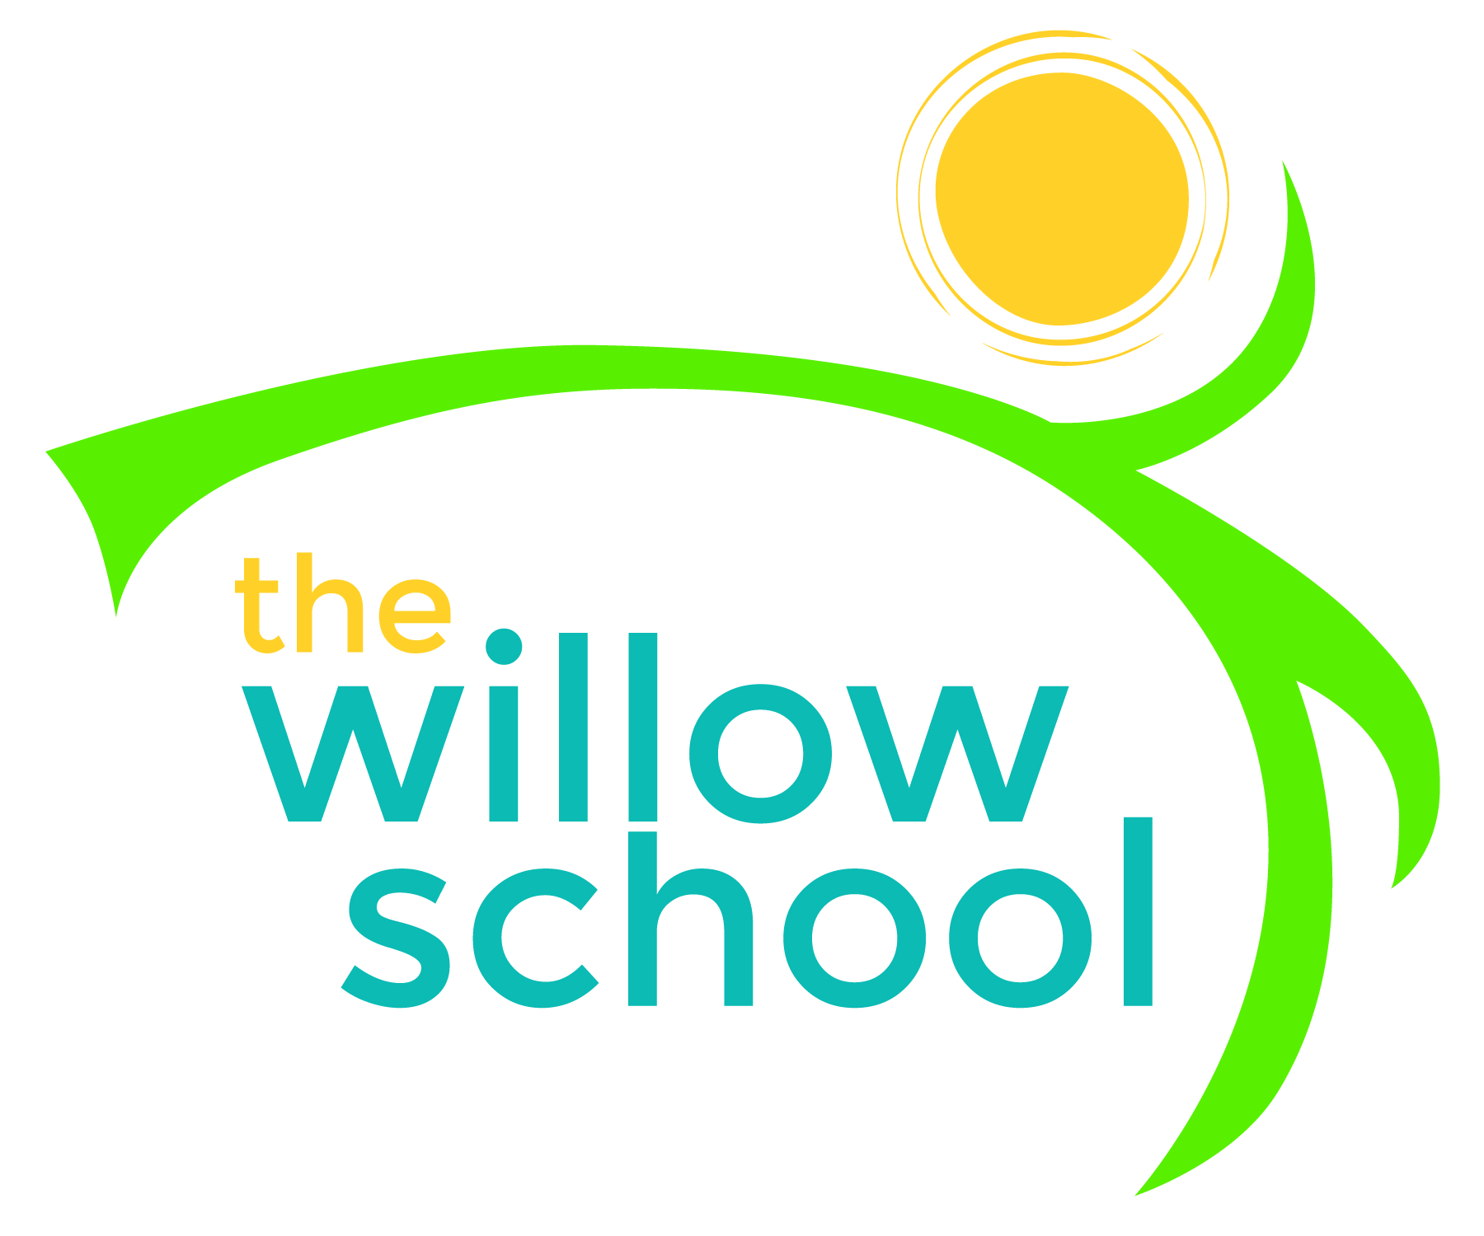 Menu – November 30 – December 4, 2015

 | Monday  November 30 | Tuesday  December 1 | Wednesday  December 2 | Thursday  December 3 | Friday  December 4
Morning Snack | Oatmeal  Dried Fruit  Water | Grits  Apples  Water | Bagels  Orange  Water | Rice Cereal  Bananas  Milk / Water | Cinnamon Toast  Mixed Berries  Water
Lunch | Red Beans  Rice  Collard Greens  Apples  Milk | Curry Vegtables  Quinoa  Melon  Milk | Black Eyed Peas  Boiled Yams  Honey Dew Melon  Sliced Avocado  Milk | Veggie Hummus Wraps  Pretzels  Cantaloupe  Milk | Veggie Mexican Lasagna  Green Salad  Mixed Fresh Fruit  Milk
Afternoon Snack | Raison Toast  Sunbutter  Bananas | Fig Bars  Strawberries  Water | Applesauce  Graham Crackers  Water | Wheat Crackers  Cheddar Cheese  Apples  Water | Sunbutter  Crackers  Sliced Oranges  Water

*Serving sizes and meal components will be in compliance with USDA as per the attached guidelines.

