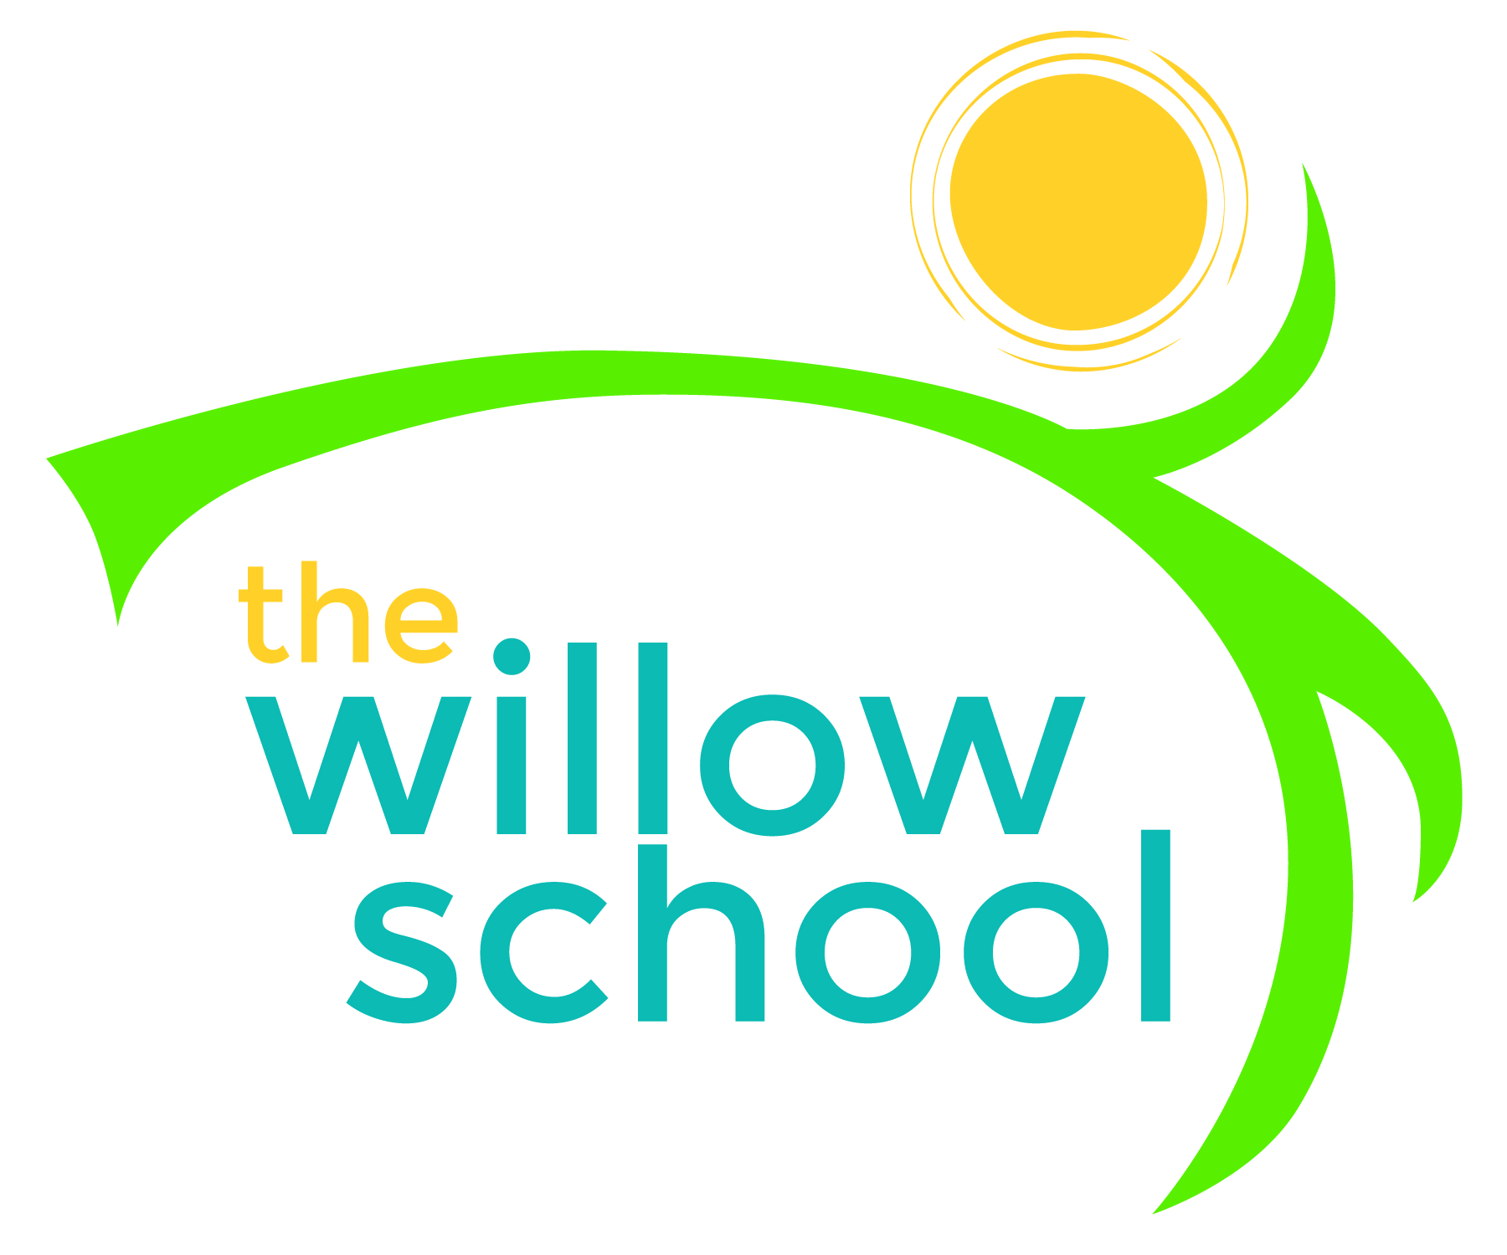 Menu – November 23 – 24, 2015

 | Monday  November 23 | Tuesday  November 24
Morning Snack | Waffles  Kiwi  Water | Pancakes  Pears  Water
Lunch | Cheese Quesadillas  Mixed Greens  Apples  Milk | Tofu Stir Fry  Penne Noodles  Mixed Vegtables  Grapes  Milk
Afternoon Snack | Hummus  Pita  Water | Trail Mix  Water

*Serving sizes and meal components will be in compliance with USDA as per the attached guidelines.

