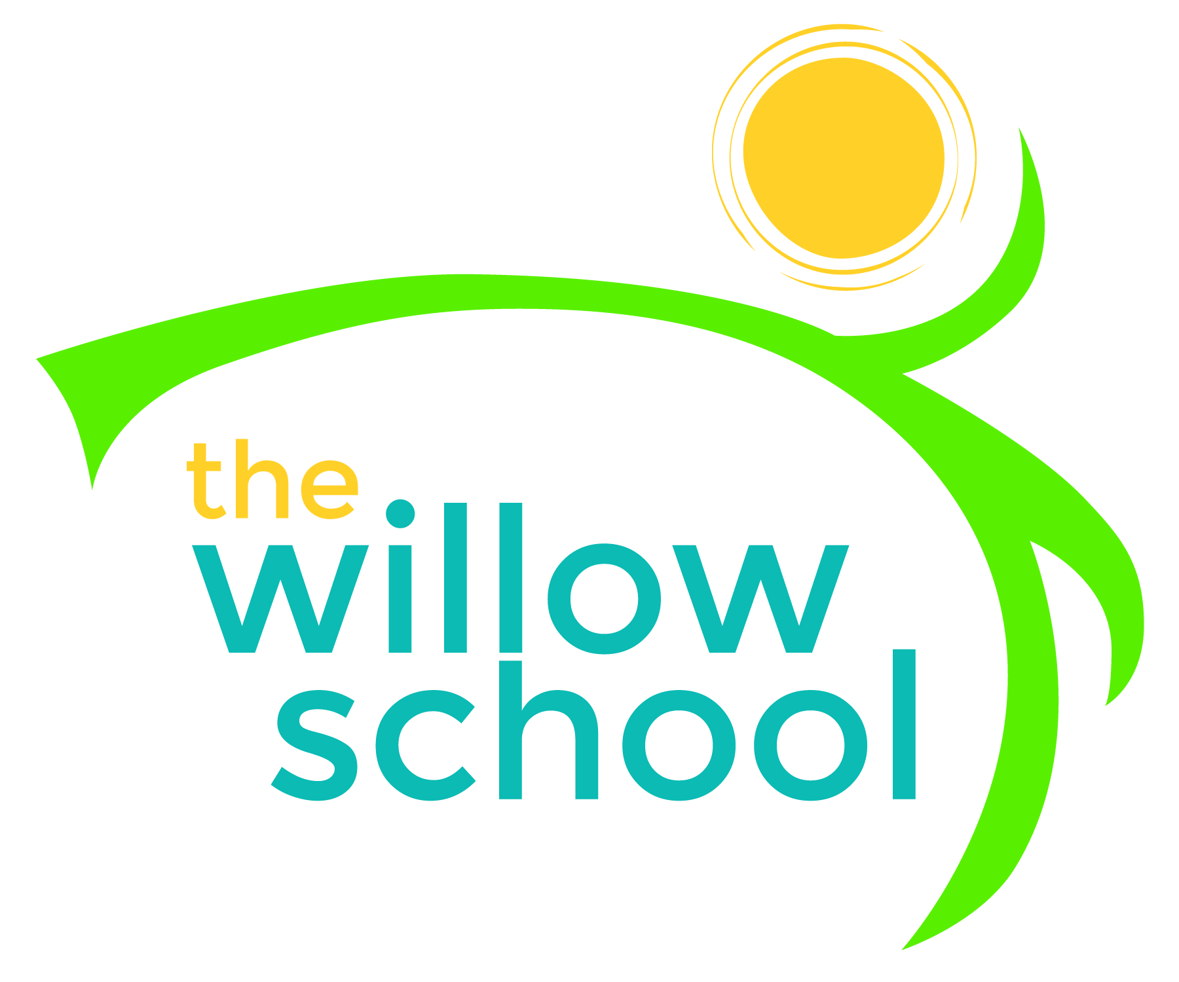 Menu – November 16-20, 2015

 | Monday  November 16 | Tuesday  November 17 | Wednesday  November 18 | Thursday  November 19 | Friday  November 20
Morning Snack | Cinnamon Yogurt  Dried Fruit  Water | Grits  Apples  Water | Whole Grain Cereal  Bananas  Milk | French Toast  Orange Slices  Water | Rice Cakes  Sun Butter  Pears  Water
Lunch | Vegetable Soup  Grilled Cheese  Kiwi  Milk | Baked Spaghetti  Garden Salad  Cantaloupe  Milk | Pancakes  Scrambled Tofu  Mixed Vegetables  Milk | Lentil Soup  Spoon Bread  Mixed Fruit  Milk | Macaroni & Cheese  Broccoli  Watermelon  Milk
Afternoon Snack | Sunbutter  Graham Crackers  Water | Pretzels  Cheese  Water | Chips  Guacamole  Water | Waffle Strawberry Shortcake  Water | Apple Crisps  Cheese Sticks  Water

*Serving sizes and meal components will be in compliance with USDA as per the attached guidelines.

