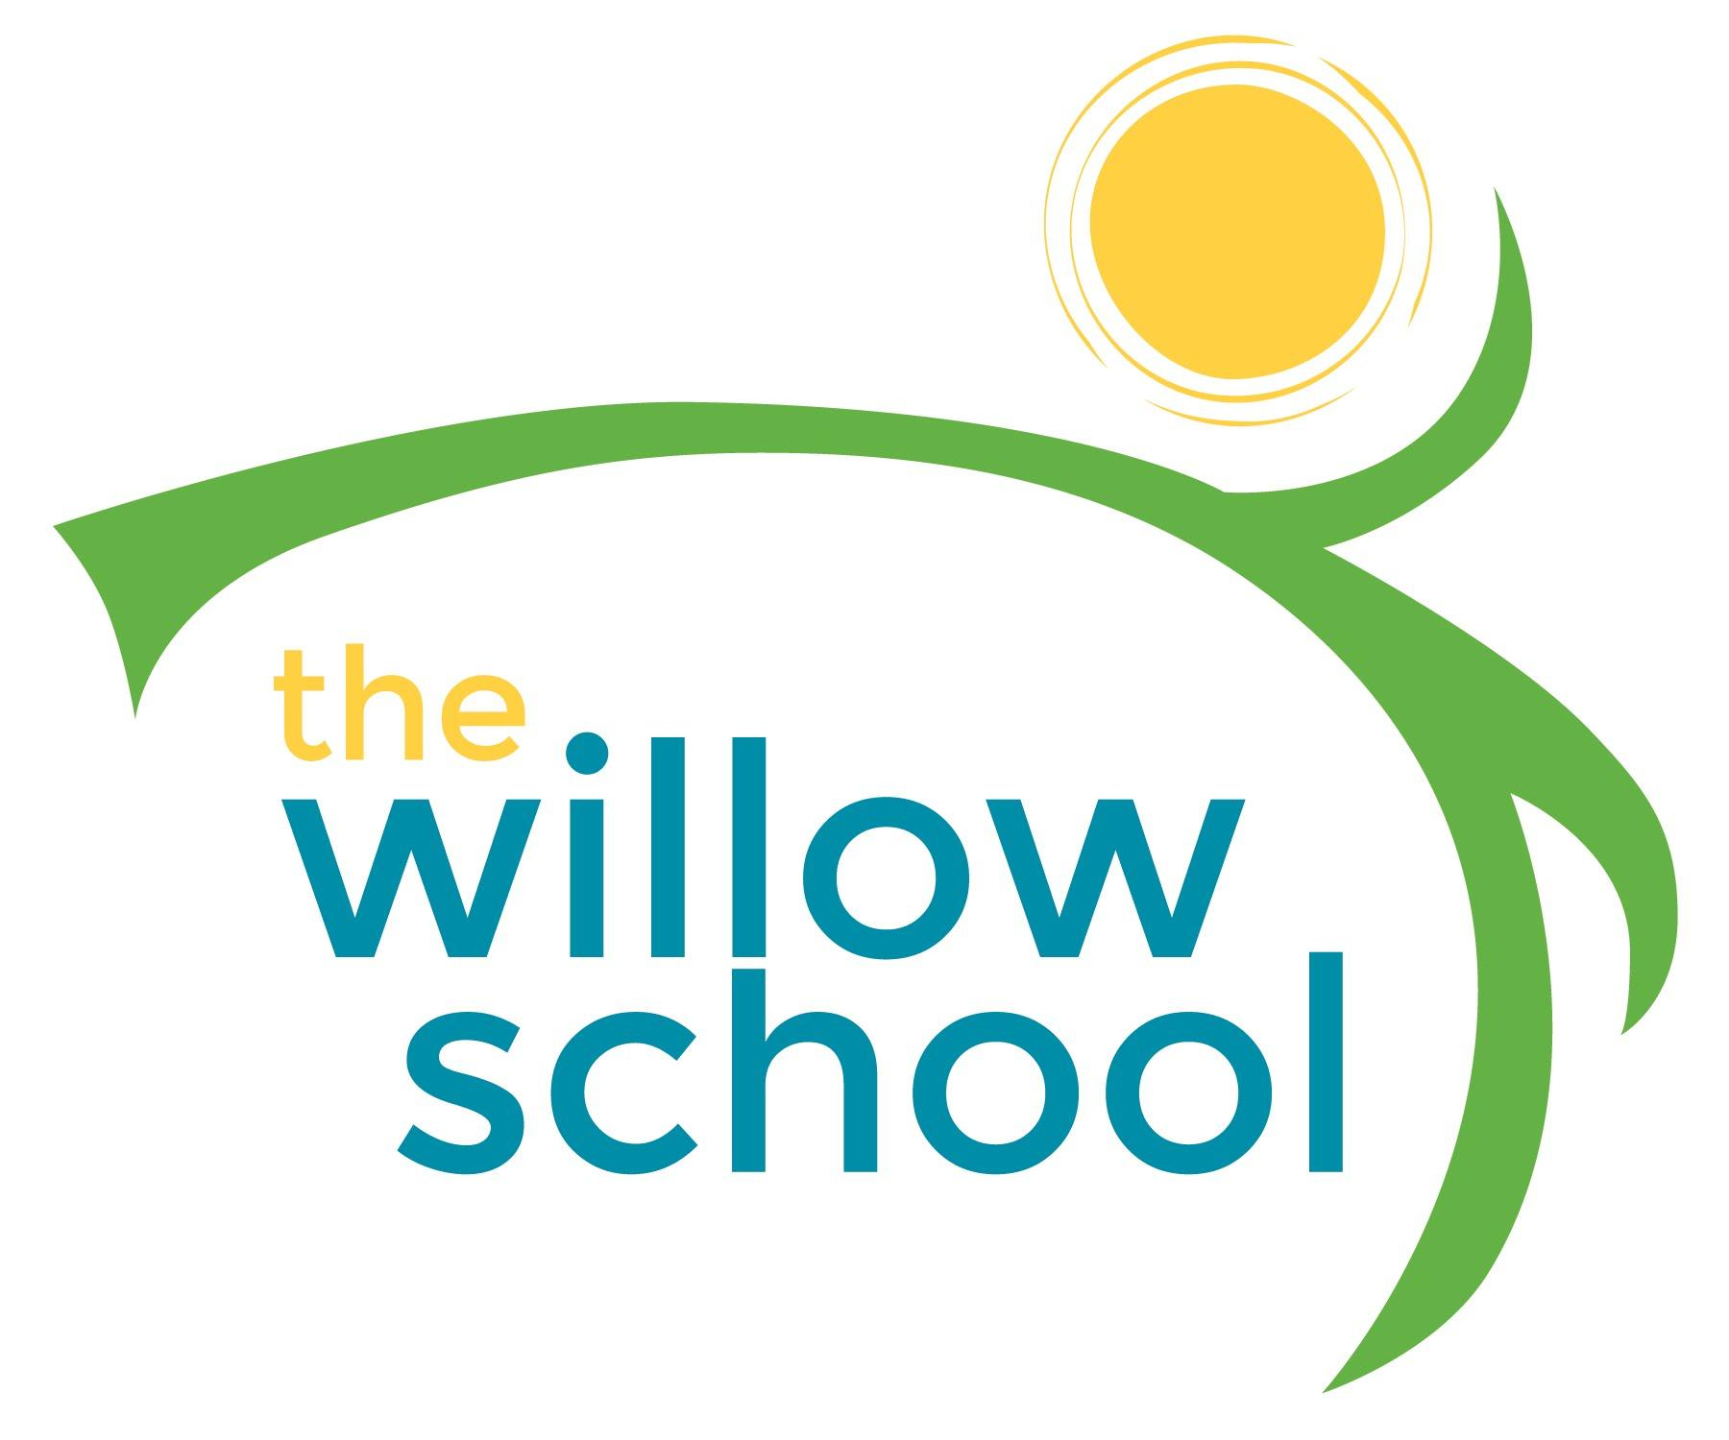 **Menu: May 23-27, 2016**

|  |  |  |  |  |  |
| --- | --- | --- | --- | --- | --- |
|  | **Monday**  **May 23** | **Tuesday**  **May 24** | **Wednesday**  **May 25** | **Thursday**  **May 26** | **Friday**  **May 27** |
| **Morning Snack** | Cheese Grits  Apricots  Milk | Cheese Toast  Strawberries  Milk | Whole Grain Cereal  Blueberries  Milk | French Toast  Bananas  Milk | CLOSED |
| **Lunch** | Vegetable Tikka Masala  Basmati Rice  Oranges  Milk | Roasted Butternut Squash & Shallot Soup  Rolls  Grapes  Milk | Grilled Cheese  Garden Salad  Melons  Milk | Saffron Stew w/White Beans  Zucchini & Cherry Tomato Salad  Milk | CLOSED |
| **Afternoon Snack** | Apple Slices  Pretzels  Sunbutter  Water | Cheese Sticks  Crackers  Craisins  Water | Graham Crackers  Peaches  Cream Cheese | Dried Fruit Trail Mix  Raisins  Water | CLOSED |

*Serving sizes and meal components will be in compliance with USDA as per the attached guidelines.