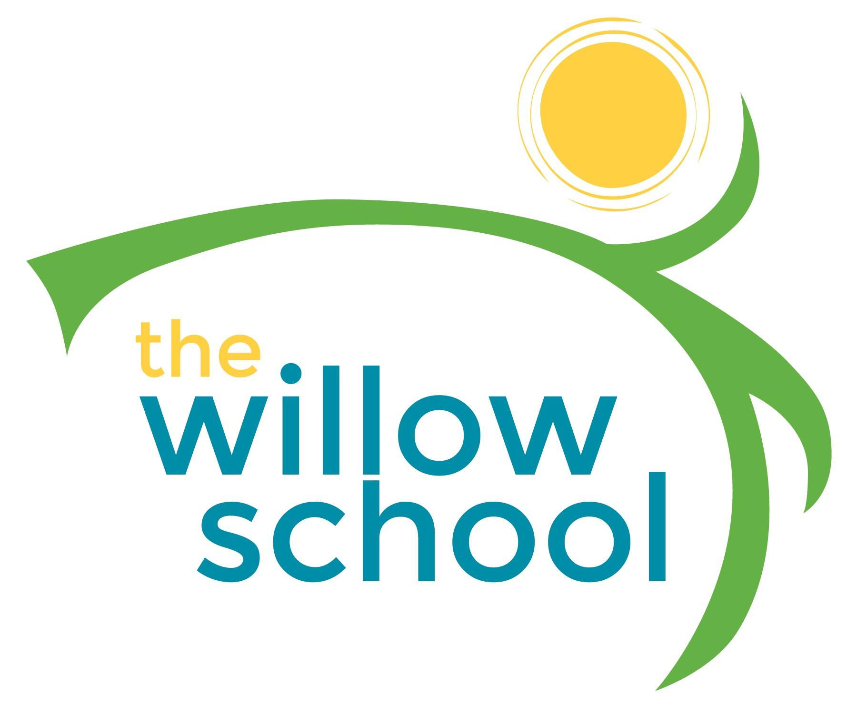 Menu May 16-20, 2016

 | Monday  May 16 | Tuesday  May 17 | Wednesday  May 18 | Thursday  May 19 | Friday  May 20
Morning Snack | Tofu Scramble Toast  Milk | Rolled Tortillas  Sunbutter  Raspberries  Milk | Cinnamon Oatmeal  Blueberries  Milk | Whole Grain Cereal  Bananas  Milk | Bagels  Goat Cheese  Raisins  Milk
Lunch | Pita Pizzas  w/Vegetables  Salad  Olives  Milk | Loaded Baked Potato Soup Broccoli  Apples  Milk | Grilled Cheese Sandwiches  Baked Beans  Oranges  Milk | Southwestern Tortilla Soup  w/Corn, Beans & Spinach  Grapes  Milk | Pasta Salad  w/Edamame  Grape Tomatoes  Clementines  Milk
Afternoon Snack | Fruit & Cheeses  Mini Platter  Water | Yogurt & Pretzels  Water | Animal Crackers  Cheese Bites  Cranberries  Water | Roasted Chickpeas  Grapes  Water | Oatmeal Raisin Cookies  Water

*Serving sizes and meal components will be in compliance with USDA as per the attached guidelines.

