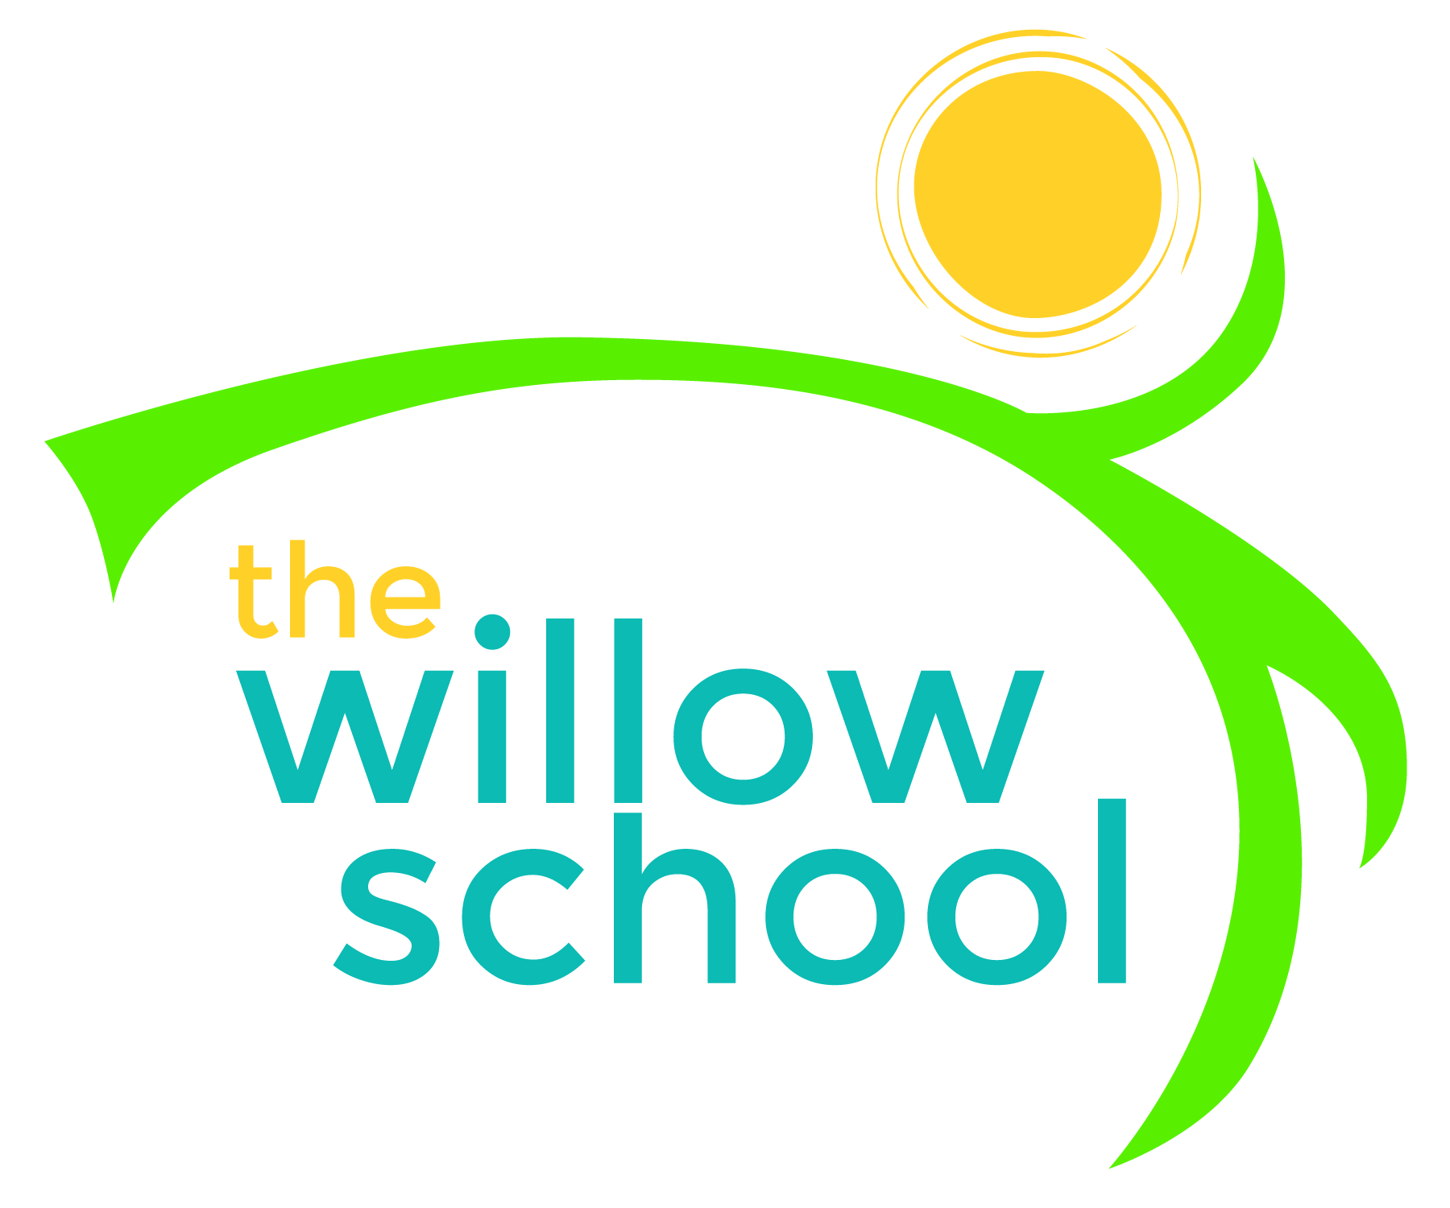 Menu – January 4-8, 2016

 | Monday  January 4 | Tuesday  January 5 | Wednesday  January 6 | Thursday  January 7 | Friday  January 8
Morning Snack | No School | Pancakes  Blueberries | Hawaiian Roll  Sunbutter  Oranges  Water | Yogurt  Blueberries  Granola  Water | Cereal  Fruit  Milk  Water
Lunch | No School | Grilled Cheese  Spinach Salad  Pineapple  Milk | Minestrone Soup  Apple Slices  Milk | Cheese, Bean & Rice Quesadilla  Cabbage Salad  Pears  Milk | Ziti  Broccoli Florets  Oranges  Milk
Afternoon Snack | No School | Cereal  Veggie Sticks  Raisons  Craisons  Water | Cheese  Crackers  Raisons  Water | Bananas  Fig Bars  Water | Rice Cakes  Sunbutter  Water

*Serving sizes and meal components will be in compliance with USDA as per the attached guidelines.

