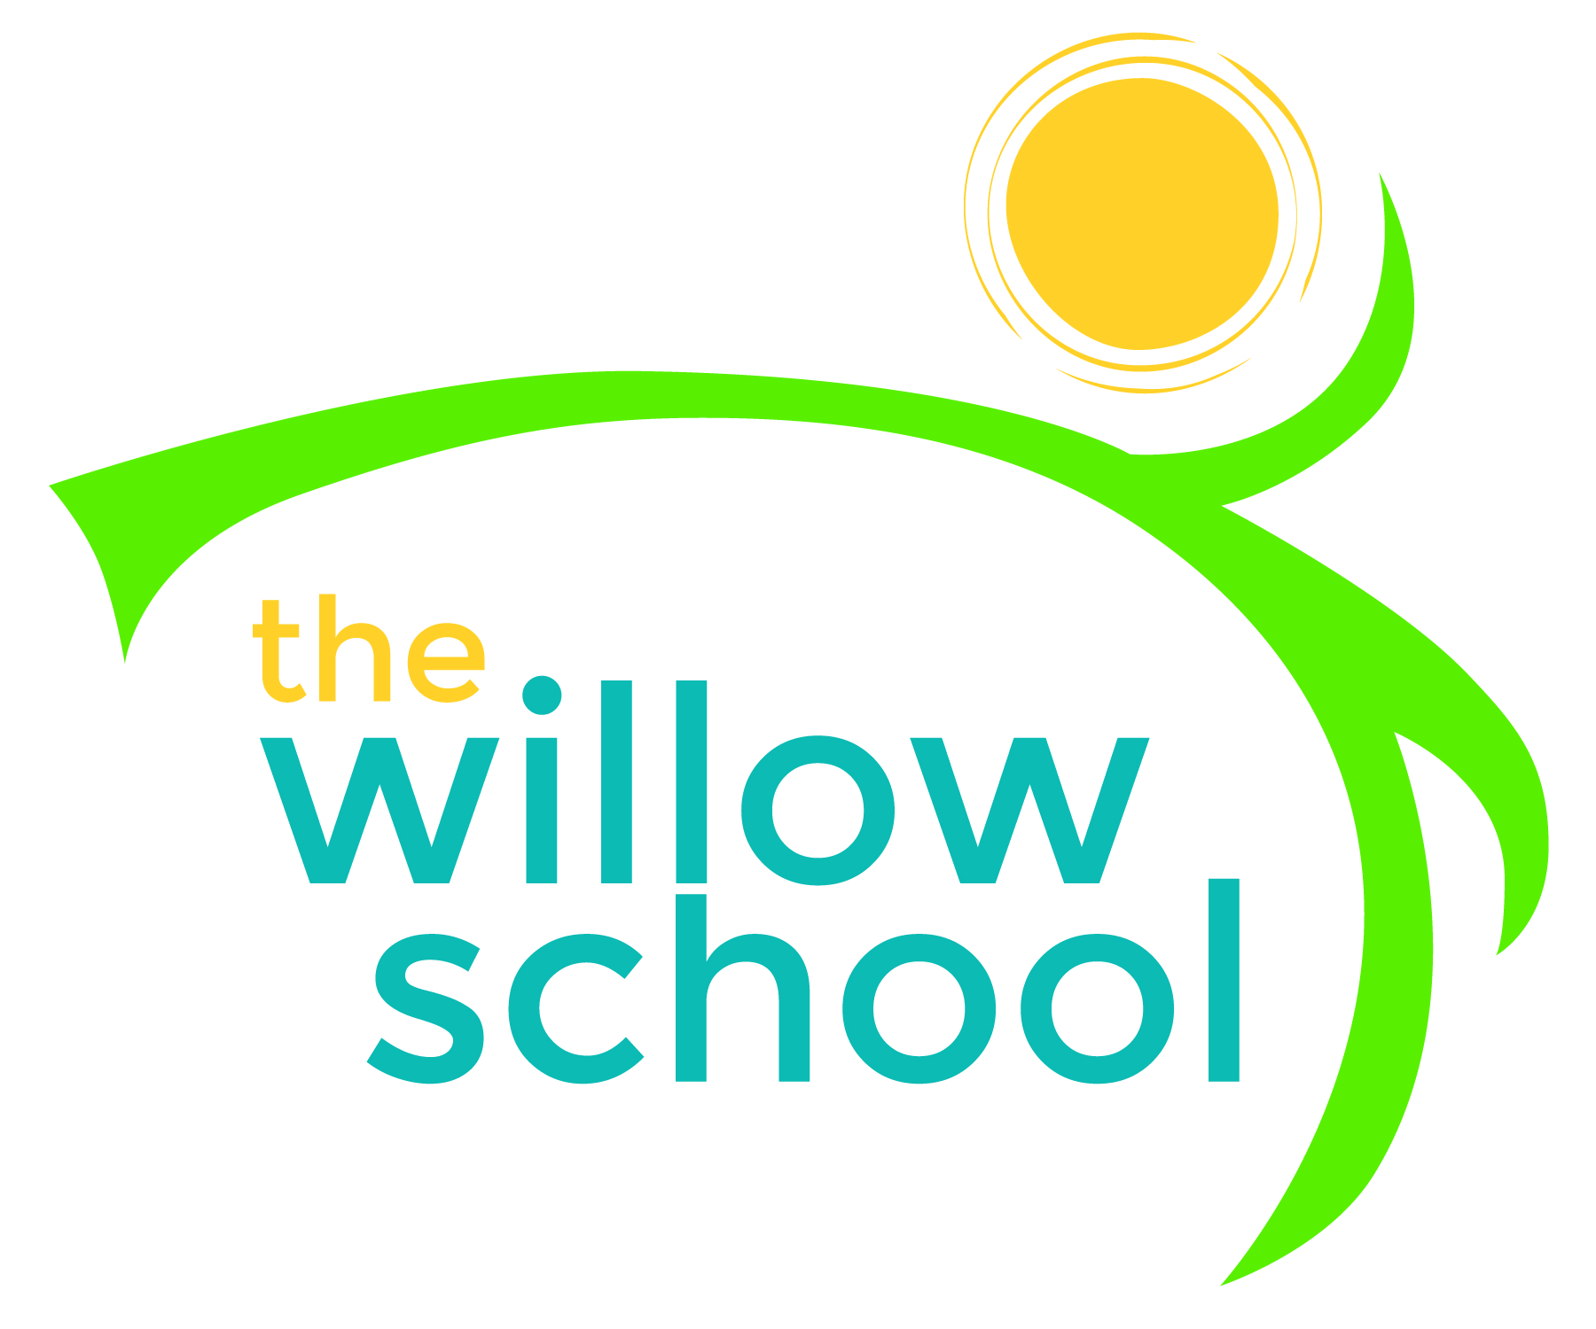 Menu – January 25-29, 2016

 | Monday  January 25 | Tuesday  January 26 | Wednesday  January 27 | Thursday  January 28 | Friday  January 29
Morning Snack | Yogurt  Fruit  Water | Quinoa  Blueberries  Water | Sunbutter Crackers  Bananas  Water | Cinnamon Toast  Apple Slices  Water | Oatmeal  Raisons  Water
Lunch | Rice, Cheese & Broccoli Casserole  Mixed Greens  Pears  Milk | Veggie Lasagna  Rolls  Green Salad  Melon  Milk | Waffles  Veggie Sausage  Pears  Milk | Pasta Salad With Beans & Vegtables  Grapes  Milk | Veggie Burgers  Buns  Tomato/Lettuce  Apples  Milk
Afternoon Snack | Apple Slices  Cheese Sticks  Water | Chips  Hummus  Water | Cereal  Dried Fruit  Water | Rice Cakes  Cream Cheese  Water | Pretzels  Sunbutter  Water

*Serving sizes and meal components will be in compliance with USDA as per the attached guidelines.

