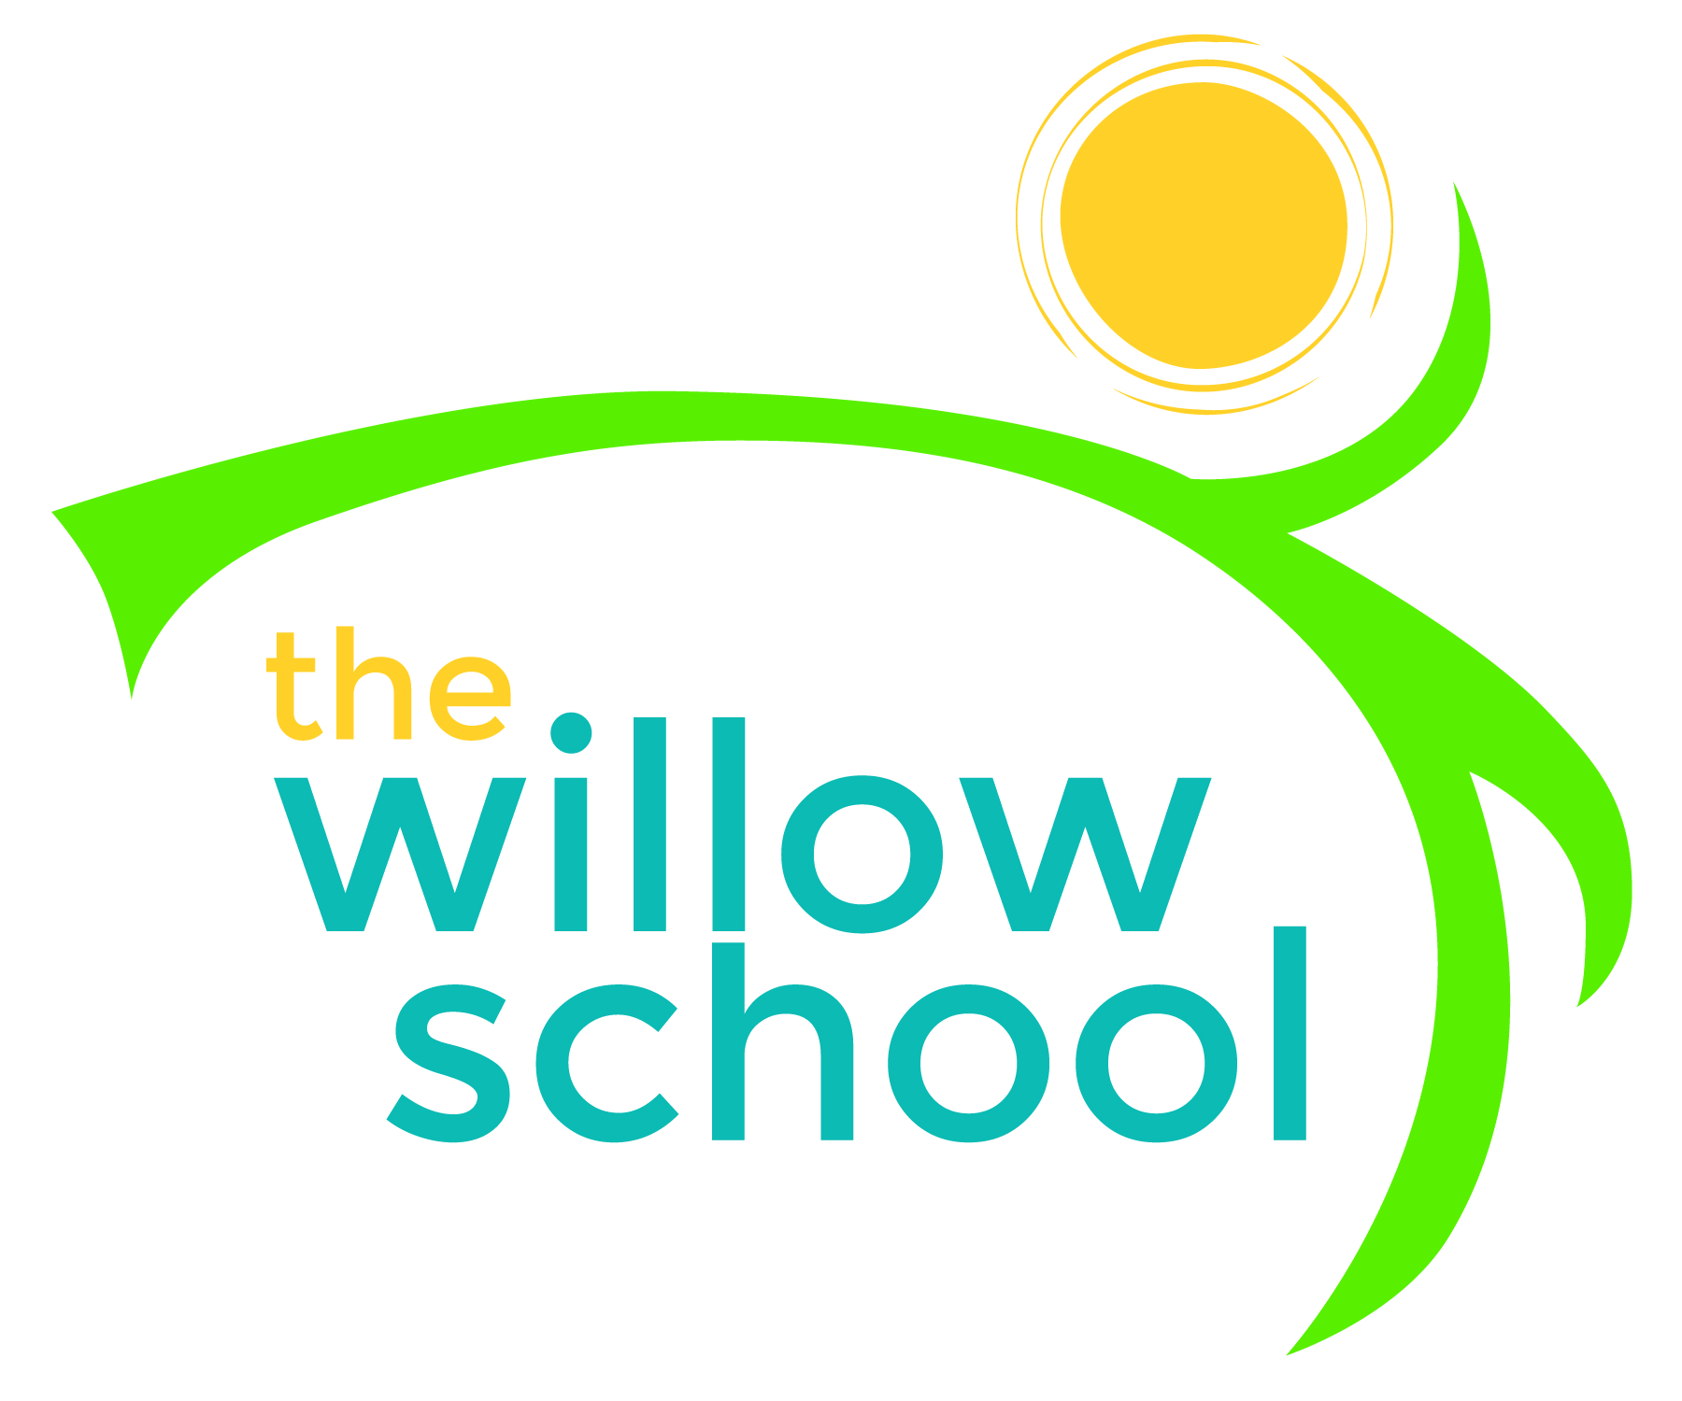 Menu – January 18-22, 2016

 | Monday  January 18 | Tuesday  January 19 | Wednesday  January 20 | Thursday  January 21 | Friday  January 22
Morning Snack | Oatmeal  Cranberries  Raisons  Water | Rice Cakes  Apple Butter  Water | Cereal  Bananas  Milk  Water | Yogurt  Mixed Fruit  Water | Graham Crackers  Sunbutter  Water
Lunch | Red Beans  Rice  Kale Salad  Oranges  Milk | Mac & Cheese  Baked Beans  Garden Salad  Melon  Milk | Butternut Squash Soup  Rolls  Grapes  Milk | Pasta  Tomato Sauce  Veggie Crumble  Pears  Milk | Three bean burrito  Tomato/Cucumber Salad  Mangos  Milk
Afternoon Snack | Guacamole  Baby Carrots  Water | Cereal  Dried Fruits  Water | Cheese  Crackers  Water | Sliced Apples  Sunbutter  Water | Chips  Salsa  Water

*Serving sizes and meal components will be in compliance with USDA as per the attached guidelines.

