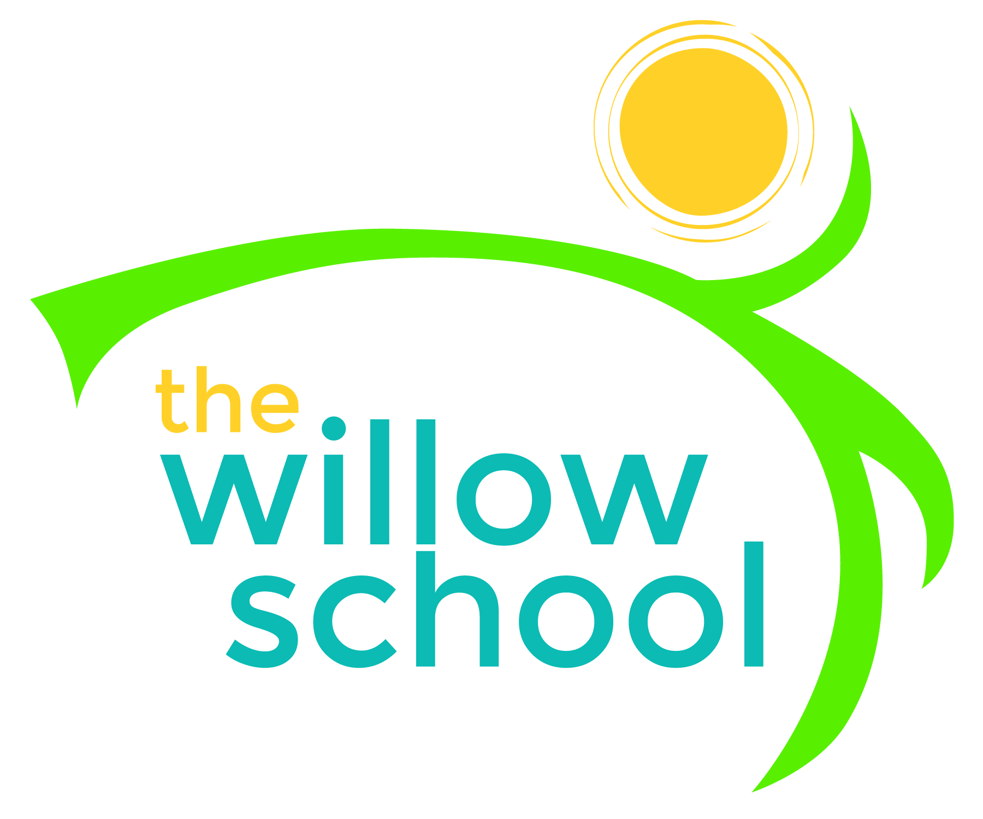 Menu – January 11-15, 2016

 | Monday  January 11 | Tuesday  January 12 | Wednesday  January 13 | Thursday  January 14 | Friday  January 15
Morning Snack | Pancakes  Bananas  Water | Cheese Toast  Apple Slices  Water | Rice Cakes  Sunbutter  Raisons  Water | Blueberry Bagels  Cream Cheese  Water | Yogurt Smoothie  Water
Lunch | BBQ Tofu  Rice  Green Beans  Melon  Milk | Flat Bread Pizza  Olives  Garden Salad  Pears  Milk | Veggie & Cheese Quesadillas  Green Salad  Mixed Berries  Milk | Mixed Bean Soup  Hawaiian Rolls  Apple Slices  Milk | Vegtable Rice  Steamed Carrots  Melon  Milk
Afternoon Snack | Celery  Sun Butter  Raison  Water | Oranges  Cheese Sticks  Water | Cereal  Raisons  Craisons  Water | Hummus  Fresh Vegtables  Water | Chips  Salsa  Avocado  Water

*Serving sizes and meal components will be in compliance with USDA as per the attached guidelines.

