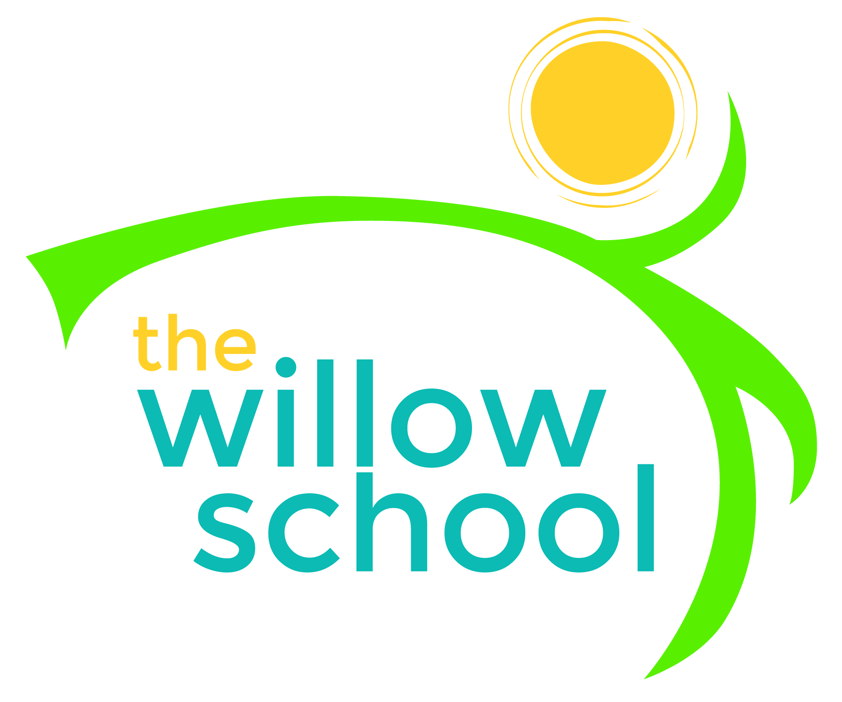 Menu – December 7-11, 2015

 | Monday  December 7 | Tuesday  December 8 | Wednesday  December 9 | Thursday  December 10 | Friday  December 11
Morning Snack | Yogurt  Bagel  Strawberries  Water | Grilled Cheese  Applesauce  Water | Whole Grain Cereal  Bananas  Water | Warm Granola  Blueberries  Water | Fried Baked Apples  Fig Bars  Water
Lunch | Bean Chili  Grapes  Baked Root Vegtables  Milk | Beans & Rice  Corn & Tomato Salad  Guacamole Chips  Milk | Broccoli Rice Casserole  String Beans  Apple Slices  Milk | Spinach Alfredo  Mixed Pasta  Spring Salad  Milk | Seared Tofu Nuggets  Broccoli & Cabbage Slaw  Fresh Mixed Fruit  Milk
Afternoon Snack | Sunbutter  Crackers  Oranges  Water | Rice Cakes  Cheese Sticks  Pears  Water | Carob Oatmeal Bar  Dried Fruit  Water | Chips  Salsa  Water | Whole Grain Cereal &  Graham Cracker Trail Mix  Water

*Serving sizes and meal components will be in compliance with USDA as per the attached guidelines.

