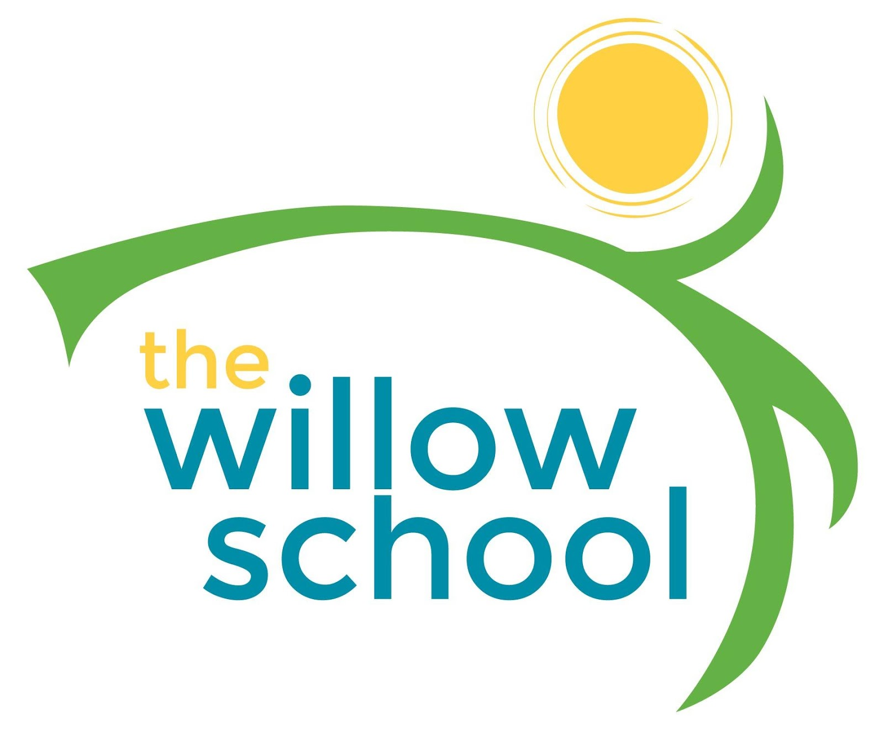 Menu –September 5-9, 2016

 | Monday | Tuesday | Wednesday | Thursday | Friday
Morning Snack | Closed | Toast & Goat Cheese  Strawberries  Milk | Banana Buttermilk  Waffles  Milk | Apple Slices w/ Sun Butter  Granola  Milk | Tropical Fruit Smoothies  Toast  Milk
Lunch | Closed | Vegetable Soup  Rosemary Buttermilk Cornbread  Oranges  Milk | Curried Lentils  Sautéed Kale  Naan Bread  Grapes  Milk | Fried Corn w/Sweet Peppers  Garden Salad  Grapes  Milk | Falafel w/ Pita  Greek Salad  Olives  Milk
Afternoon Snack | Closed | Fruit Salad  w/String Cheese  Graham Crackers  Water | Cheese & Animal Crackers  Melons  Water | Black Bean Dip  Pita  Carrots  Water | Banana Bread  Milk

*Serving sizes and meal components will be in compliance with USDA as per the attached guidelines.

