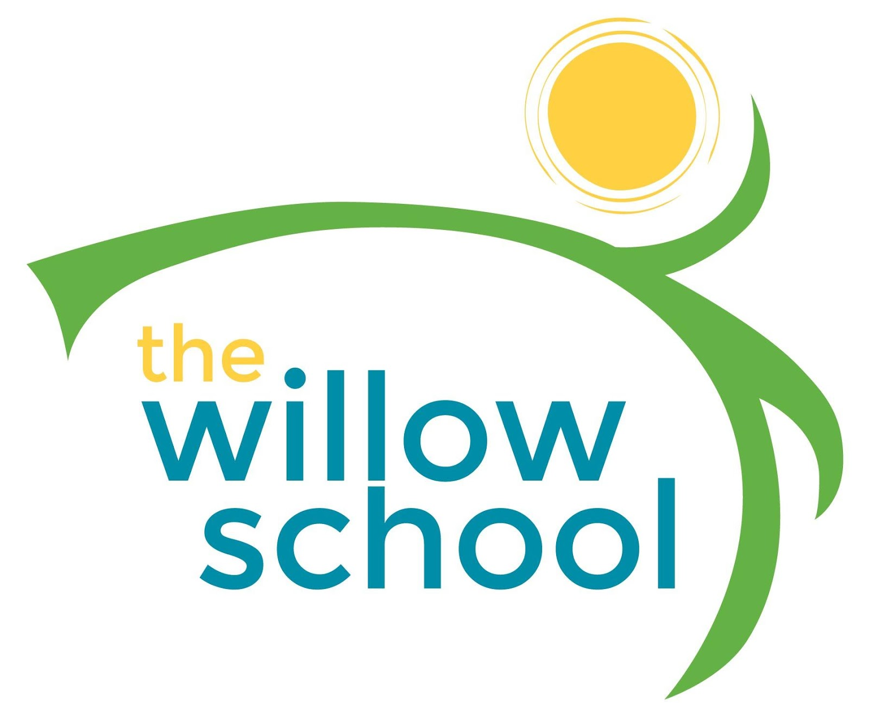 Menu –September 26-30, 2016

 | Monday | Tuesday | Wednesday | Thursday | Friday
Morning Snack | Eggs & Toast  Grapefruit  Milk | Whole Grain Cereal  Raisins  Milk | Toasted Ezekiel Toast w/ Avocado  Milk | Warm Cinnamon Tortillas  Cream Cheese  Grapes  Milk | Rice Cereal w/ Mixed Fruit  Milk
Lunch | Vegetable Tikka Masala  Basmati Rice  Oranges  Milk | Vegetable Noodle Soup  Rosemary Cornbread  Mixed Berries  Milk | Rice & Peas w/ Coconut Milk  Grilled Plantains  Greens  Milk | Loaded Baked Potato Soup  Melons  Milk | Pita Pizzas  Garden Salad  Oranges  Milk
Afternoon Snack | Fruit & Cheese Platter  Crackers  Water | Animal Crackers  String Cheese  Water | Graham Crackers  Cream Cheese Peaches  Water | Rice Cakes  Sun Butter  Melons  Water | Oatmeal Raisin Cookies  Milk

*Serving sizes and meal components will be in compliance with USDA as per the attached guidelines.

