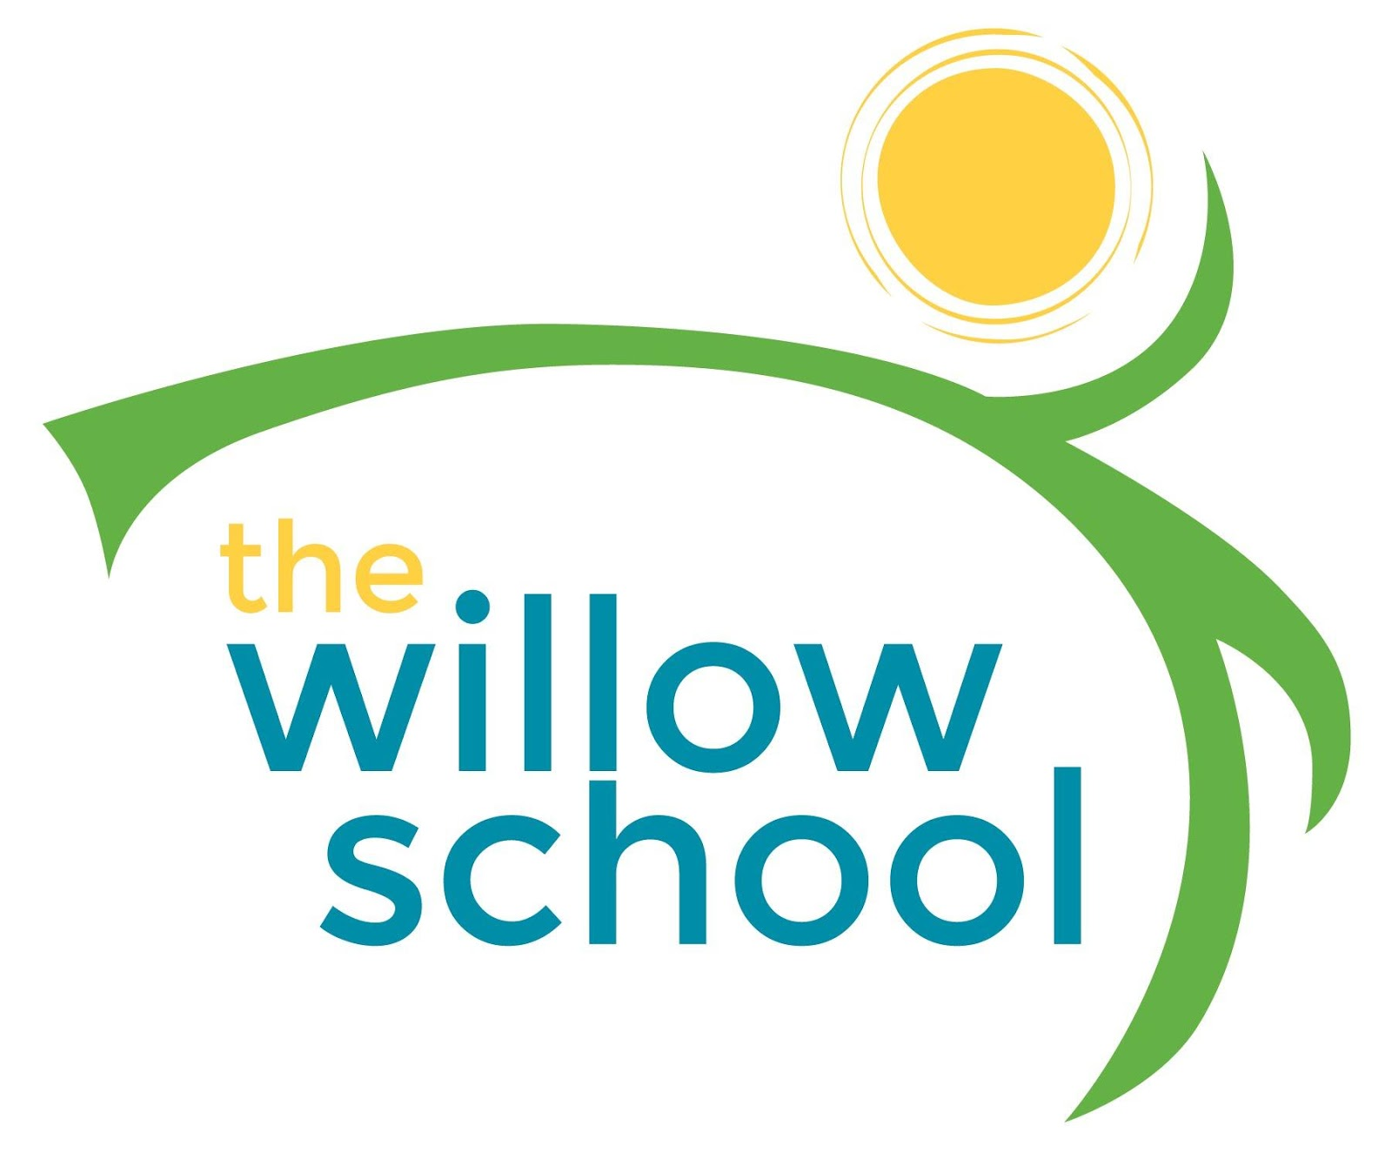 Menu –September 19-23, 2016

 | Monday | Tuesday | Wednesday | Thursday | Friday
Morning Snack | Cream Cheese & Berry Tortilla Wraps  Milk | Oatmeal & Raisins  Milk | Whole Grain Cereal  Bananas  Milk | Yogurt  & Granola  Berries | Bagels & Goat Cheese  Raisins  Milk
Lunch | Pasta Salad w/ Edamame & Parmesan Cheese  Cucumber Salad  Milk | Baked Ziti  Salad  French Bread  Orange Slices  Milk | Three Bean Chili w/ Vegetables  Corn Bread  Tomato & Goat Cheese Salad  Milk | Spaghetti w/ Zucchini  Garden Salad  Apples  Milk | Grilled Cheese  Baked Beans  Garden Salad  Mixed Berry Fruit Salad  Milk
Afternoon Snack | Roasted Cheesy Chickpeas  Grapes  Water | Chips & Salsa  Crasins  Water | Pretzels & Hummus  Orange Slices  Water | Bananas Foster  Water | Trail Mix  Dried Fruit  Water

*Serving sizes and meal components will be in compliance with USDA as per the attached guidelines.

