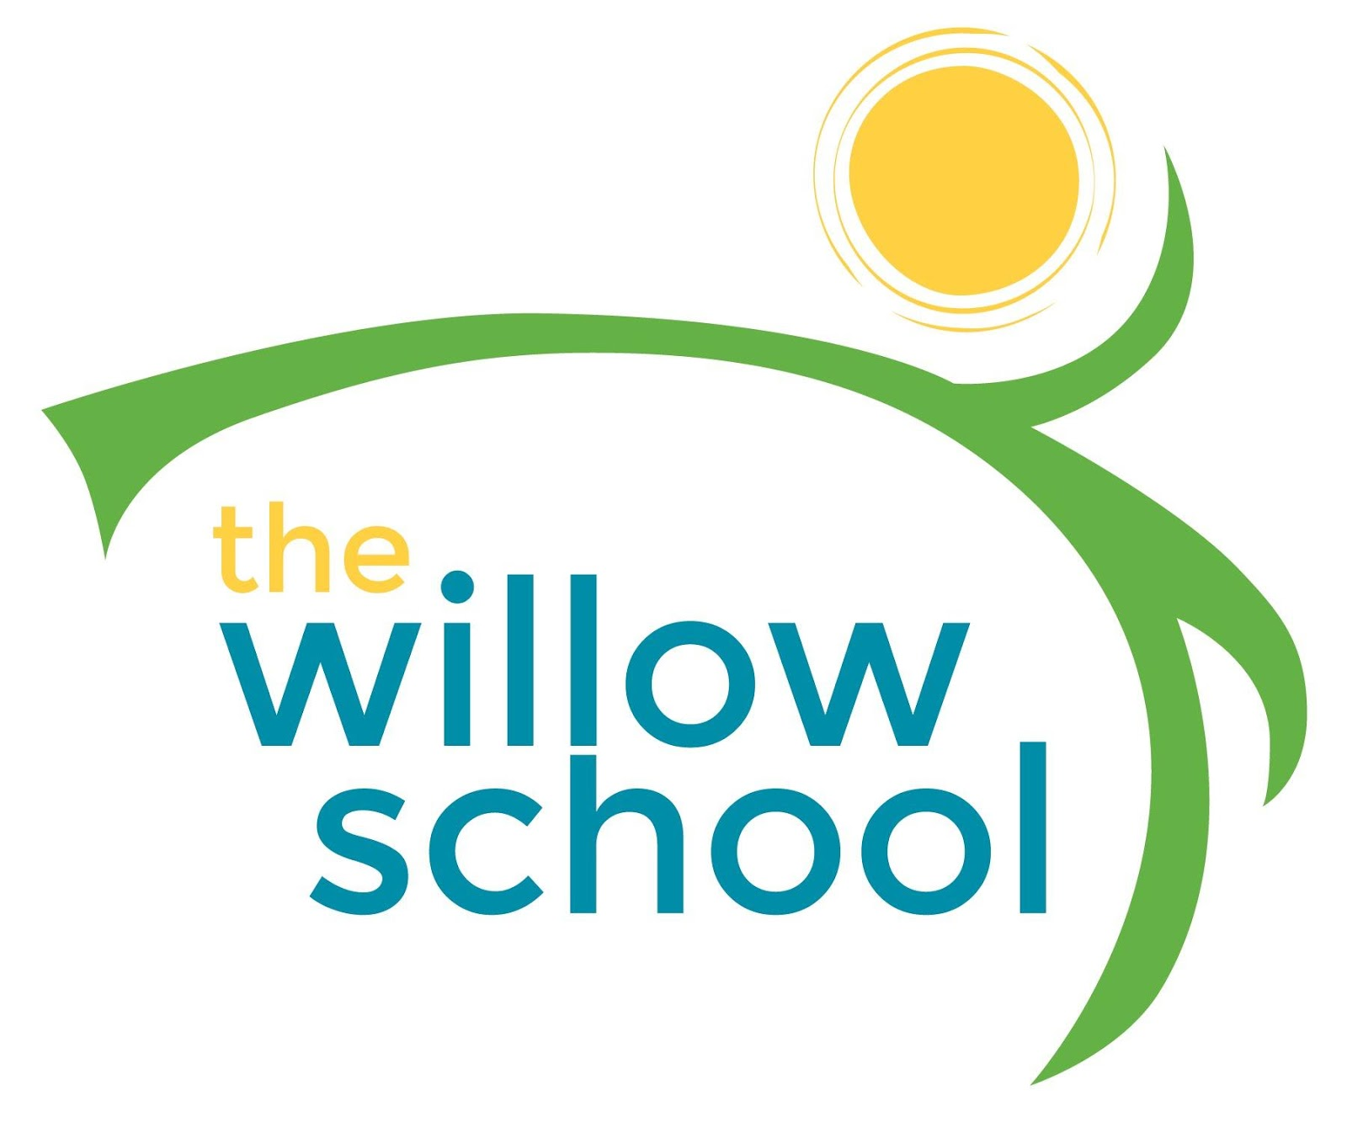 Menu – October 3-7, 2016

 | Monday | Tuesday | Wednesday | Thursday | Friday
Morning Snack | Whole Grain Cereal & Bananas  Milk | Ezekiel Toast w/Cream Cheese  Raisins  Milk | Whole Grain Cereal  Plums  Milk | Banana Waffles  Milk | Bagels & Blueberry Goat Cheese  Milk
Lunch | Cheese & Black Bean Quesadillas  Garden Salad  Clementine’s  Milk | Vegetable Noodle Soup  French Bread  Grapes  Milk | Succotash w/ Tomatoes, Corn, & Lima Beans  Jasmine Rice  Milk | Cheddar & Broccoli Soup  Crackers  Strawberries  Milk | Cheese, Avocado & Sprout Sandwiches  Sweet Potato Fries  Milk
Afternoon Snack | Chips & Garden Salsa  Kiwi  Water | Hummus  Carrots & Cucumbers  Water | String Cheese  & Crackers  Dried Bananas | Dried Fruit & Trail Mix  Water | Jamaican Spice Bun & Cream Cheese

*Serving sizes and meal components will be in compliance with USDA as per the attached guidelines.

