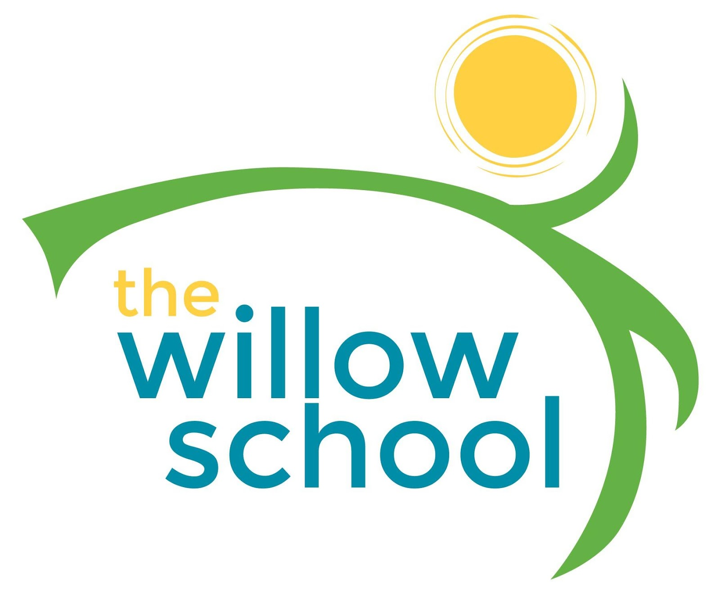 Menu –October 17 - 21, 2016

 | Monday | Tuesday | Wednesday | Thursday | Friday
Morning Snack | Granola Cereal  Blueberries  Milk | Raison Toast  Goat Cheese  Apples  Milk | Pumpkin Bagels  Cream Cheese  Prunes  Milk | Whole Grain Cereal  Bananas  Milk | English Muffins  Sunbutter  Strawberries  Milk
Lunch | Tofu & Vegetable  Stir Fry  Apple Slices  Steamed Rice  Milk | Lentil Soup  Whole Wheat Rolls  Orange Slices  Milk | Pinto Beans  Cheese Toast  Applesauce  Milk | Pasta with Veggie Crumble  Steamed Carrots  Milk | Veggie Wraps  Honey Dew Melons  Milk
Afternoon Snack | Apples  Cream Cheese  Crackers  Water | Fruit Salad  w/String Cheese  Graham Crackers  Water | Trail Mix With Dried Fruit & Pepitas  Cheese Sticks  Water | Hummus  Pita Bread  Cherry Tomatoes  Water | Tortilla Chips  Guacamole  Salsa  Water

*Serving sizes and meal components will be in compliance with USDA as per the attached guidelines.

