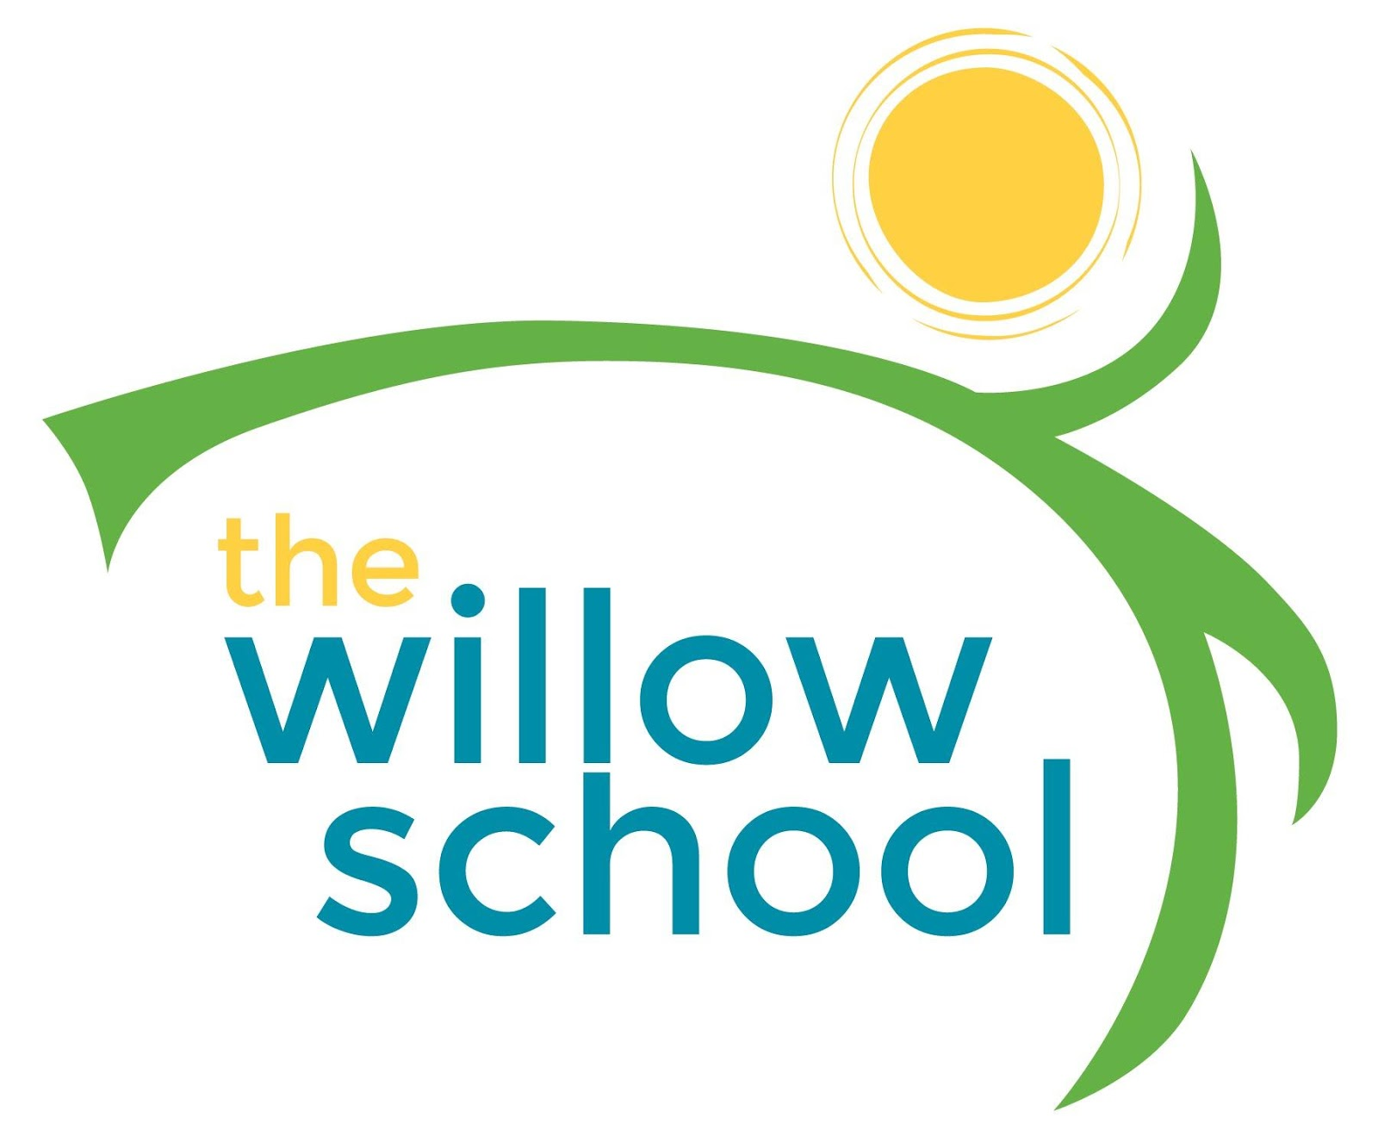 Menu –October 24-28, 2016

 | Monday | Tuesday | Wednesday | Thursday | Friday
Morning Snack | Whole Grain Cereal  Bananas  Milk | Toast  Sun butter  Cranberries  Milk | Granola Cereal  Dried Fruit  Milk | Breakfast Biscuits  Raspberries  Milk | Whole Grain Cereal  Blackberries  Milk
Lunch | Sweet & Sour Tofu and Vegetables  Jasmine Rice  Pineapples  Milk | Garden Minestrone Soup  Crackers  Clementine’s  Milk | Egg, Cheddar Cheese & Salsa Burritos  Avocado  Milk | Tomato Soup  Grilled Zucchini  Fruit Salad  Milk | Veggie & Hummus Wraps  French Fries  Apples  Milk
Afternoon Snack | Fruit Platter w/ Cheese  Water | Cheesy Roasted Chickpeas  Blueberries | Dried Mangos  Pumpkin Seeds  Sunflower Seeds  Cheese  Water | Fig Bars  Bananas  Water | Oatmeal Raisin Balls  Water

*Serving sizes and meal components will be in compliance with USDA as per the attached guidelines.

