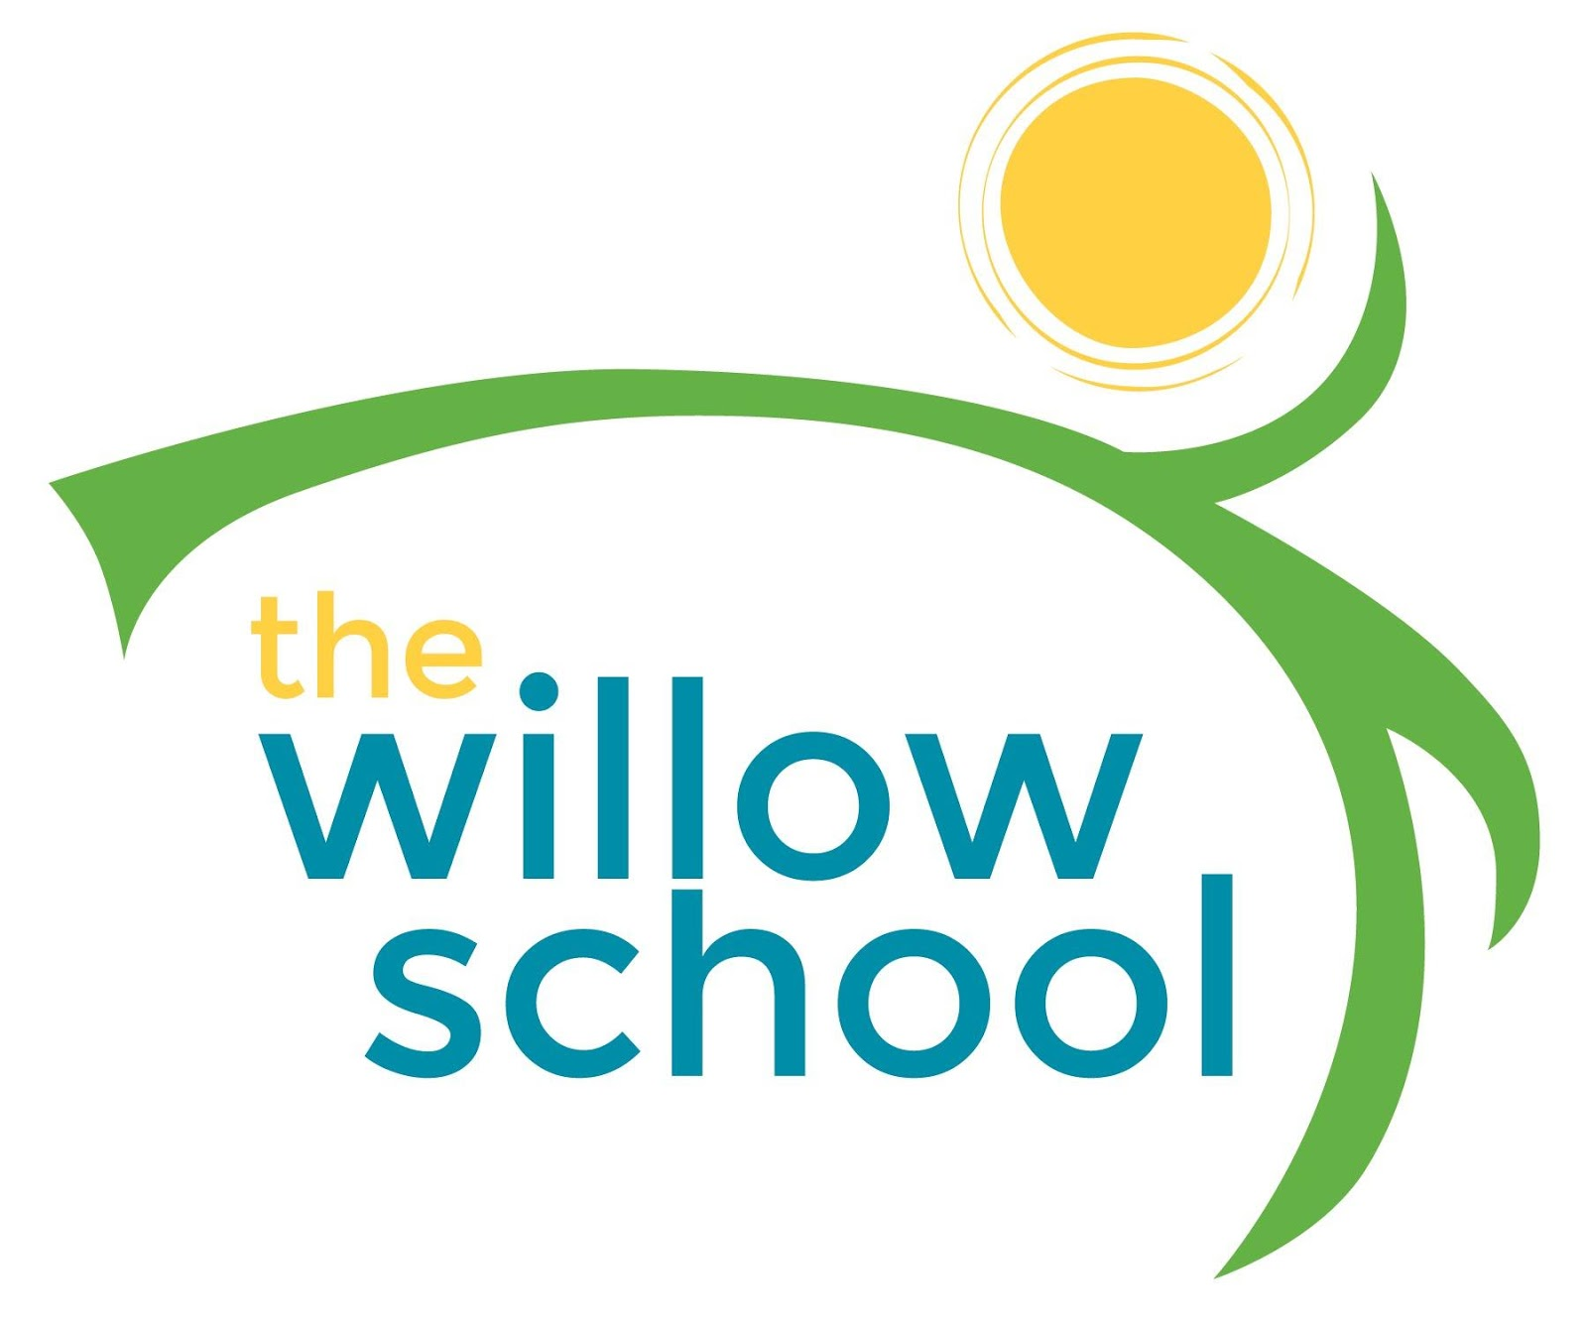 Menu –10-14, 2016

 | Monday | Tuesday | Wednesday | Thursday | Friday
Morning Snack | Whole Grain Cereal  Dried Plums  Milk | English Muffins  w/Sun Butter  Cranberries  Milk | Granola Cereal  Raspberries  Milk | Breakfast Biscuits  Oranges  Milk | Whole Grain Cereal  Blackberries  Milk
Lunch | Spaghetti w/Zucchini  Garden Salad  Blueberries  Milk | Saffron Stew w/ White Beans  Cucumber & Cherry Tomato Salad  Milk | Savory Cheese Waffles w/ Chives  Cantaloupe  Milk | Curried Pumpkin & Shallot Soup  Rolls  Grapes  Milk | Grilled Cheese  Sweet Potato Fries  Apple Sauce  Milk
Afternoon Snack | Cheese Sticks  Crackers  Raisins  Water | Rice Cakes  Strawberry Cream Cheese  Water | Animal Crackers  Cheese Slices  Dried Bananas | Parmesan Bread Sticks  Marinara  Water | Tortilla Chips Salsa  Water

*Serving sizes and meal components will be in compliance with USDA as per the attached guidelines.

