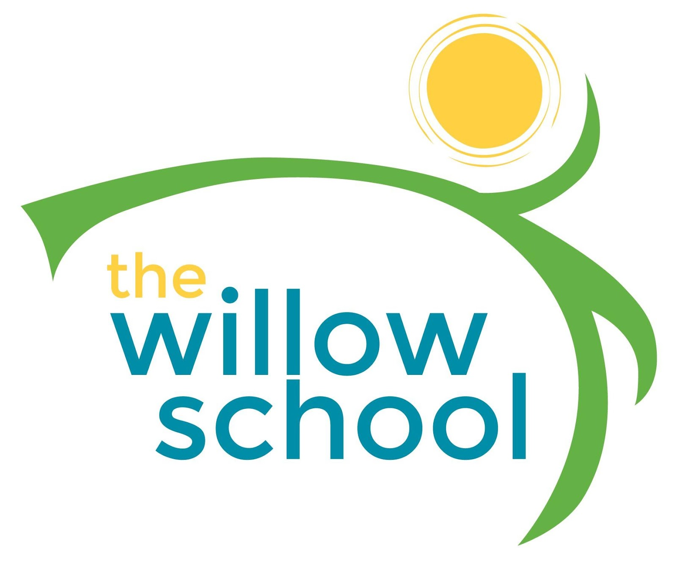 Menu –November 7 - 11, 2016

 | Monday | Tuesday | Wednesday | Thursday | Friday
Morning Snack | Toast  Goat Cheese  Blueberries  Milk  Water | No School | Apple Cranberry Oatmeal Bars  Milk  Water | Whole Grain Cereal  Bananas  Milk  Water | Breakfast Biscuits  Cheese  Milk  Water
Lunch | Broccoli & Cheese Rice  Black Eyed Peas  Bananas  Milk | No School | Elbow Macaroni  Greek Yogurt & Tomato Sauce  Garden Salad  Oranges  Milk | Veggie Pizza  Ceasar Salad  Grapes  Milk | Grilled Cheese Sandwich  Fruit Medley  Sweet Potato Fries  Milk
Afternoon Snack | Graham Crackers  Sunbutter  Apples  Water | No School | Pretzels  Sunbutter  Strawberries  Water | Pita Bread  Bean Dip  Grape Tomatoes  Water | Crackers  Hummus  Carrot Sticks  Water

*Serving sizes and meal components will be in compliance with USDA as per the attached guidelines.

