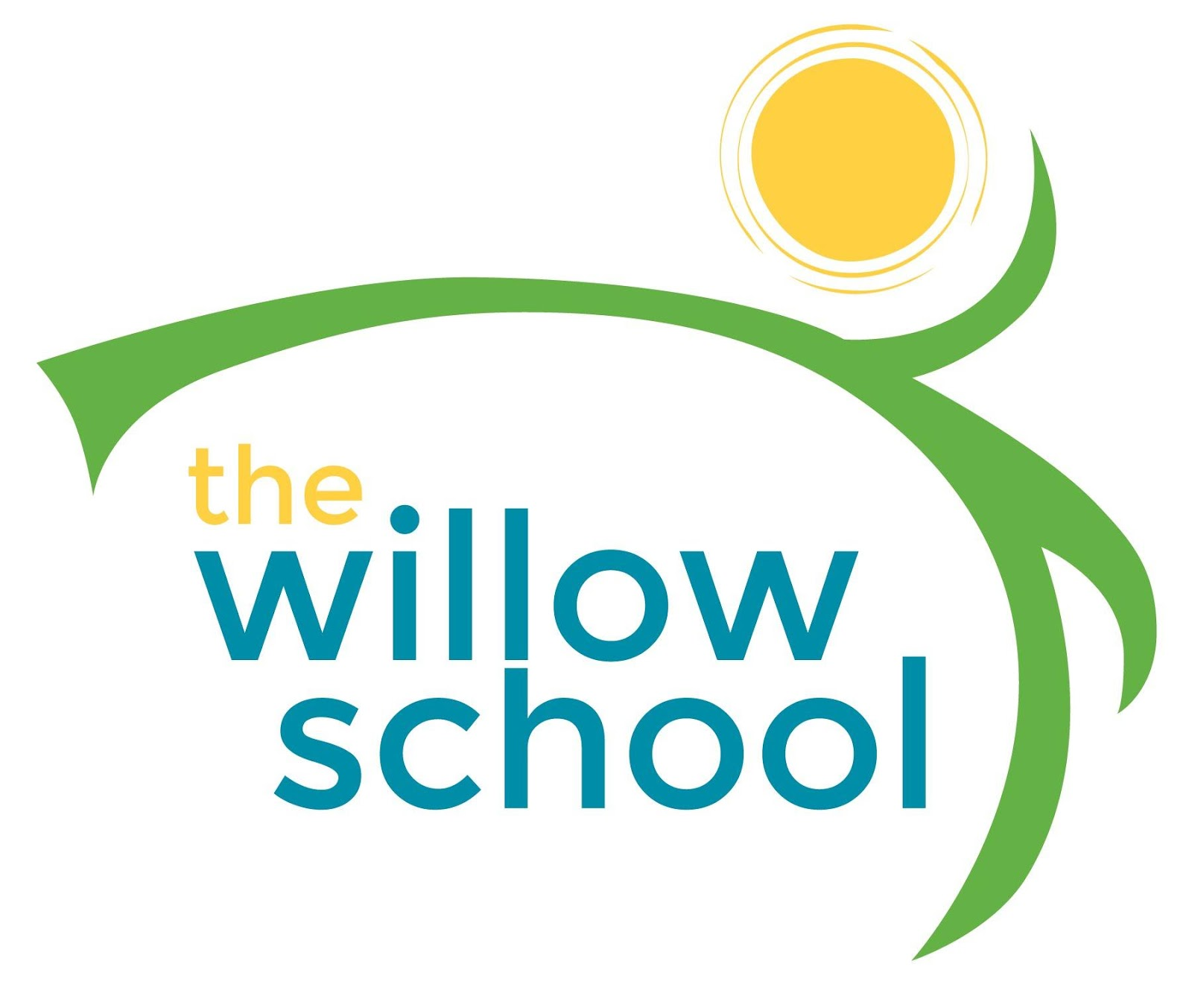 Menu –November 14 - 18, 2016

 | Monday | Tuesday | Wednesday | Thursday | Friday
Morning Snack | French Toast  Blueberries  Milk  Water | Strawberry Crostini  Milk  Water | Banana Pancakes  Milk  Water | Oatmeal  Raisons  Milk  Water | Pita Bread  Goat Cheese  Grapes  Milk  Water
Lunch | Potato Cheese Soup  Oranges  Crescent Rolls  Milk | Veggie Egg Rolls  Chinese Fried Rice  Pineapples  Milk | Mac & Cheese  Veggie Sausage  Green Salad  Grapes  Milk | White Bean Chili  Corn Bread  Melon  Milk | Rice & Bean Burritos  Tortillas  Apples  Milk
Afternoon Snack | Wheat Crackers  Hummus  Carrots  Water | Trail Mix  String Cheese  Water | Pita Bread  Cucumbers  Goat Cheese  Water | Animal Crackers  Apples  Sunbutter  Water | Oatmeal Sunbutter Balls  Oranges  Water

*Serving sizes and meal components will be in compliance with USDA as per the attached guidelines.

