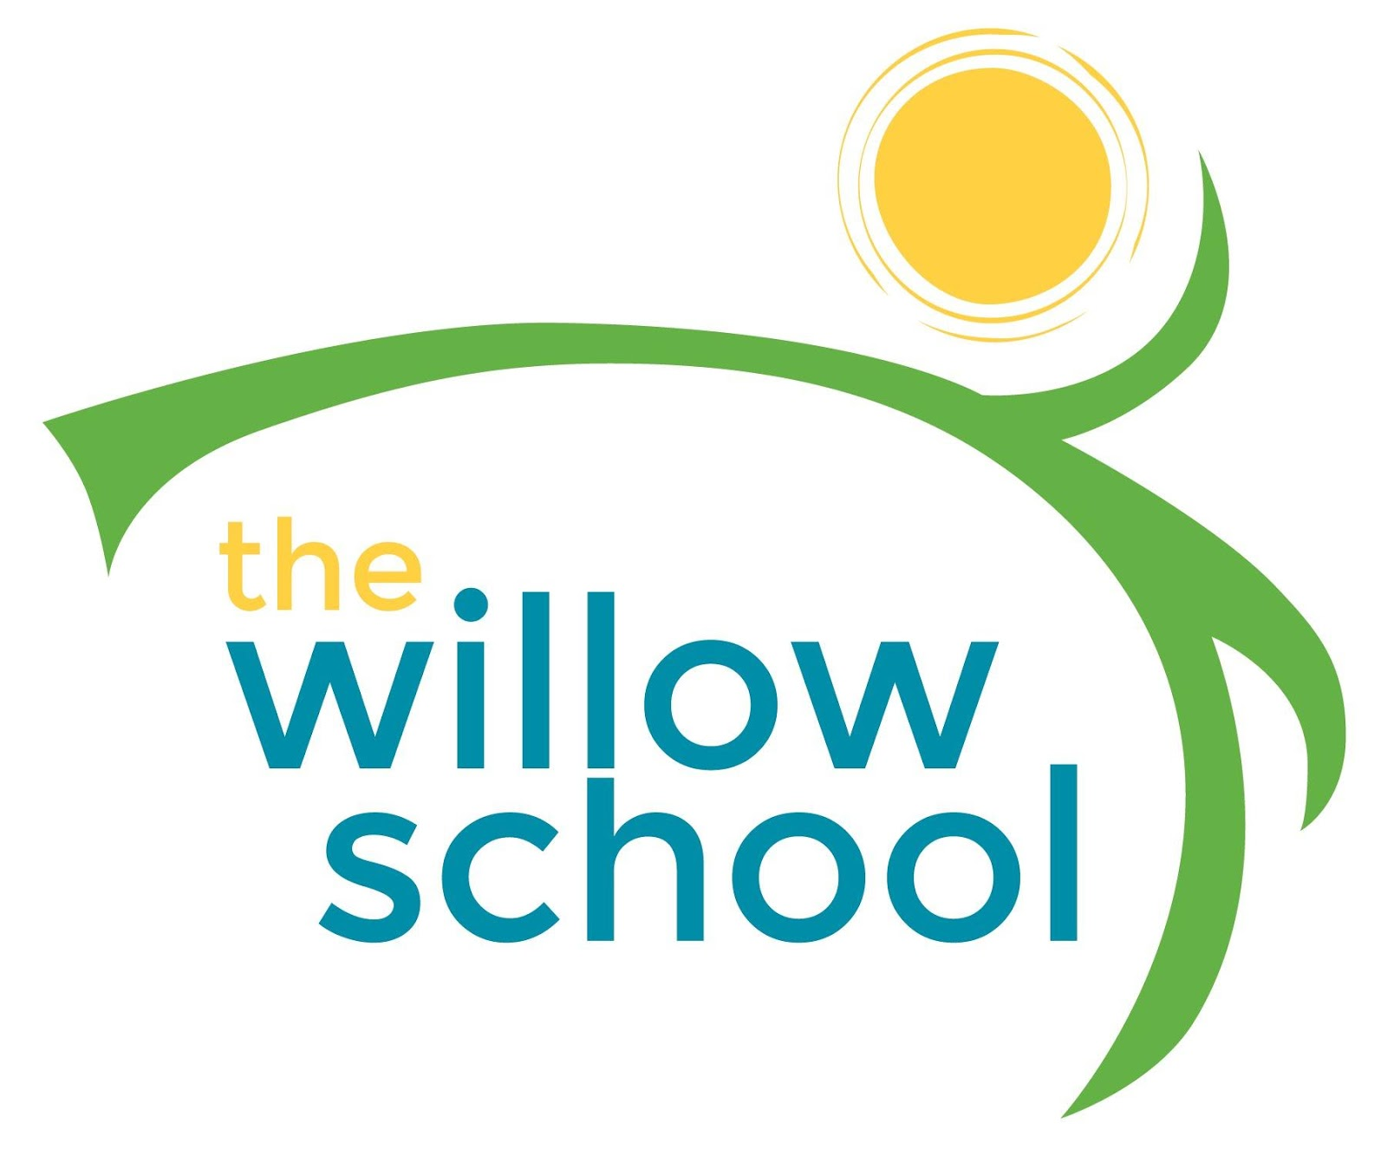 Menu – November 28- Dec. 2, 2016

 | Monday | Tuesday | Wednesday | Thursday | Friday
Morning Snack | Breakfast Biscuits  Blueberries  Milk | Breakfast Egg Muffin  Pears  Milk | Cheese Grits  Grapes  Milk | Cinnamon Apple Oatmeal  Milk | Whole Grain Cereal  Bananas  Milk
Lunch | Spinach Alfredo  Garlic Bread  Green Beans  Milk | Pesto Grilled Cheese  Cherry Tomatoes  Milk | Chickpea Curry  Rice  Pineapples  Milk | Honey Soy Tofu  Strawberries  Milk | Slit Pea Soup  Garden Salad  Milk
Afternoon Snack | Animal Crackers  Oranges  Water | Wheat Thins  Hummus  Pears  Water | Pretzels  String Cheese  Apples  Water | Graham Crackers  Sunbutter  Oranges  Water | Trail Mix  String Cheese  Grapes  Water

*Serving sizes and meal components will be in compliance with USDA as per the attached guidelines.

