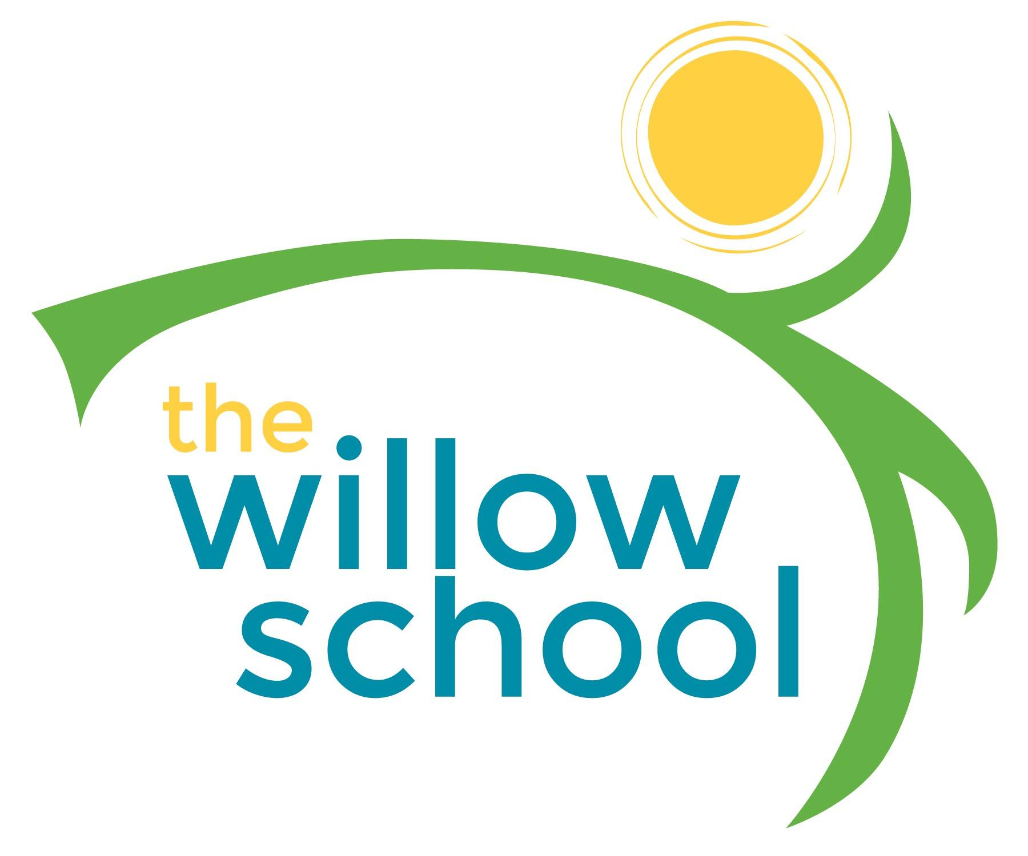 Menu: May 9-13, 2016

 | Monday  May 9 | Tuesday  May 10 | Wednesday  May 11 | Thursday  May 12 | Friday  May 13
Morning Snack | Grits  Melon  Milk | Blueberry Waffles  Milk | Sunbutter Toast  Bananas  Milk | Whole Grain Cereal  Raisons  Milk | Applesauce  Graham Crackers  Milk
Lunch | Pita Pizza W/Olives  Green Salad  Apple Slices  Milk | Curried Lentil Soup  Steamed Broccoli  Pears  Milk | Wild Rice  Tofu  Creamed Mushroom Gravy  Oranges  Milk | Three Bean Chili  Zucchini  Rosemary Cornbread  Milk | Penne Pasta  Garden Salad  Feta  Cantalope  Milk
Afternoon Snack | Guacamole  Chips  Cucumber Slices  Water | Rice Cakes  Cream Cheese  Strawberries  Water | Wheat Crackers  Cheese Sticks  Apple Slices  Water | Dried Mango, Sunflower Seeds & Pumpkin Seeds  Water | Pretzels  Hummus  Cherry Tomatoes  Water

*Serving sizes and meal components will be in compliance with USDA as per the attached guidelines.

