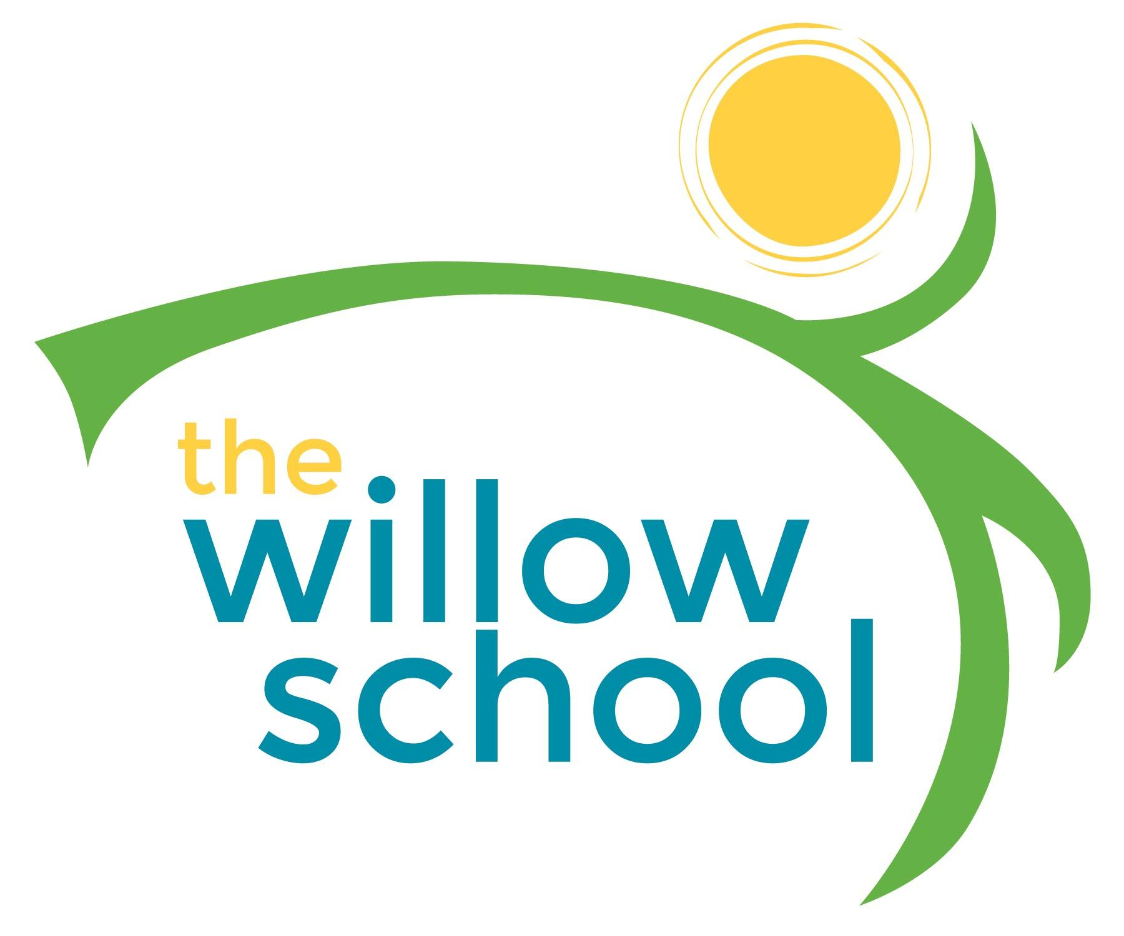 Menu –May 2-6, 2016

 | Monday  May 2 | Tuesday  May 3 | Wednesday  May 4 | Thursday  May 5 | Friday  May 6
Morning Snack | Toast  Strawberry Jam Cream Cheese  Milk | Cinnamon Honey Grits  Bananas  Milk | Peaches & Cream Oatmeal  Milk | Whole Grain Cereal  Blueberries  Milk | Cinnamon Tortillas  Strawberries  Feta  Milk
Lunch | Sweet & Sour Tofu  Fried Rice Vegetables  Apples & Pineapple  Milk | Red Lentils  Rice  Sauteed Cabbage  Melon  Milk | Vegetable Pot Pies  Garden Salad  Oranges  Milk | Cheese, Tomato, & Sprout Sandwiches  Sweet Potato Fries  Bananas  Milk  *Bananas & Granola Bars for Wylde Center trip* | Louisiana Style Vegetable & Bean Gumbo  Rice  Apple Sauce  Milk
Afternoon Snack | Grapes  Cheese Sticks  Wheat Crackers  Water | Carrot & Celery Sticks  Sunbutter  Water | Pretzels  Hummus  Raisons  Water | Rice Cakes  Cream Cheese  Cantalope  Water | Animal Crackers  Cheese Bits  Cranberries  Water

*Serving sizes and meal components will be in compliance with USDA as per the attached guidelines.

