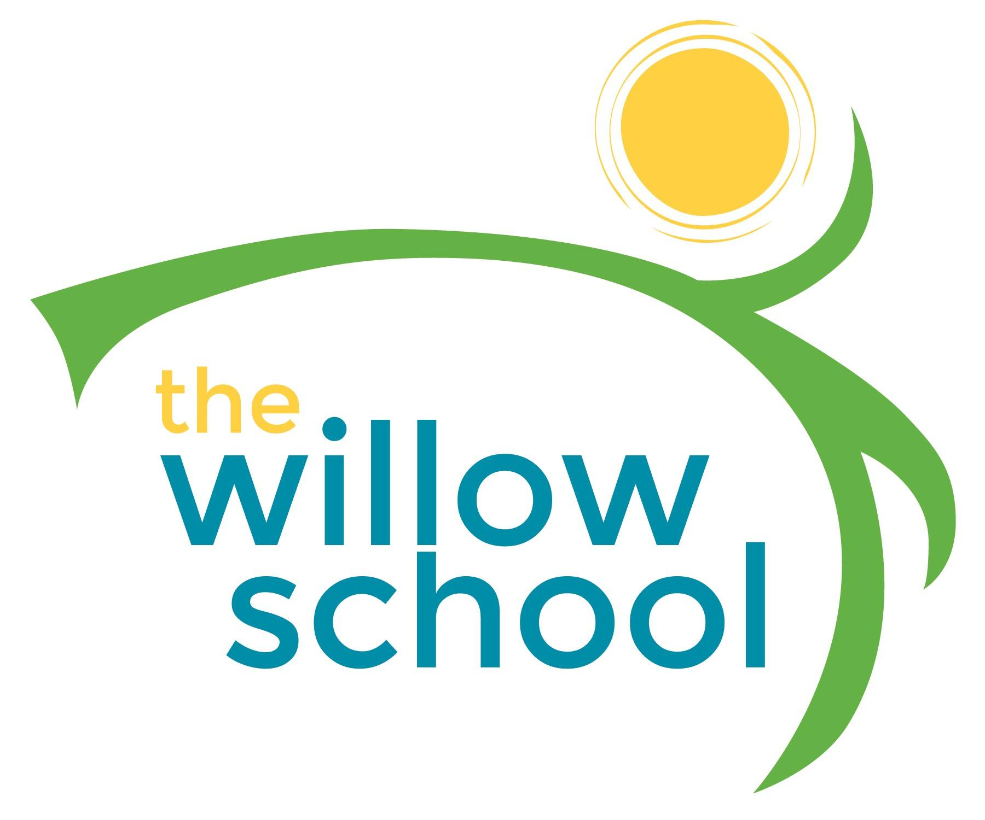 Menu –March 28-April 1, 2016

 | Monday  March 28 | Tuesday  March 29 | Wednesday  March 30 | Thursday  March 31 | Friday  April 1
Morning Snack | Toast  Scrambled Eggs  Water | Banana Pancakes  Water | Oatmeal  Peaches  Water | Chocolate Grits  Watermelon  Water | Cinnamon Tortillas  Dried Fruit w/ Cream Cheese  Water
Lunch | Pita Pizzas Mozzarella Cheese Tomato Sauce  Oranges  Milk | Mexican Style Pinto Beans & Rice  Corn Bread  Pears  Milk | Pasta Salad Chickpeas & Tomatoes  Salad  Grapes  Milk | White Bean Chili  Corn  Corn Bread  Grapes  Milk | Vegetable & Bean Soup  Rice  Melons  Milk
Afternoon Snack | Celery  Sunbutter & Crackers  Water | Granola & Yogurt  Water | Graham Crackers  Cream Cheese  Pineapples  Water | Mangos & Pretzels  Hummus & Raisins  Water | Corn Tortilla Chips  & Guacamole  Salsa  Water

*Serving sizes and meal components will be in compliance with USDA as per the attached guidelines.

