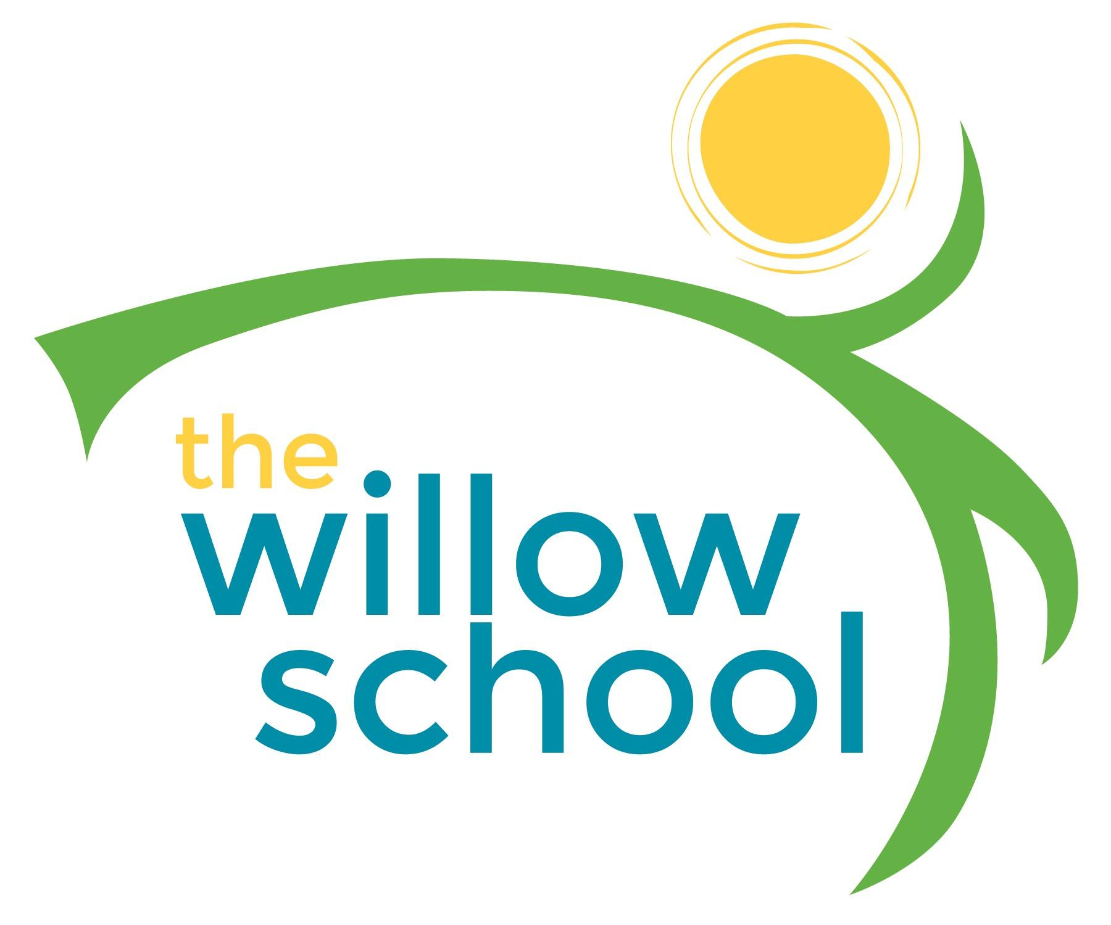
Menu –March 21-25,2016

 | Monday  March 21 | Tuesday  March 22 | Wednesday  March 23 | Thursday  March 24 | Friday  March 25
Morning Snack | Yogurt & Fruit Parfait  Water | Cinnamon Roll  Quinoa  Raisins  Water | Toast  Sunbutter  Bananas  Water | Whole Grain Cereal w/Milk  Grapes  Water | Toasted Bagels  Apple Butter Cream Cheese  Water
Lunch | Teriyaki Glazed Tofu  Rice & Peas  Oranges  Milk | Sauteed Zucchini  & Squash  Black Beans  Couscous  Pineapple  Milk | Tuscan Kale &  Bean Soup  Rolls  Kiwi  Milk | Sweet Potato Souffle  Lentils &  Steamed Spinach  Pineapples  Milk | Red Beans & Rice  Grilled Plantains  Salad  Plums  Milk
Afternoon Snack | Wheat Crackers & Hummus  Grapes  Water | Pretzels  Cheese Sticks  Blueberries  Water | Rice Cakes  Blueberry Cream  Cheese  Water | Melons  Roasted Chickpeas  Crackers  Water | Graham Crackers  Cheddar Cheese Slices  Apple Sauce  Water

*Serving sizes and meal components will be in compliance with USDA as per the attached guidelines.

