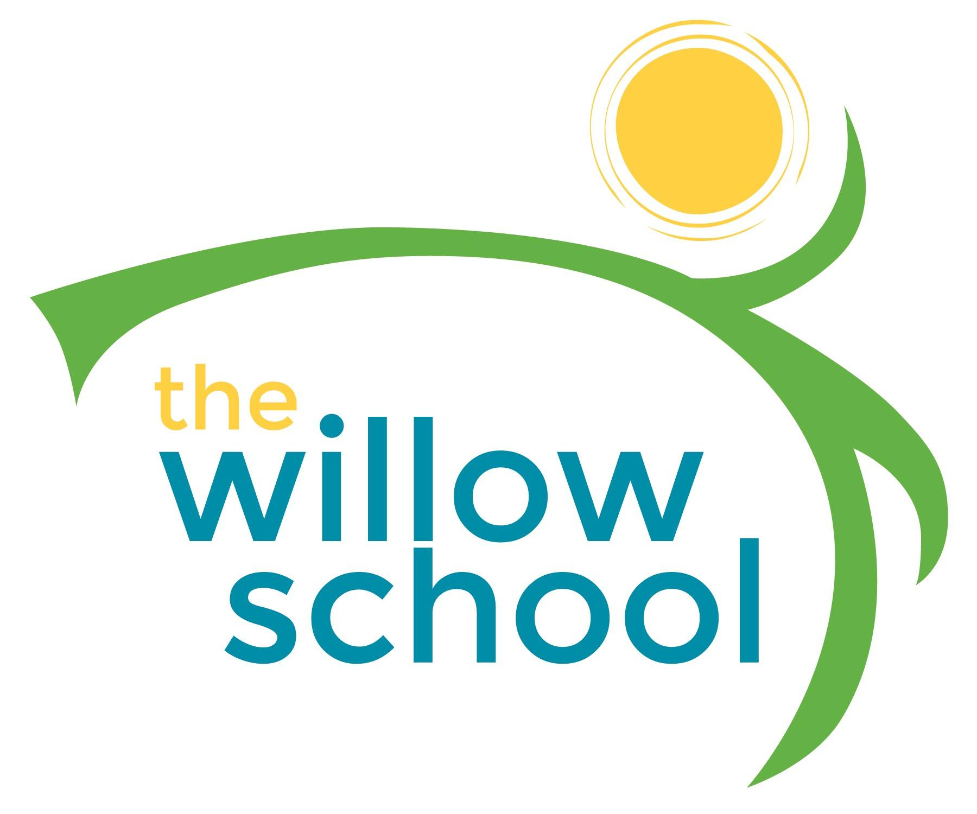 Menu –March 14-18, 2016

 | Monday  March 14 | Tuesday  March 15 | Wednesday  March 16 | Thursday  March 17 | Friday  March 18
Morning Snack | Cinnamon Toast  Dried Apricots  Water | Whole Grain Cereal  Bananas  Water | French Toast  Kiwis  Water | Mixed Fruit Salad  Bagel  Water | Oatmeal  Melons  Water
Lunch | Sauteed Brussel Sprouts w/Carrots  Rice  Strawberries  Milk | Grilled Cheese  Veggie Chips  Strawberries  Milk  *picture day* | Vegetable Fried Rice  Cabbage Salad  Oranges  Milk  *picture day* | Tomato Soup  Cheese & Crackers  Spinach Salad  Milk | Cheese Ravioli  Garden Salad  Blueberries  Milk  (*pre school Needs lunch for field trip*)
Afternoon Snack | Pretzels  Sunbutter  Berries  Water | Tortilla Chips  Salsa  Dried Mangos  Water | Pears  String Cheese  Water | Pita Bread  Marinara Sauce  Water | Celery  Ranch Dressing  Crasins

*Serving sizes and meal components will be in compliance with USDA as per the attached guidelines.

