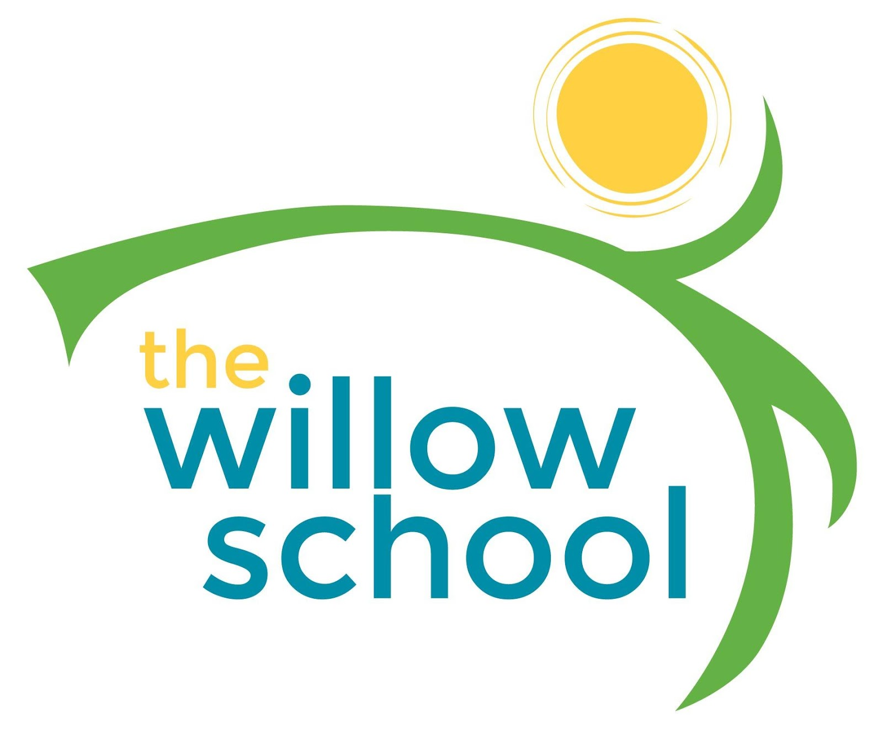 Menu –June 6-10, 2016

 | Monday  June 6 | Tuesday  June 7 | Wednesday  June 8 | Thursday  June 9 | Friday  June 10
Morning Snack | Whole Grain Cereal  Blueberries  Milk | English Muffins  Strawberry Jam & Goat Cheese  Milk | Oatmeal  Raisins  Milk | Apple Sauce  Cinnamon Toast  Milk | Blueberry Pancakes  Milk
Lunch | BBQ Tofu  Baked Beans  Garden Salad  Strawberries  Milk | Summer Squash & Corn Chowder Soup  Summer Peas  Grapes  Milk | Tofurky Sub Sandwiches  French Fries  Pineapples  Milk | Broccoli & Cheese Soup  Rolls  Plums  Milk | Grilled Cheese Sandwiches  Garden Salad  Mangos  Milk
Afternoon Snack | Rice Cakes Cream Cheese  Apple Slices  Water | Pretzels  Hummus  Tomatoes  Water | Animal Crackers  Cheese Bits  Cranberries  Water | Trail Mix  (Granola, Sunflower Seeds, Pumpkin Seeds, Raisins)  Water | Mixed Berry Smoothie Pops

*Serving sizes and meal components will be in compliance with USDA as per the attached guidelines.

