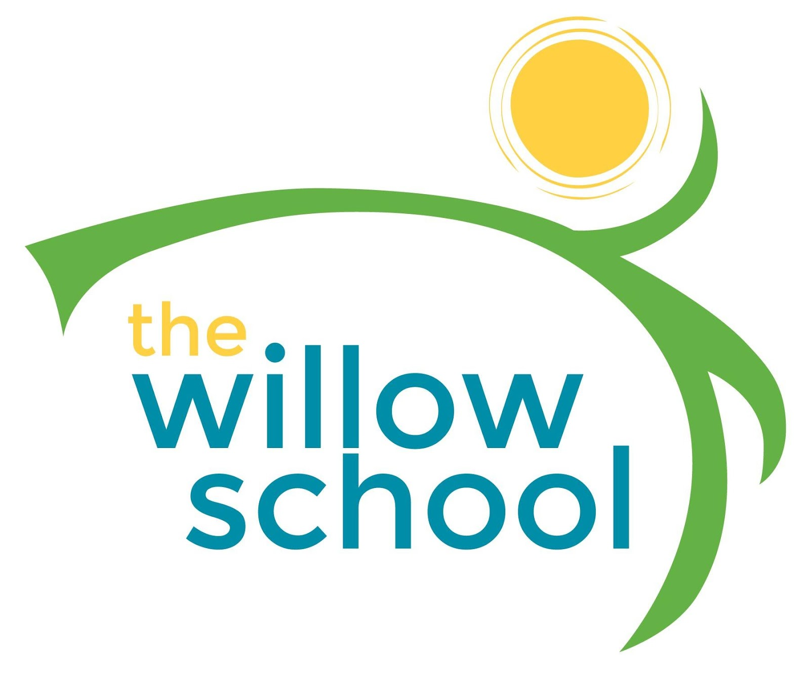 Menu –June 20-24, 2016

 | Monday  June 20 | Tuesday  June 21 | Wednesday  June 22 | Thursday  June 23 | Friday  June 24
Morning Snack | Whole Grain Cereal  Blueberries  Milk | Scrambled Eggs & Cheese  Strawberries  Milk | Blueberry  Waffles  Milk | Toast  Sunbutter  Raisins  Milk | Cinnamon Tortilla Wraps Raspberries  Goat Cheese  Milk
Lunch | Macaroni & Cheese Collard Greens  Cantaloupe  Milk | Garden Minestrone Soup  Rolls  Grapes  Milk | Sweet & Sour Tofu  w/ Mixed Vegetables  Jasmine Rice  Pineapples  Milk | Avocado Buttermilk Soup  w/Spinach  Pears  Milk | Cheese, Tomato & Sprout Sandwiches  Sweet Potato Fries  Kiwi  Milk
Afternoon Snack | Fruit & Cheese Platter  Water | Pretzels  Hummus  Apple Slices  Water | Roasted Chickpeas  Grapes  Water | Dried Mangos  Sunflower Seeds  Pumpkin Seeds  Cheese  Water | Oatmeal Raisin Bake  Water

*Serving sizes and meal components will be in compliance with USDA as per the attached guidelines.

