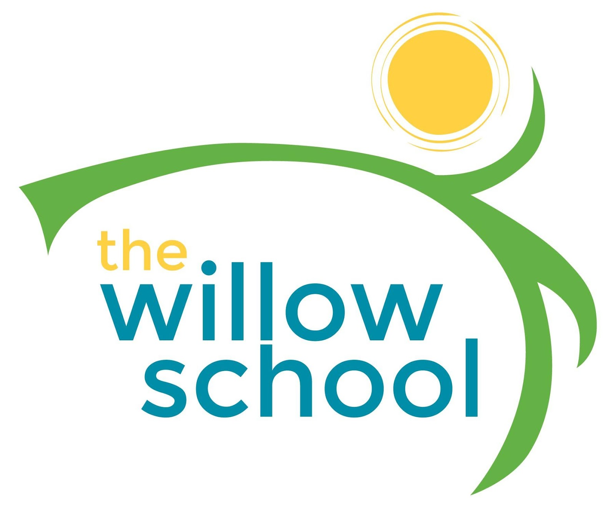 Menu –June 13-17, 2016

 | Monday  June 13 | Tuesday  June 14 | Wednesday  June 15 | Thursday  June 16 | Friday  June 17
Morning Snack | French Toast  w/Fruit Compote  Milk | Bagels w/ Cream Cheese  Craisons  Milk | Whole Grain Cereal  Bananas  Milk | Yogurt Parfait w/  Raspberries & Granola  Milk | Cinnamon Toast  Raisins  Milk
Lunch | Black Bean & Cheese Burritos  Tomato & Cucumber Salad  Mangos  Milk | Indian Spiced Lentil Soup w/ Spinach & Carrots  Papaya  Milk | Mexican Elotes Corn  Pinto Beans  Mixed Salad  Honey Dew Melon  Milk | Roasted Mushroom &  Wild Rice Soup  Broccoli  Watermelon  Milk | Sunbutter & Jam Sandwiches  Steamed Carrots  Peaches  Milk
Afternoon Snack | Guacamole  Chips  Water | Trail Mix  Cheese  Water | Carrots w/ Hummus  Water | Blue Corn Chips & Salsa  Water | Banana Bread  Water

*Serving sizes and meal components will be in compliance with USDA as per the attached guidelines.

