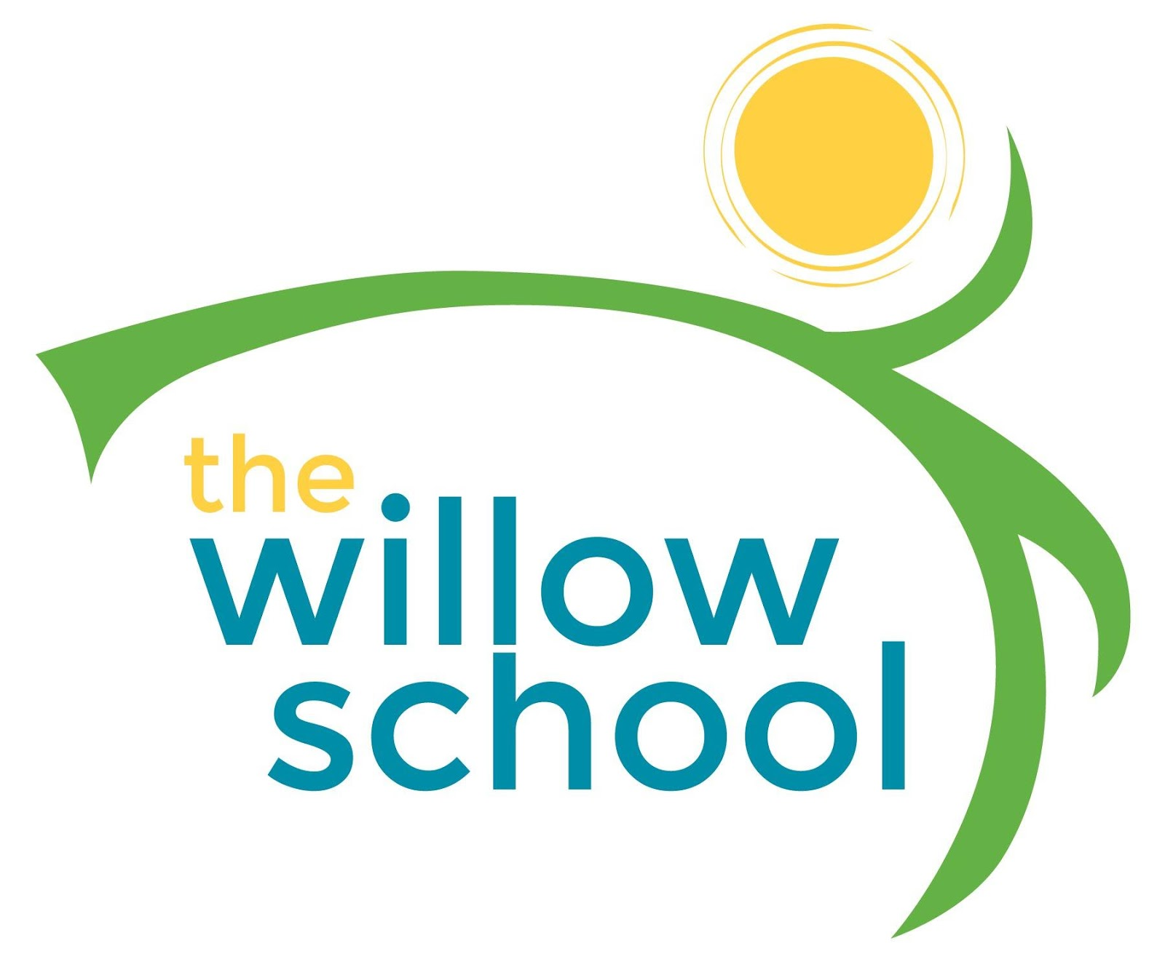 Menu – June 1-3, 2016

 | Monday | Tuesday | Wednesday  June 1 | Thursday  June 2 | Friday  June 3
Morning Snack | Closed | Closed | Graham Crackers & Cream Cheese  Raisins  Milk | Cheese Toast  Peaches  Milk | Cinnamon Waffles  Strawberries  Milk
Lunch | Closed | Closed | Spinach, Olive & Cheese  Pita Pizzas  Garden Salad  Pears  Milk | Vegetable Noodle Soup  Rolls  Orange Slices  Milk | Lettuce, Tomato &  Avocado Sandwiches  Sweet Potato Fries  Plums  Milk
Afternoon Snack | Closed | Closed | Pretzels  Sun Butter  Apple Slices  Water | Cheese Sticks  Crackers  Water | Graham Crackers  Pineapple Cream Cheese  Water

*Serving sizes and meal components will be in compliance with USDA as per the attached guidelines.

