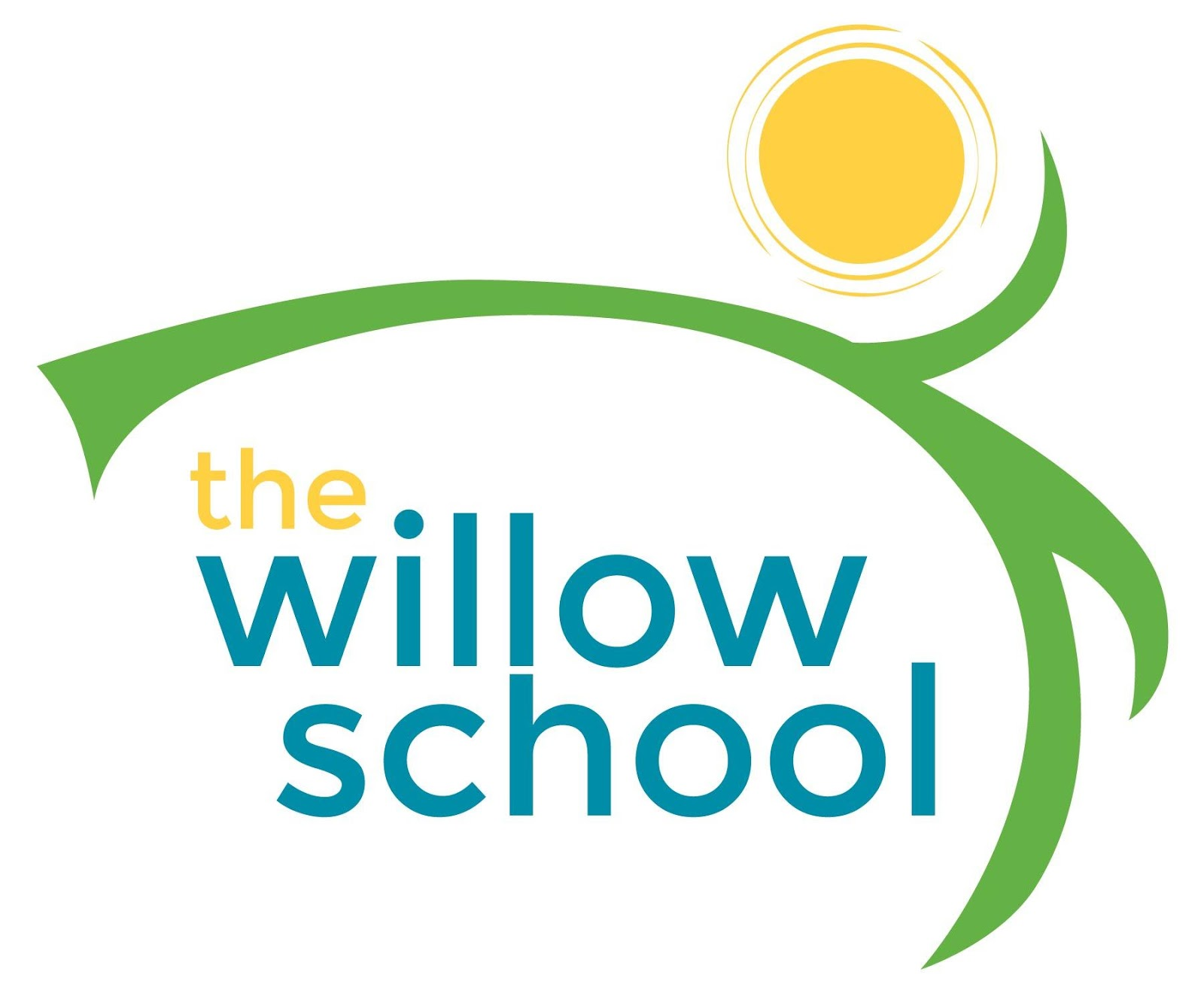 Menu – January 31- February 4, 2016

 | Monday  January 31 | Tuesday  February 1 | Wednesday  February 2 | Thursday  February 3 | Friday  February 4
Morning Snack | Bagels  Goat Cheese  Bananas  Water | Mixed Berry &  Banana Smoothie  Water | Cornmeal Porridge  Cinnamon & Raisons  Water | Graham Crackers Cream Cheese  Cranberries/Raisons  Water | Oatmeal  Strawberries  Water
Lunch | Lentil Soup  Rice  Green Beans  Oranges  Milk | Mixed Vegetable & Spinach Soup  Tomato & Cucumber Salad  Milk | Kale Salad w/Avocado, Beets & Cranberries  Pancakes  Milk | Black Eyed Peas  Honey Carrots  Melon  Milk | Creamy Spinach  Black Beans  Rice  Grapes  Milk
Afternoon Snack | Carrot Sticks  Ranch Dressing  Water | Fig Bars  Grapes  Water | Raisons  Craisons  Chex Cereal  Water | Pretzels  Sunbutter  Apple Slices  Water | Veggie Straws  Black Eyed Pea Hummus  Water

*Serving sizes and meal components will be in compliance with USDA as per the attached guidelines.

