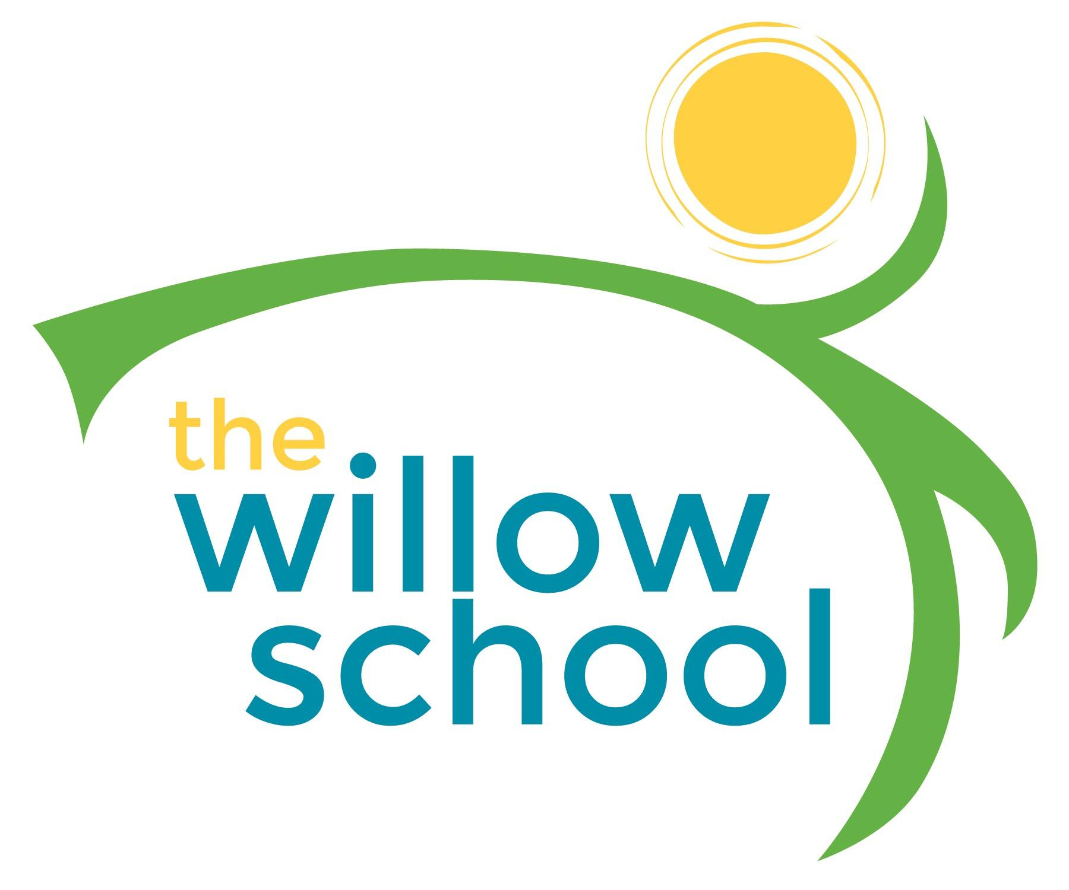 *International Week*
Menu – February 8-February 12, 2016

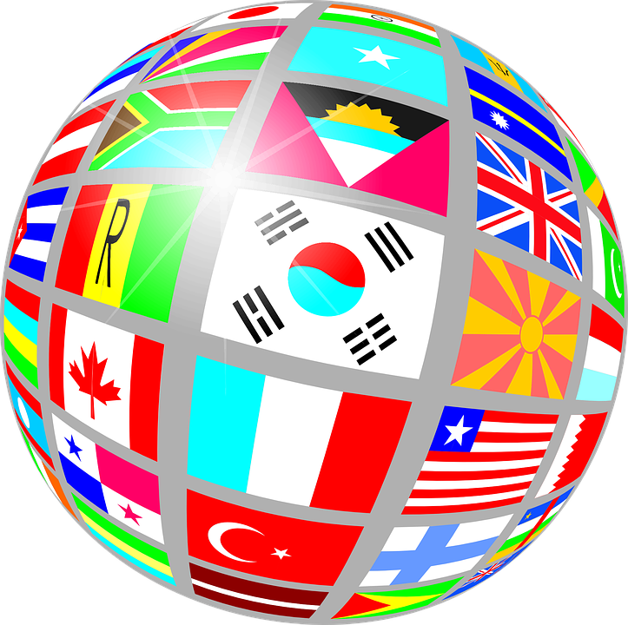 | Monday  February 8  China | Tuesday  February 9  Great Britain | Wednesday  February 10  Mexico | Thursday  February 11  Ethiopia | Friday  February 12  North America
Morning Snack | Rice Cakes  Apple Butter  Water | Eggs & Cheese  English Muffins  Grapes  Water | Whole Grain Cereal  Oranges & Cranberries  Water | Yogurt  Blueberries  Water | Wheat Toast  Goat Cheese  Water
Lunch | Lo Mein  Mixed Vegetables  Garden Salad  Milk | Cucumber & Cream Cheese Wraps  Baked Beans  Strawberries  Milk | Mexican Style Cheese Enchiladas  Black Beans  Avocado  Milk | Shiro (Red Lentils Injera (Bread)  Gomen (Greens)  Milk | Creamy Succotash  (Lima Beans & Corn)  Garden Salad  Melons  MIlk
Afternoon Snack | Ginger Snaps  Apples  Water | Granola, Raisin, Dried Banana  Trail Mix  Water | Black Bean Dip & Tortilla Chips  Water | Graham Crackers  Strawberries  Water | Crackers  Cheese Sticks  Pineapple  Water
*Serving sizes and meal components will be in compliance with USDA as per the attached guidelines.

