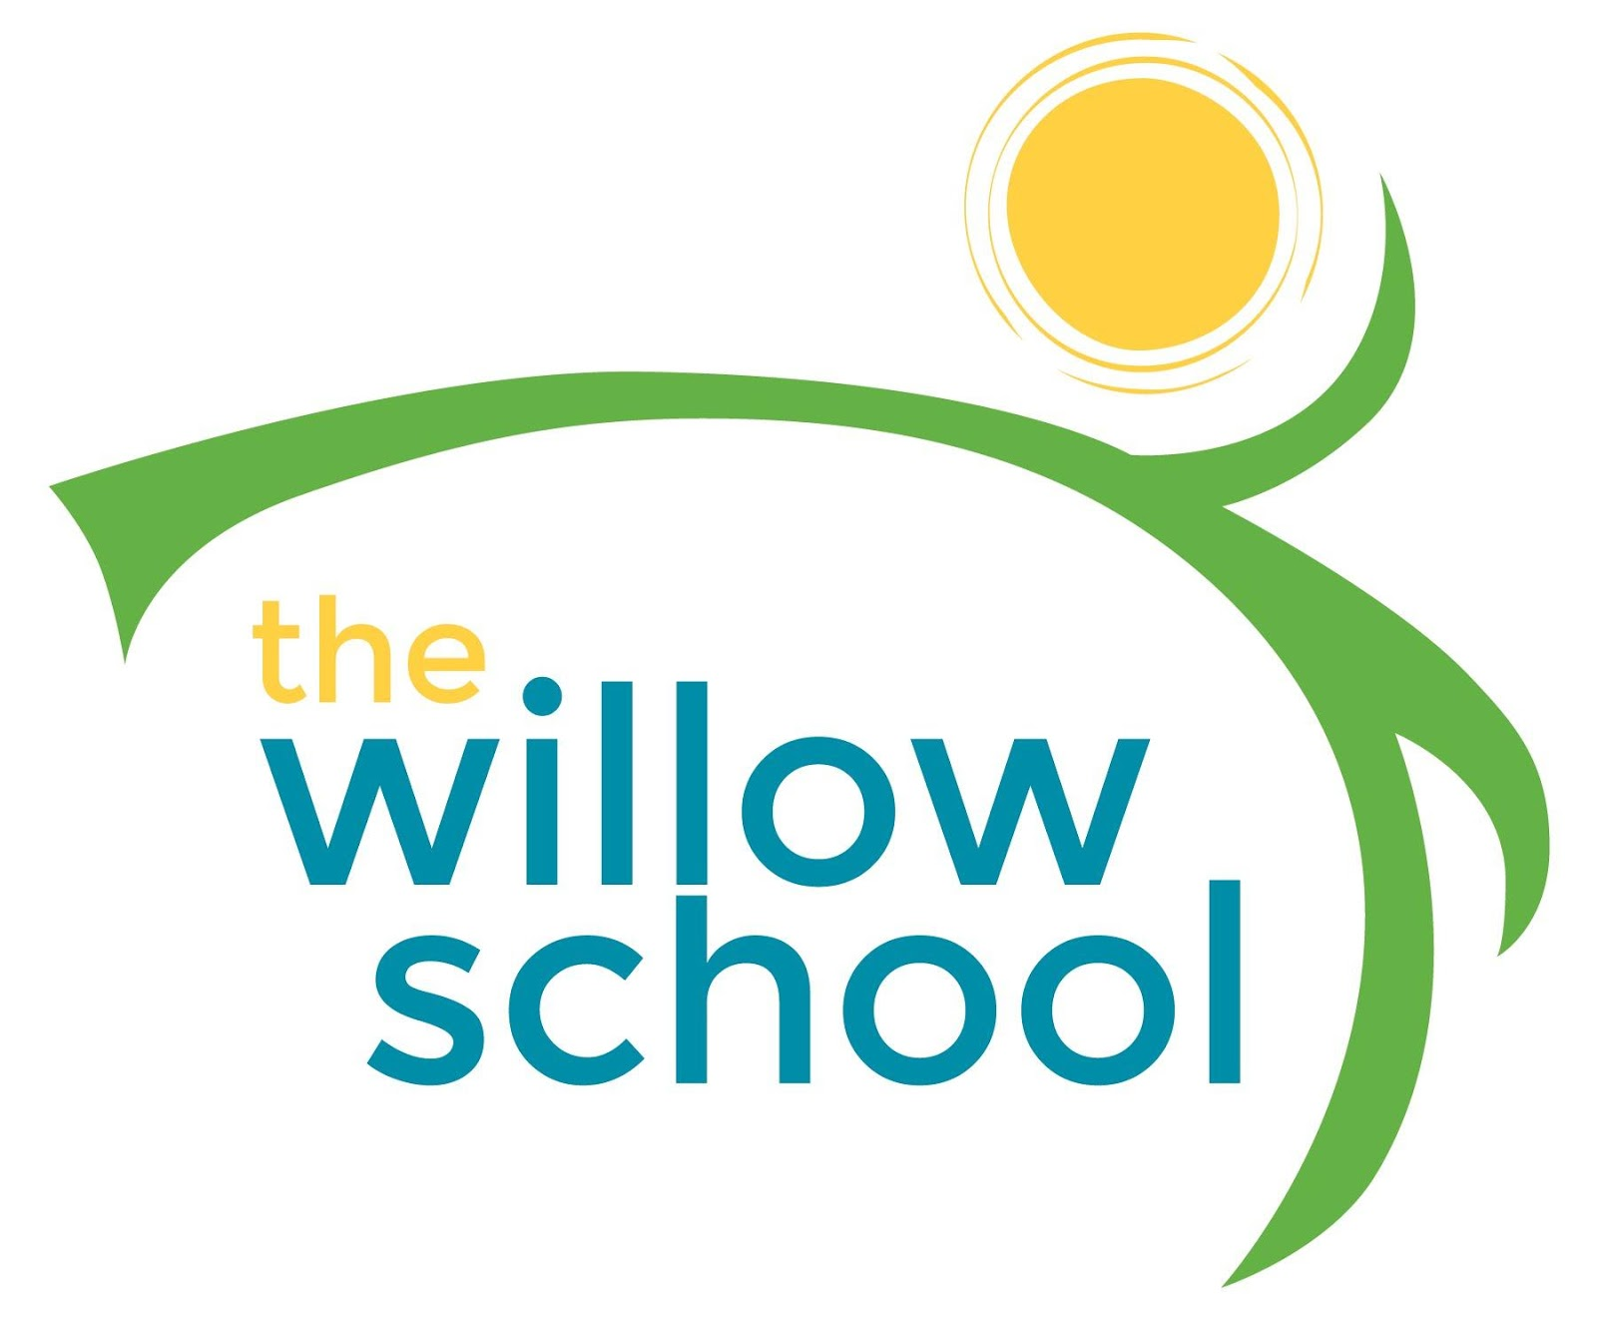 Menu – February 22-26, 2016

 | Monday  February 22 | Tuesday  February 23 | Wednesday  February 24 | Thursday  February 25 | Friday  February 26
Morning Snack | Granola Cereal  Raisins  Milk | Cheese Grits  Water | Cinnamon & Honey Toast  Banana Bites  Water | Cinnamon Apple  Pear Sauce  Water | Oatmeal  Strawberries  Water
Lunch | Penne Pasta  Marinara Sauce  Garlic Bread  Grapes  Milk | Macaroni & Cheese  Steamed Broccoli  Pineapples  Milk | Curry Potato & Chickpea Soup  Green Beans  Orange Slices  Milk | Sun Butter Sandwiches  Veggie Chips  Grapes  Milk | Sweet Potato Soufflé  Strawberry, Feta Spinach Salad  Milk
Afternoon Snack | Celery  Sun Butter  Raisin  Water | Hummus  Carrots  Water | Crackers  Apple Butter  Water | Pretzels  Apple Slices  Water | Animal Crackers  Frozen Fruit Bars  Water

*Serving sizes and meal components will be in compliance with USDA as per the attached guidelines.

