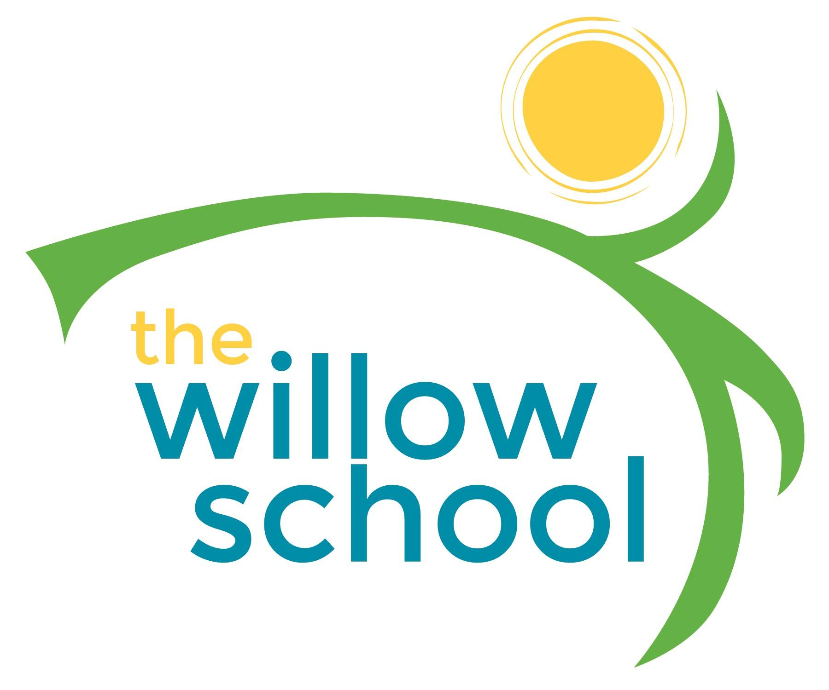 Menu – February 15-19, 2016

 | Monday  February 15 | Tuesday  February 16 | Wednesday  February 17 | Thursday  February 18 | Friday  February 19
Morning Snack | Toast  Strawberry Jam  Bananas  Water | Cereal  Apple Slices  Water | Cinnamon Oatmeal & Strawberries  Water | Blueberry Waffles  Water | Graham Crackers  Sunbutter  Water
Lunch | Vegtable Soup  Crackers  Grapes  Milk | Lasagna  Zucchini  Rolls  Kiwi  Milk | Veggie Taco Salad  Lettuce Tomato & Cheese  Mango & Papaya  Milk | Cheese, Tomato & Sprout Sandwiches  Sweet Potato Chips  Cantaloupe  Milk | Black Eye Pea Fritters  Pita Bread  Tabouli Salad  Grapes  Milk
Afternoon Snack | Corn Tortilla Chips  Mandarin Oranges  Water | Animal Crackers  Apple Bits  Water | Cheese &  Crackers  Water | Fresh Dates  Veggie Straws  Water | Oatmeal & Blueberry No Bake Bars  Water

*Serving sizes and meal components will be in compliance with USDA as per the attached guidelines.

