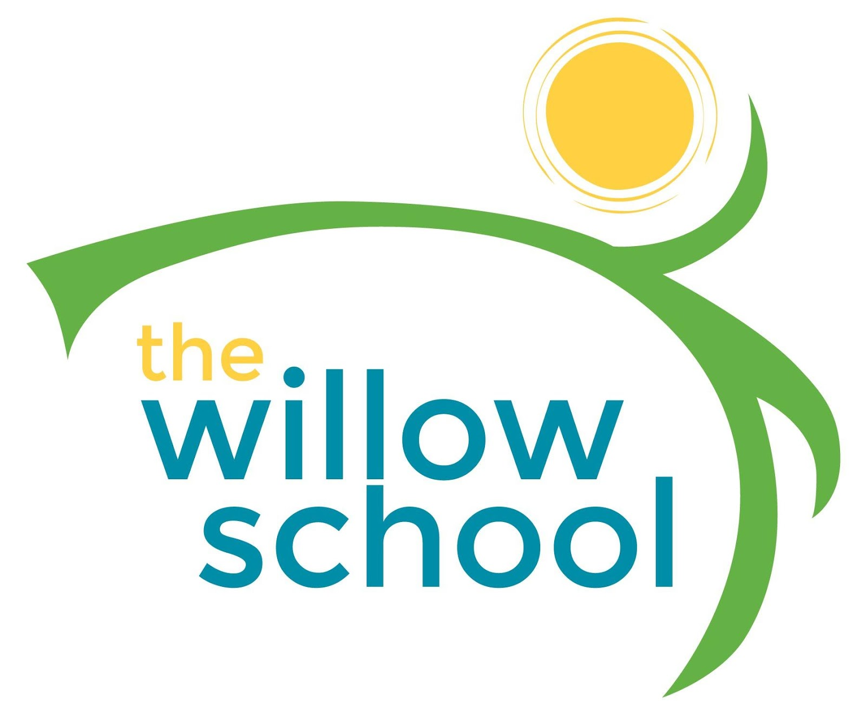 Menu – December 5–9, 2016

 | Monday | Tuesday | Wednesday | Thursday | Friday
Morning Snack | Toast  Sunbutter  Grapefruit  Milk | Whole Grain Cereal  Bananas  Milk | Cheese Grits  Grapes  Milk | Oatmeal  Raisons  Milk | Breakfast Biscuits  Apples  Milk
Lunch | Black Bean & Kale Soup  Rolls  Apples  Milk | Mac & Cheese  Turnips  Grapes  Milk | Veggie Wraps  Lima Beans  Milk | Broccoli Cheese Soup  Rolls  Apples  Milk | Cheese Quesadilla  Purple Bell Peppers  Oranges  Milk
Afternoon Snack | Wheat Thins  Goat Cheese  Oranges  Water | Pretzels  Hummus  Tomatoes  Water | Trail Mix  String Cheese  Grapes  Water | Graham Crackers  Ricotta Cheese  Strawberries  Water | Carrots  Hummus  Pita  Water

*Serving sizes and meal components will be in compliance with USDA as per the attached guidelines.

