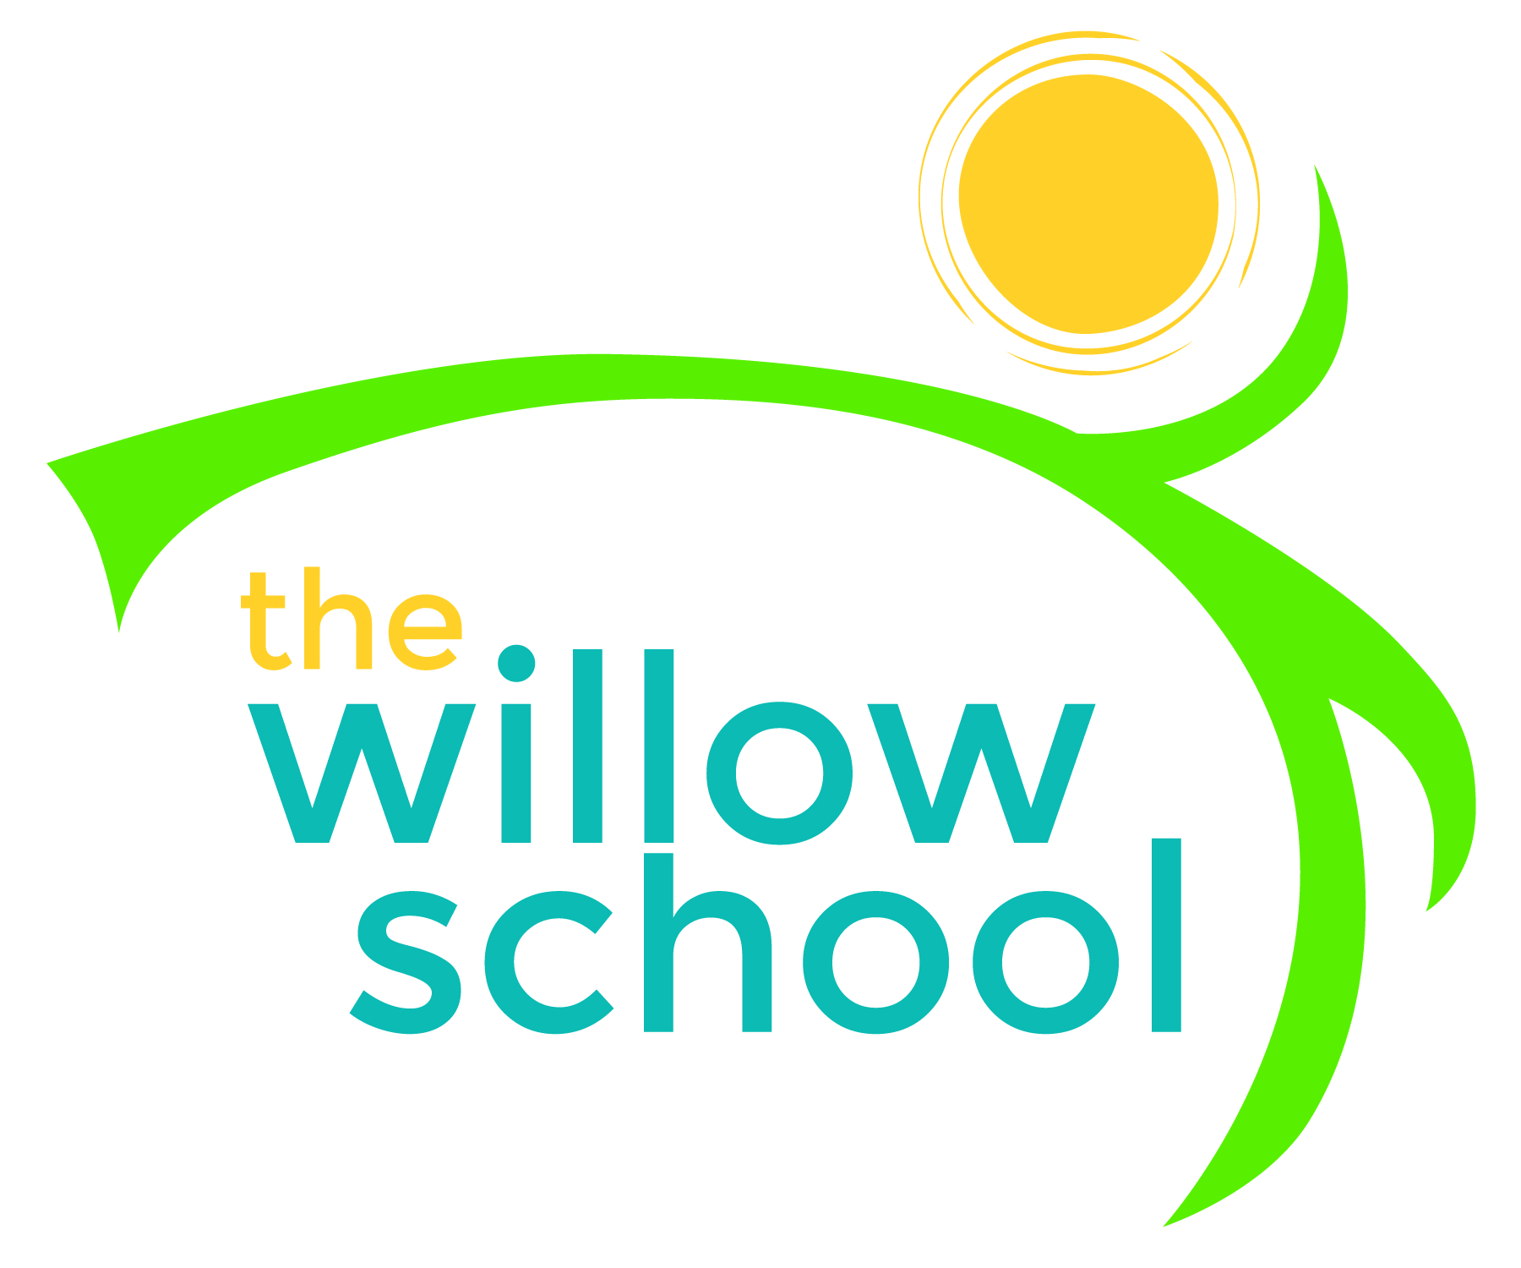 Menu – December 12-16, 2016

 | Monday  Dec 12, 2016 | Tuesday  Dec 13, 2016 | Wednesday  Dec 14, 2016 | Thursday  Dec 15, 2016 | Friday  Dec 16, 2016
Morning Snack | Fruit & Cheese Platter w/Cinnamon Tortillas  Milk | Whole Grain Cereal with Bananas  Milk | Honey Roasted Chickpeas  Raisins  Milk | Pumpkin Bread  Oranges  Milk | Bagels w/Cream Cheese  Pineapple  Milk
Lunch | Avocado Boats with Pico de Gallo  Pinto Beans  Mango Slices  Milk | Spaghetti w/Portobello Marinara  Green Salad  Rolls  Milk | Three Bean Chili  Cole Slaw w/Lime Vinaigrette  Corn Chips  Milk | Grilled Cheese  Sautéed Kale & Rainbow Chard  Grapes  Milk | Black Beans  Potato Latkes  Cranberry Applesauce  Milk
Afternoon Snack | Pita  Hummus  Baby Carrots  Water | Pretzels  String Cheese  Raisins  Water | Graham Crackers  w/Sunbutter  Blueberries  Water | Wheat Crackers  Cheddar Cheese  Apple Slices | Dried Fruit and Seed Trail Mix

*Serving sizes and meal components will be in compliance with USDA as per the attached guidelines.

