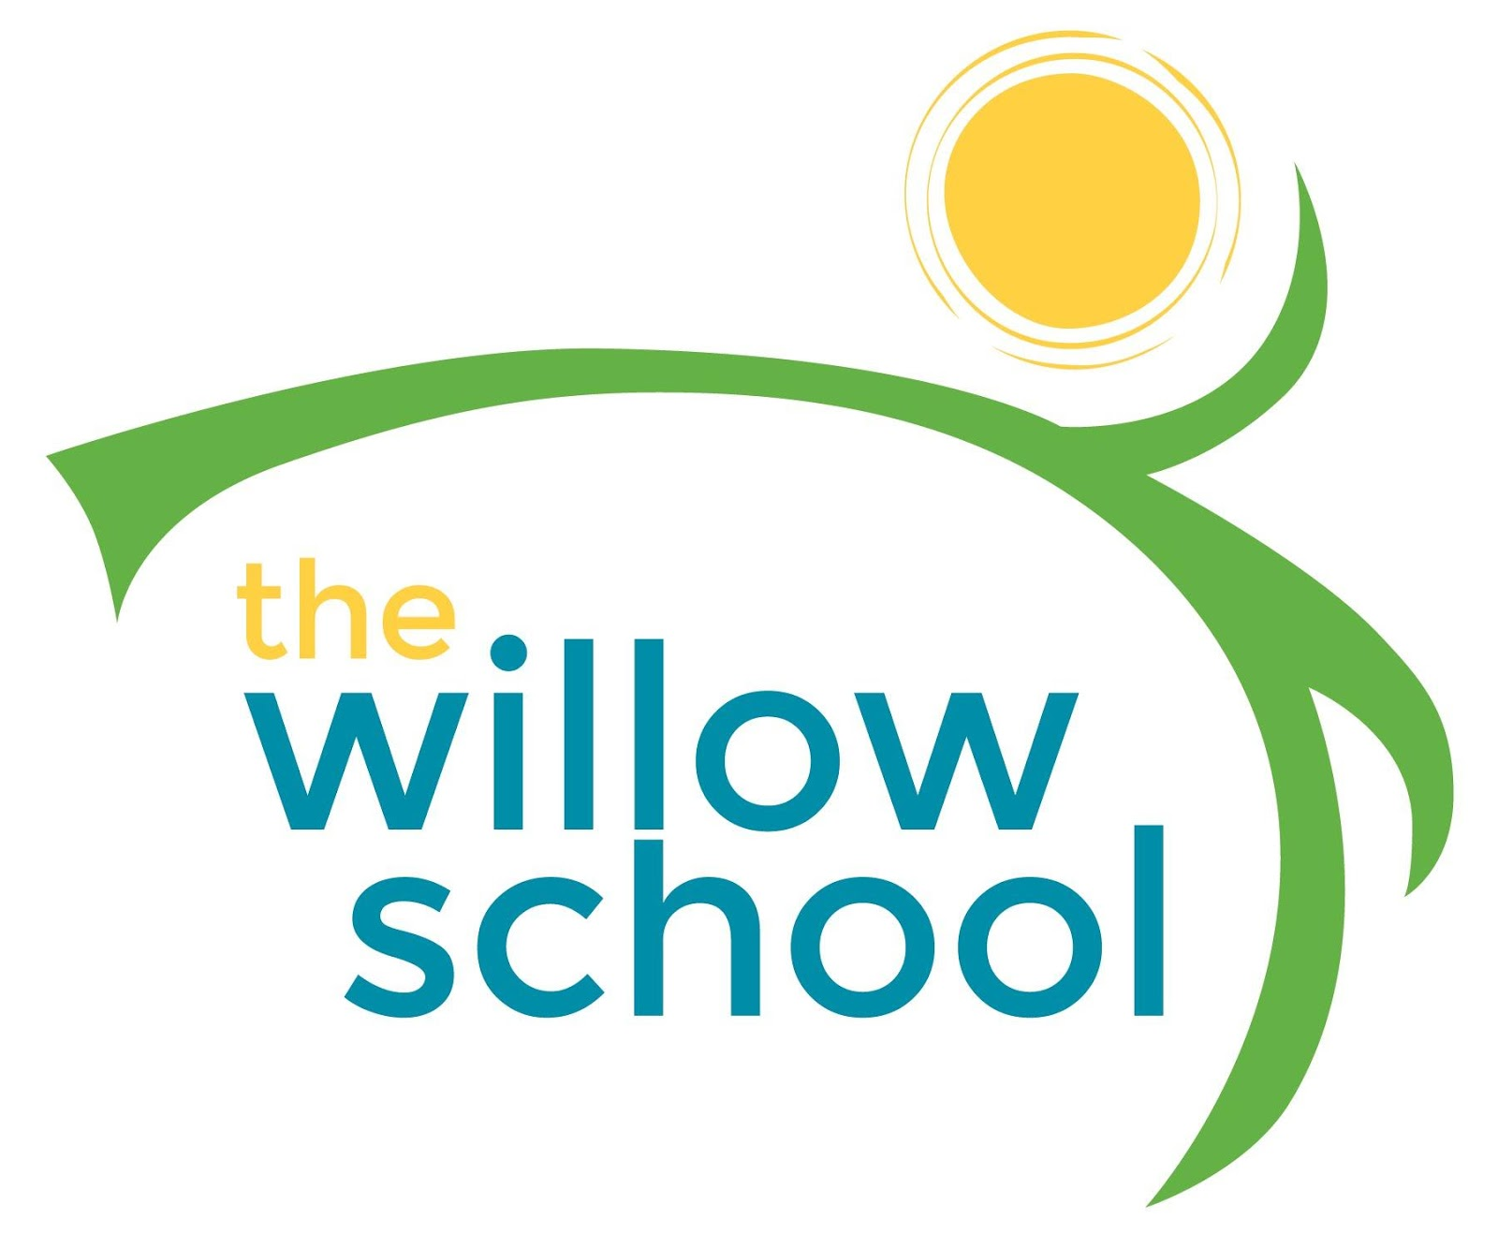 Menu August- 8-12, 2016

 | Monday | Tuesday | Wednesday | Thursday | Friday
Morning Snack | Yogurt  Fresh Strawberries  Milk | Creamy Quinoa  Blueberries  Milk | Warm Granola  w/Figs  Milk | Bagels w/Cream Cheese  Milk | Whole Grain Cereal & Bananas  Milk
Lunch | Cheese & Spinach Quesadillas  Pinto Beans  Oranges  Milk | Minestrone Soup  Spring Salad  French Bread  Grapes  Milk | Broccoli, Cheese & Rice Casserole  Oranges  Milk | Savory Cheese & Chives Waffles  Honey Dew Melon  Milk | Pita Pizzas w/Peppers, Spinach & Olives
Afternoon Snack | Trail Mix  Water | Crackers  Hummus  Carrots  Water | Sliced Apples  w/Cinnamon  Water | Graham Crackers  Sun Butter  Cranberries  Water | Dates, Crackers & Cheese Slices

*Serving sizes and meal components will be in compliance with USDA as per the attached guidelines.

