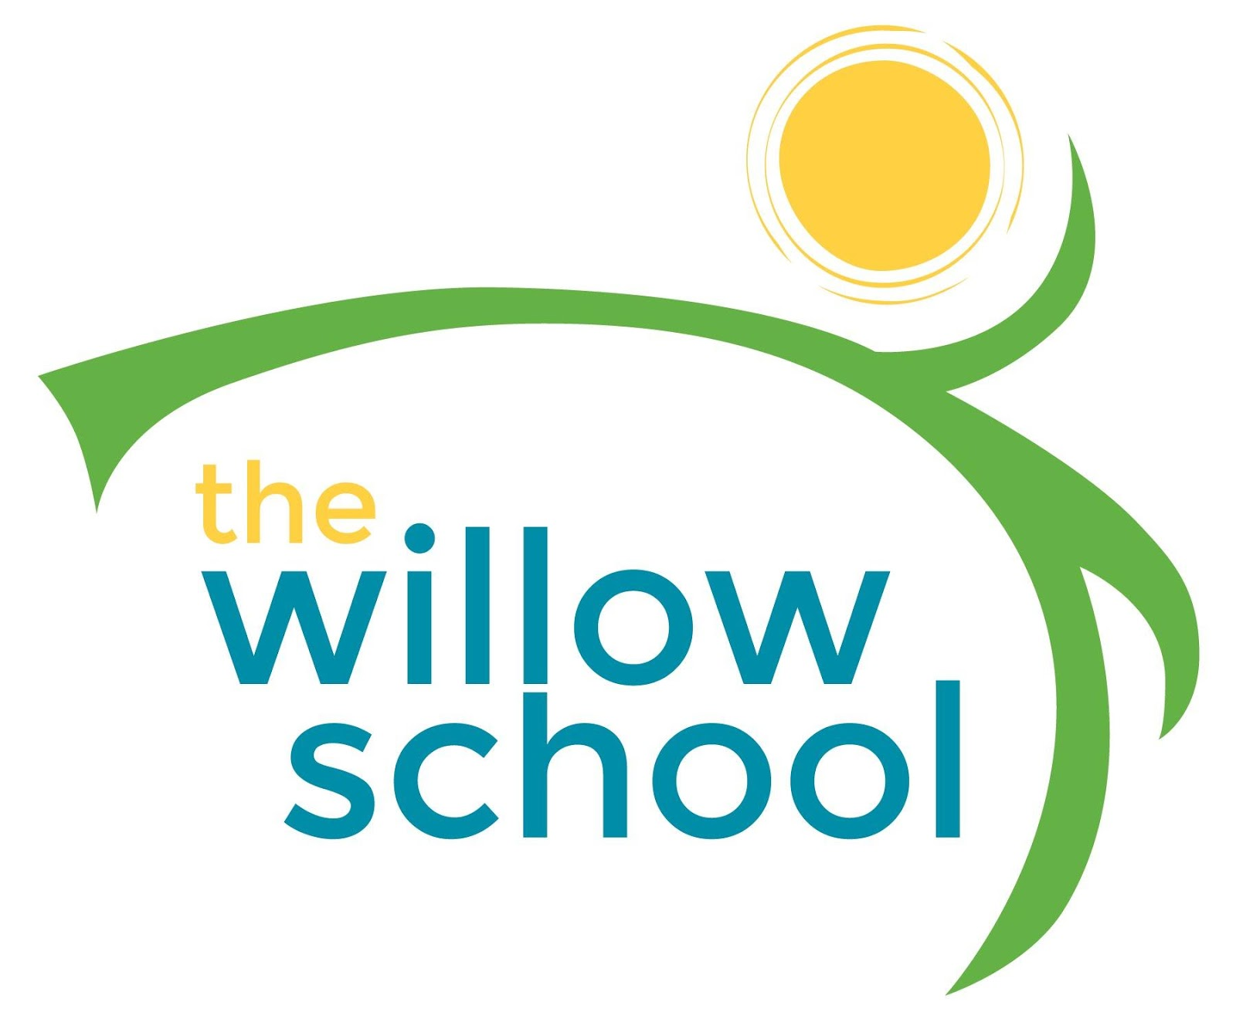 Menu August 22–26, 2016

 | Monday | Tuesday | Wednesday | Thursday | Friday
Morning Snack | Blueberry Pancakes  Milk | Applesauce  Cheese Toast  Milk | Cornmeal Porridge  Bananas  Milk | Yogurt Parfaits  Milk | Whole Grain Cereal  Pears  Milk
Lunch | Lentil Soup w/Carrots  Whole Wheat Rolls  Cherry Tomatos  Milk | Pasta Salad  Steamed Broccoli  Strawberries  Milk | Creamy Succotash w Basmati Rice  Apple Slices  Milk | Vegetable & Cheese Quesadillas  Cantaloupe  Milk | Tofu Stir fry  w/Mixed Vegetables  Brown Rice  Pineapples  Milk
Afternoon Snack | Homemade Gingerbread  Water | Apples  Sun Butter  Crackers | Chocolate Oatmeal Bake  Water | Peach Cobbler  Water | Melons  String Cheese  Water

*Serving sizes and meal components will be in compliance with USDA as per the attached guidelines.

