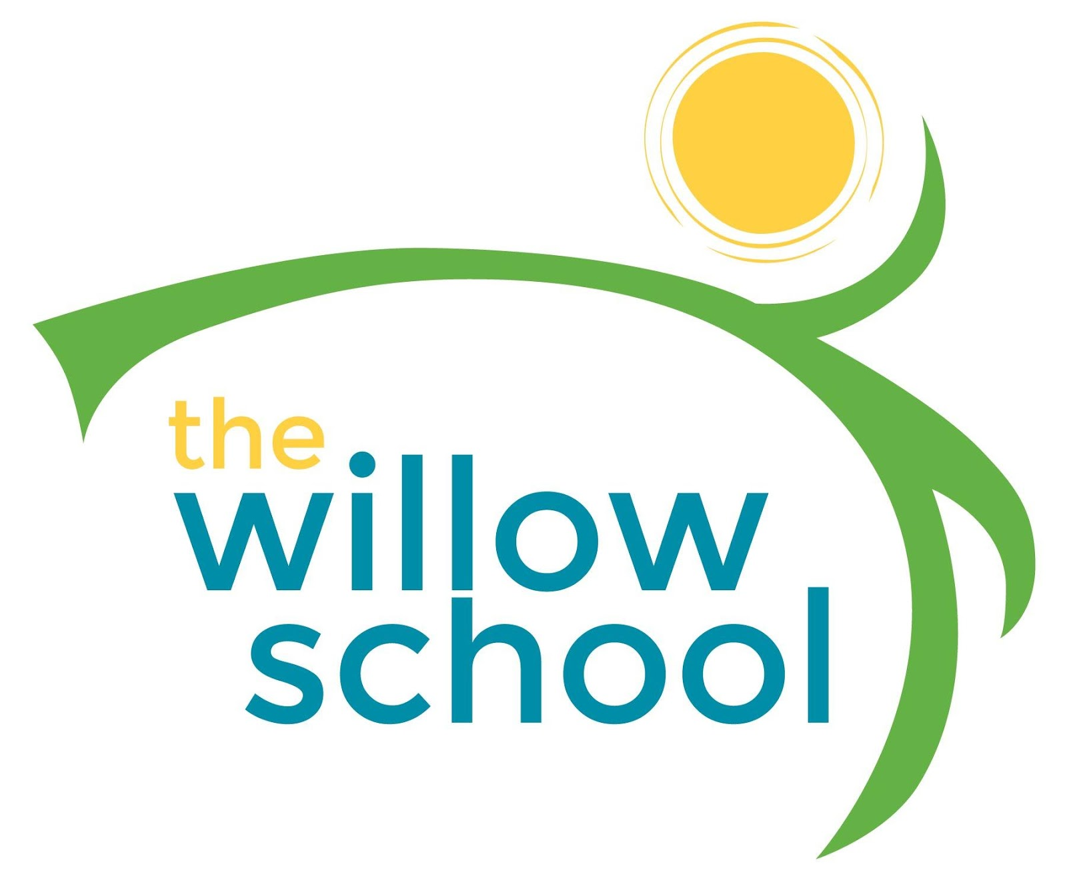 Menu –August 15-19, 2016

 | Monday | Tuesday | Wednesday | Thursday | Friday
Morning Snack | Cottage Cheese w/Mixed Berries  Milk | Cinnamon Toast  Bananas Foster  Milk | Chocolate Raisin Oatmeal  Milk | Whole Grain Cereal  Bananas  Milk | Yogurt w Blueberries  Milk
Lunch | Black Eyed peas  Sweet Potatoes  Honey Dew Melon  Milk | Veggie Hummus Wraps  Pineapple Fruit Kabobs  Milk | Cajun Red Beans & Rice  Collard Greens  Grapes  Milk | Mexican Lasagna  Garden Salad  Avocado  Milk | Penne Pasta w/Marinara Sauce  Sautéed Zucchini  Oranges  Milk
Afternoon Snack | Celery, Sun butter & Raisins  Water | Waffle Strawberry Shortcake  Water | Tortilla Chips & Salsa  Cheese  Water | Cheesy Roasted Chickpeas  Grapes | Apple Crisp  String Cheese  Water
*Serving sizes and meal components will be in compliance with USDA as per the attached guidelines.

