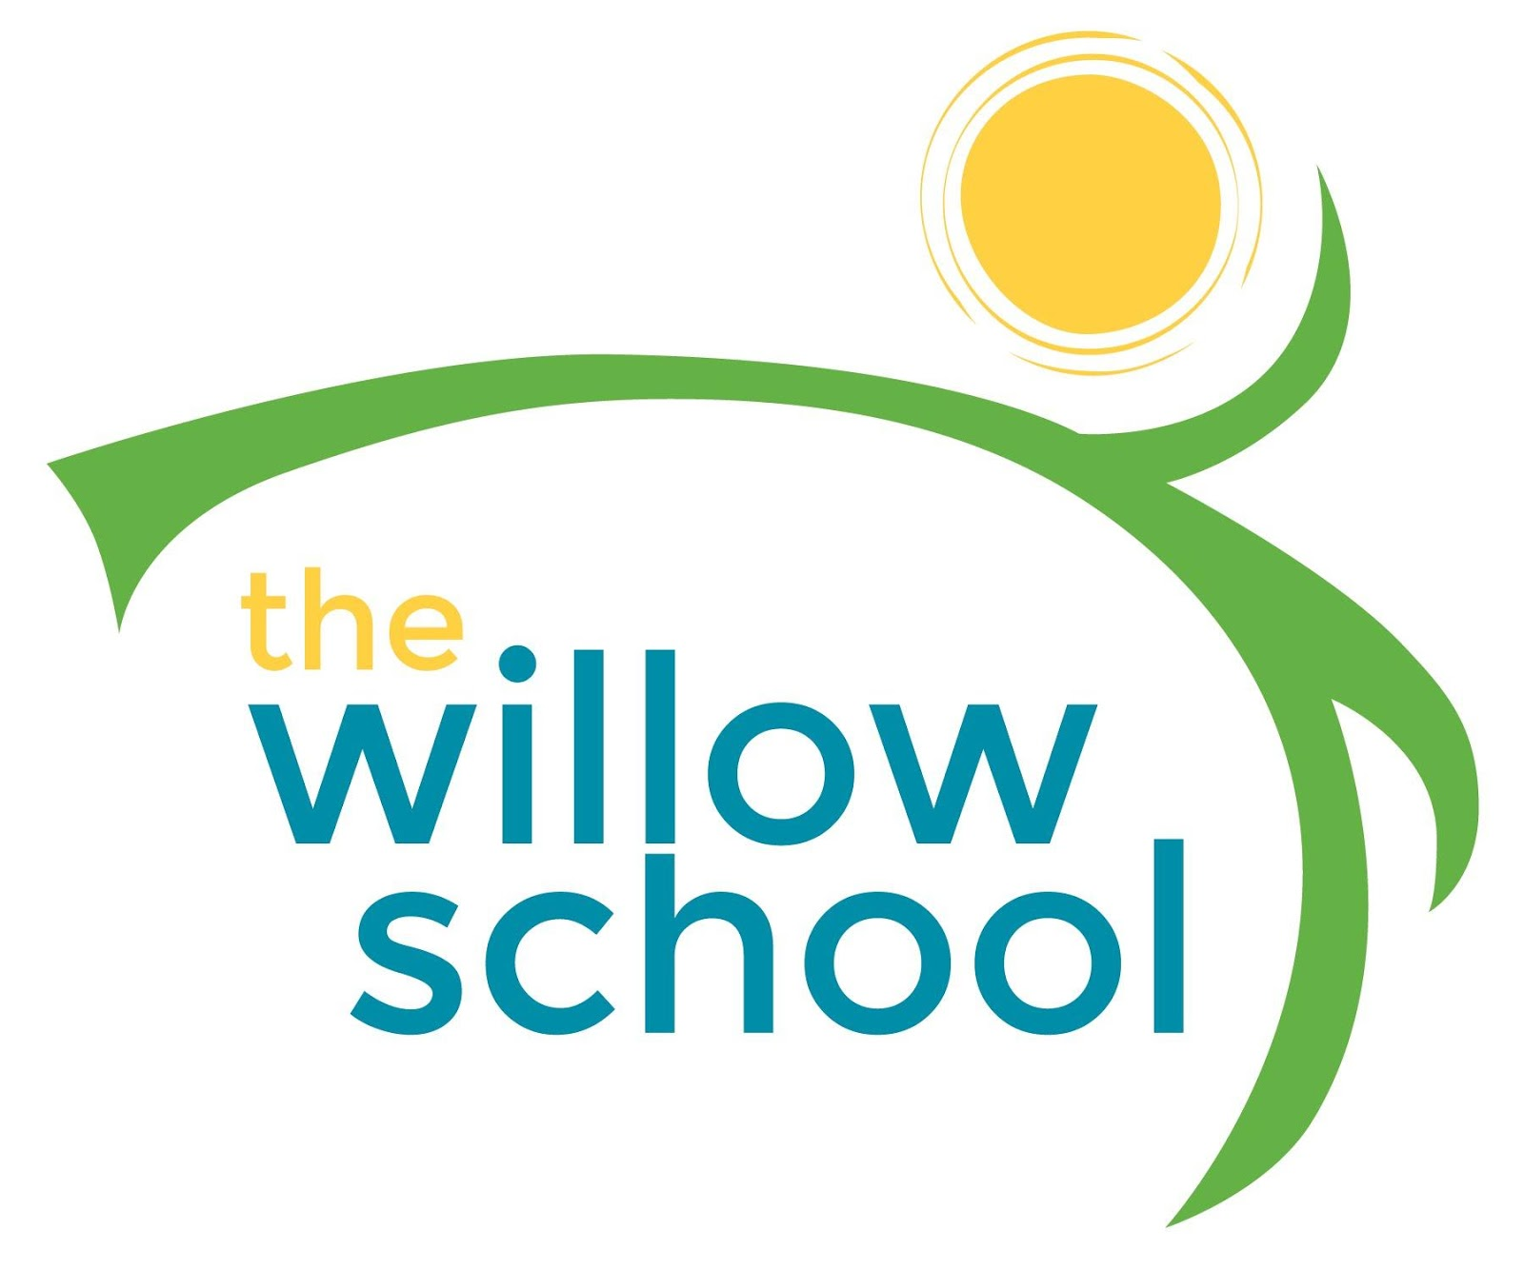
Menu – August 1-August 5, 2016

 | Monday  August 1 | Tuesday  August 2 | Wednesday  August 3 | Thursday  August 4 | Friday  August 5
Morning Snack | Whole Grain  Cereal  Apple Bits  Milk | Cheesy Grits  Clementine’s  Milk | French Toast  Bananas  Milk | Sun Butter & Strawberry Jam Roll-Ups  Milk | Peaches & Cream  Oatmeal  Milk
Lunch | Vegetable Bean Soup  Whole Wheat Rolls  Plums  Milk | Curried Chickpeas  Jasmine Rice  Steamed String Beans  Dates  Milk | Spinach Alfredo Pasta  Garden Salad  Blackberries  Milk | Grilled Cheese Sandwiches  Tomato & Cucumber Salad  Milk | Black & Cheese Bean Burritos  Corn Salad  Avocados  Milk
Afternoon Snack | Pretzels  Cheese Slices  Dried Fruit  Water | Tortilla Chips & Salsa  Kiwi  Water | Watermelon  String Cheese  Wheat Crackers  Water | Rice Cakes  Cream Cheese  Pears  Water | Oatmeal Raisin Bars  Water

