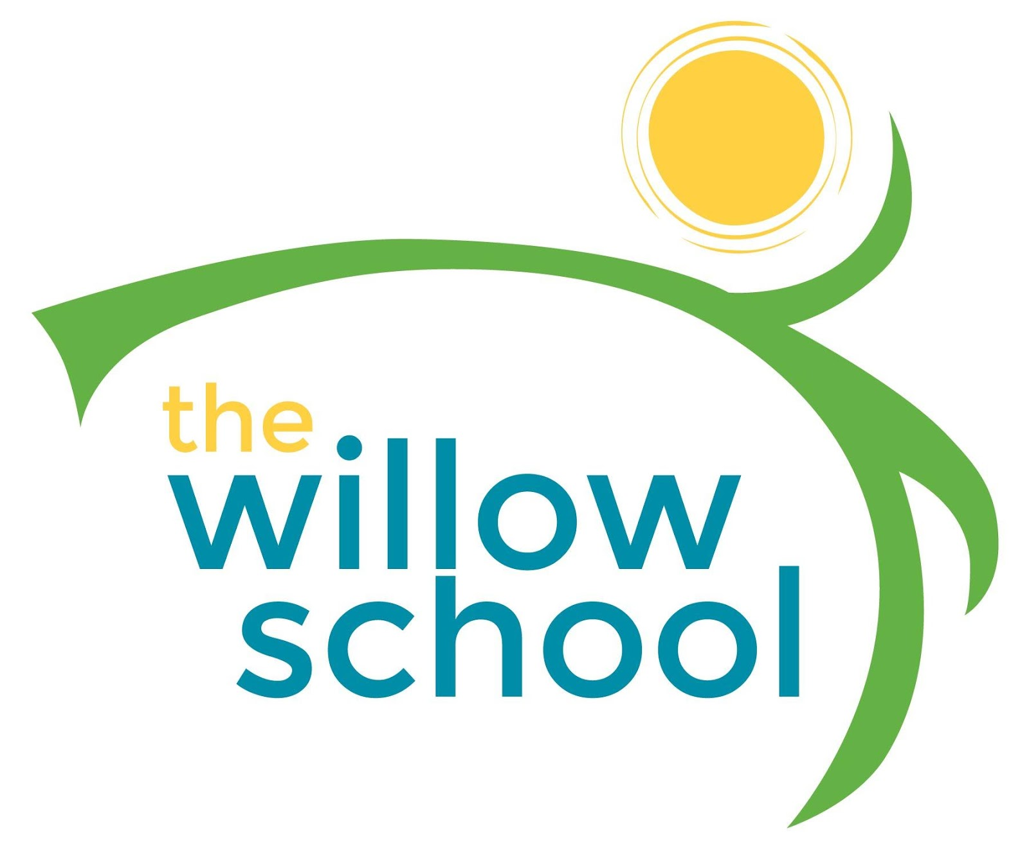 Menu – Aug 29-Sept 2, 2016

 | Monday | Tuesday | Wednesday | Thursday | Friday
Morning Snack | Wheat Toast  Goat Cheese  Strawberries  Milk | Egg & Cheese English Muffins  Bananas  Milk | Whole Grain Cereal  Kiwi  Milk | Yogurt  & Cinnamon Toasted Pita Bread  Milk | Cocoa Cream of Wheat  w/Apple Bits & Honey  Milk
Lunch | Veggie Non Beef Stroganoff  Garden Salad  French Bread  Milk | Veggie Lo Mein w/Edamame  Mixed Greens Salad  Clementine’s  Milk | White Bean Tortilla Soup w/Spinach  Oranges  Milk | Mexican Elotes Corn  Pinto Beans  Apple Sauce  Milk | BBq Tofu Sliders  Cole Slaw Baked Beans  Melons  Milk
Afternoon Snack | Granola &  Dried Fruit Trail Mix  Water | Graham Crackers  Sun Butter  Apples  Water | Pears w/ Cream Cheese & Cinnamon | Guacamole & Chips  Water  (Crackers for Infants) | Vegan Banana Pudding  Milk

*Serving sizes and meal components will be in compliance with USDA as per the attached guidelines.

