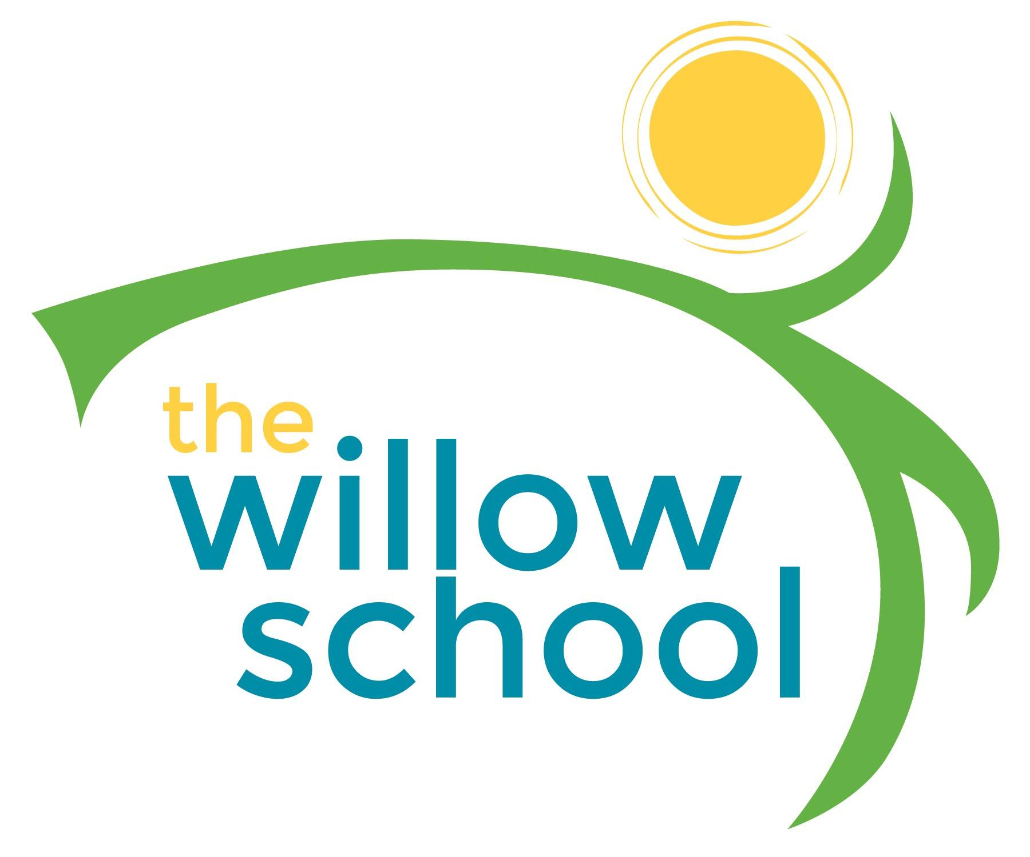 Menu – April 18-22, 2016

 | Monday  April 18 | Tuesday  April 19 | Wednesday  April 20 | Thursday  April 21 | Friday  April 22
Morning Snack | Yogurt w/Granola  Mixed Fruit  Water | Bagels w/Cream Cheese  Apples  Water | Whole Grain Cereal  Bananas  Milk  Water | Cinnamon Toast  Fruit Compote  Water | French Toast  Strawberries  Water
Lunch | Lasagna  Veggie Crumble  Zucchini  Pears  Milk | Grilled Cheese Sandwiches  Garden Salad  Oranges  Milk | Black Beans  Rice  Kale Salad  Avocados  Milk | Homemade Vegetable Soup  Garden Salad  Rolls  Melon  Milk | Bean Burrito  Tomato/Cucumber Salad  Mangos  Milk
Afternoon Snack | Rice Cakes w/Cream Cheese  Raisins  Water | Graham Crackers  Sunbutter  Bananas  Water | String Cheese  Apples  Water | Sliced Apples  Sunbutter  Water | Pita Bread  Chips  Salsa  Water

*Serving sizes and meal components will be in compliance with USDA as per the attached guidelines.

