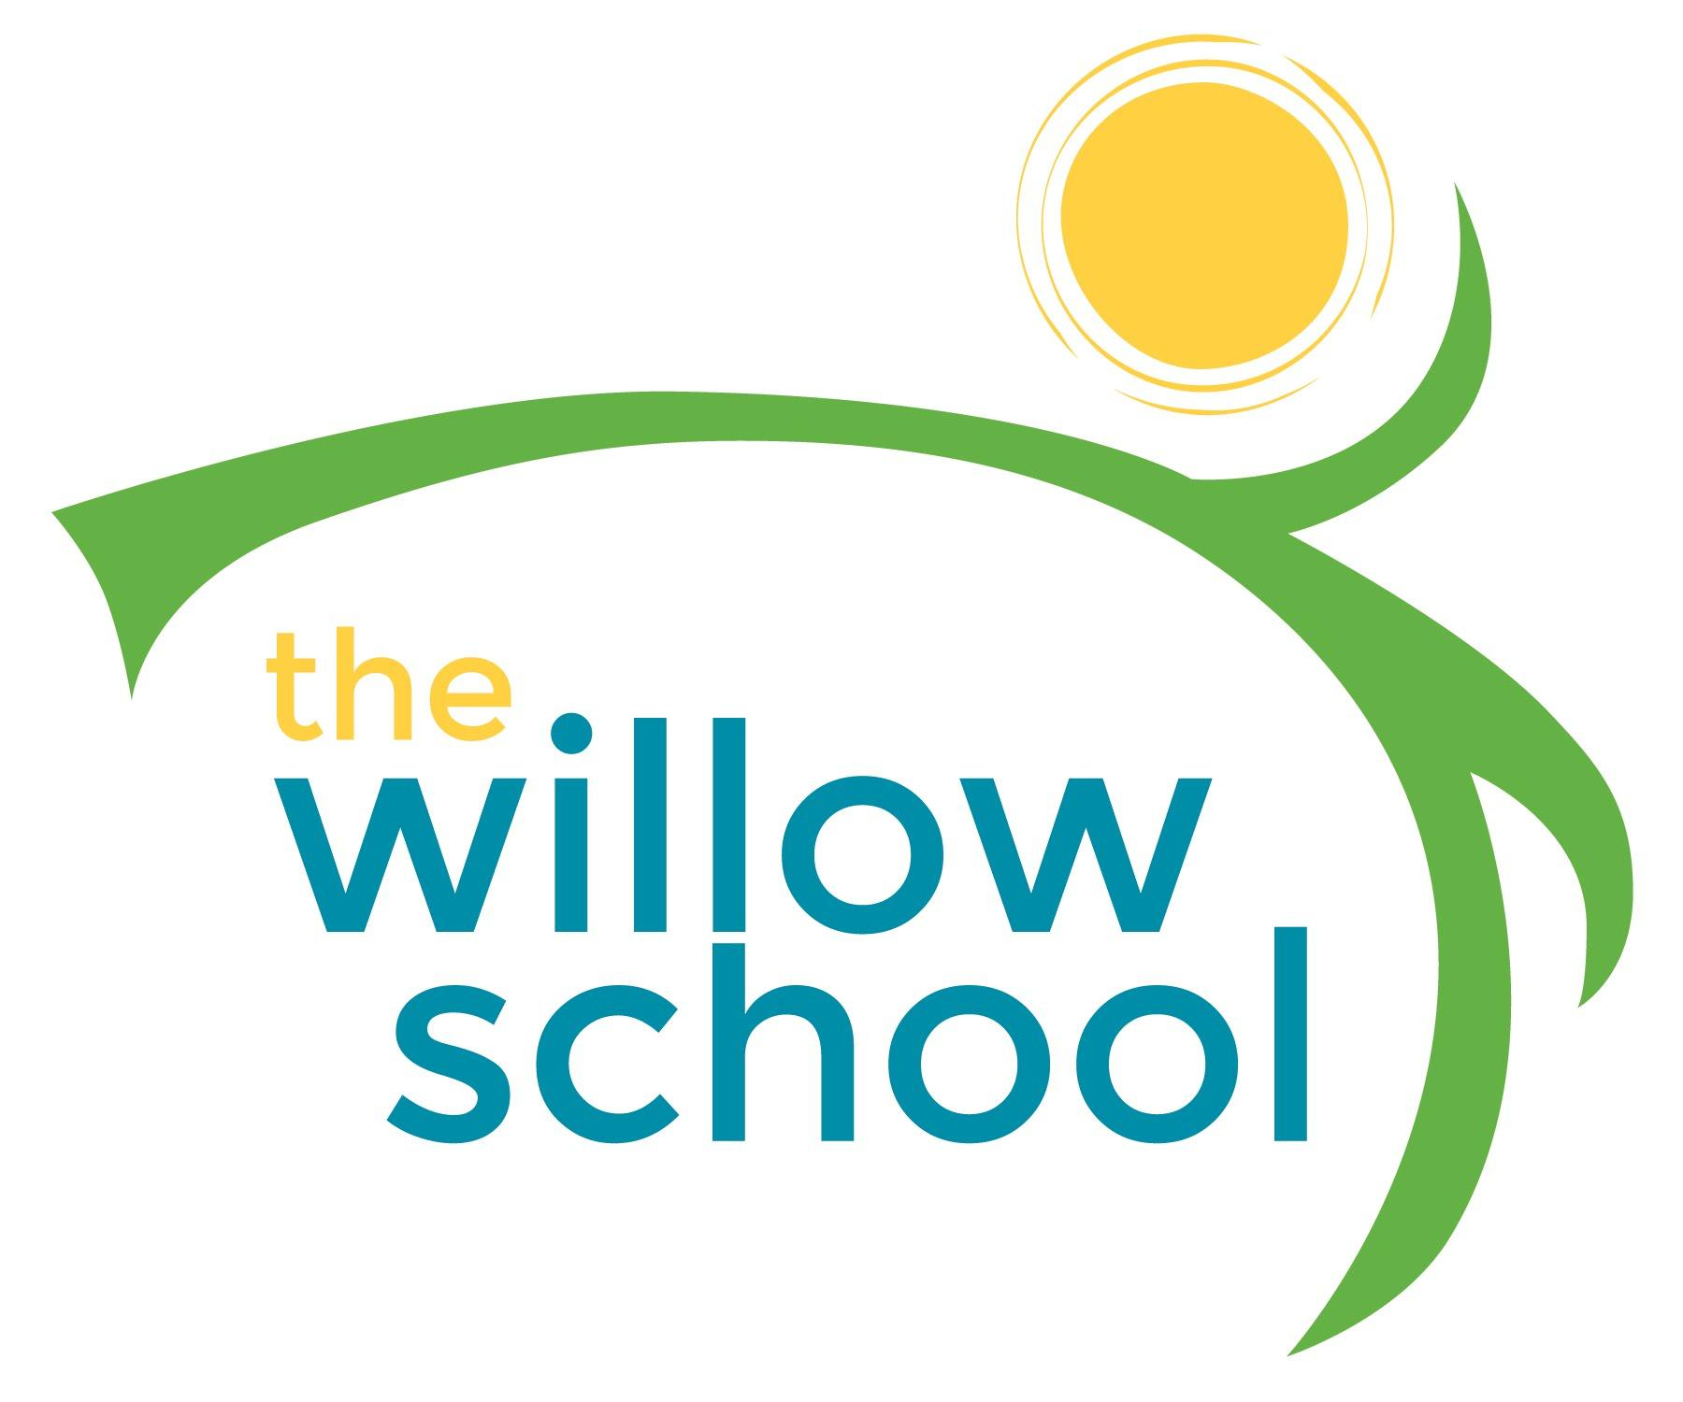 Menu – April 11-15, 2016

 | Monday  April 11 | Tuesday  April 12 | Wednesday  April 13 | Thursday  April 14 | Friday  April 15
Morning Snack | Oatmeal  Strawberries  Water | Toast  Sunbutter  Oranges  Water | Whole Grain Cereal  Bananas  Milk  (Twos – Snack Bars) | Raison Bagels  Cream Cheese  Milk | Cream of Wheat  Raisons  Milk
Lunch | Spaghetti  Garden Salad  Tomatoes  Cheese  Strawberries  Milk | Lentil Soup  Carrots  Steamed Broccoli  Pineapple  Rolls  Milk | Cheese & Pepper  Fajitas  Saffron Rice  Melons  Milk  (Twos- Sunbutter Sandwich, Orange Slices, Carrots & Milk) | Kale Soup  Tomatoes  Celery  Carrots  Crackers  Grapes  Milk | Falafel & Pita  Sandwiches  Garden Salad  Feta Cheese  Blueberries  Milk
Afternoon Snack | Carrots  Hummus  Corn Chips  Water | Pretzels  String Cheese  Berries  Water | Oatmeal  Dried Fruits & Sunbutter Balls  Water | Rice Cakes  Cream Cheese  Apple Slices  Water | Crackers  Cheese Slices  Apples  Water

*Serving sizes and meal components will be in compliance with USDA as per the attached guidelines.

